Habitat Annual Review Report

April 1999
(Revised May 1999)

Prepared and Reviewed by:

Essential Fish Habitat Technical Team

This document serves as the habitat component to the annual Stock Assessment and Fishery Evaluation (SAFE) reports. The intent of this report is to assist the Council in meeting the habitat-related provisions of the Sustainable Fisheries Act.

New England Fishery Management Council
Saugus, Massachusetts
Table of Contents

Executive Summary i
Introduction i
Activities and Projects ii
New and Additional Habitat-Related Information ii
Management Alternatives iii
Research and Information Needs and Goals iv
Section 1.0: Introduction 1
1.1 Habitat Annual Review Report Development Process 1
1.2 EFH Strategic Plan 2
1.3 Essential Fish Habitat Technical Team 4
Section 2.0: Activities and Projects 6
2.1 Accomplishments of the Past Year 6
2.1.1 Habitat Committee and Advisors 6
2.1.2 EFH Technical Team 7
2.1.3 Council Staff 8
2.1.4 National Marine Fisheries Service 9
2.2 Proposed Activities and Projects for the Coming Year 10
2.3 Recent and On-Going Research Projects Related to EFH 12
Section 3.0: New and Additional Habitat-Related Information 28
3.1 Description and Identification of EFH 28
3.1.1 State Data and Information 28
3.1.2 Offshore Data and Information 30
3.1.3 Inshore versus Offshore EFH Designations 31
3.2 Designation of Habitat Areas of Particular Concern 33
3.2.1 EFH Overlays and Intersections 34
3.2.2 Areas of High Concentration 71
3.2.3 Information from the Fishing Industry 102
3.2.4 Juvenile Atlantic Cod and Inshore Gulf of Maine 107
3.3 Fishing and Non-Fishing Related Impacts 120
3.3.1 Non-Fishing Related Adverse Impacts to Fish Habitat 120
3.3.2 Fishing Related Adverse Impacts to Fish Habitat 120
Section 4.0: Management Alternatives 124
4.1 Proposed Revisions to EFH and HAPC Designations 124
4.1.1 Inshore Gulf of Maine 124
4.1.2 Great South Channel 125
4.1.3 Areas of High Species Concentration 125
4.1.4 EFH Overlays and Intersections 135
4.2 Alternatives to Minimize Adverse Impacts to EFH 135
4.2.1 Measures to Protect Newly Proposed HAPCs 135
4.2.2 Measures to Minimize Adverse Impacts of Fishing Gear and Practices 139
Section 5.0: Research and Information Needs and Goals 141
Section 6.0: EFH Technical Team 144
Section 7.0: References 145

Appendix A: Rhode Island State Survey Report
Appendix B: Connecticut State Survey Report

New England Fishery Management Council
Essential Fish Habitat Technical Team

Habitat Annual Review Report

April 1999

Executive Summary

Introduction

In 1996, the Sustainable Fisheries Act amended the Magnuson-Stevens Fishery Conservation and Management Act to require that fishery management plans (FMPs) describe and identify essential fish habitat (EFH), adverse impacts on EFH, and actions to conserve and enhance EFH. Beginning in 1999, the New England Fishery Management Council's (Council) EFH Technical Team will prepare a separate habitat component to the annual Stock Assessment and Fishery Evaluation (SAFE) reports. This habitat component, titled the Habitat Annual Review Report (HARR), will include all new information related to the designation of EFH and habitat areas of particular concern (HAPC), additional information on the effects of fishing activities, and an update on the status of the research and information needs identified by the Council. This report will assist the Council in meeting the habitat-related provisions of the Sustainable Fisheries Act. Each new annual report will update and provide new information to supplement the Council's omnibus EFH amendment to its fishery management plans (NEFMC 1998).

In April of 1999 and February of each year beginning in 2000, the Habitat Committee will meet to focus on the information presented in the EFH Technical Team's annual report. The annual review by the Habitat Committee will focus on four areas: (a) EFH and HAPC designations; (b) identification of threats to EFH; (c) management measures to protect EFH; and, (d) research and information needs. The Habitat Committee will develop any appropriate recommendations based on the information presented in the annual report and present these recommendations to the full Council for consideration. Council action on these Committee recommendations will follow and be incorporated into the Council's annual review and adjustment cycles for the groundfish, sea scallop, Atlantic herring, and monkfish fishery management plans.

The Council's EFH Amendment contains a strategic plan for fulfilling the requirement to review and revise the EFH components of its fishery management plans within five years, and provides a context and structure within which the Council will work. This strategic plan addresses the processes and actions of the Council for a five-year timeframe following implementation of the EFH Amendment. A major component of the Council’s plans to continue the EFH management process is the development of the HARR. The Habitat Annual Review Report is prepared by Council staff with the assistance of the EFH Technical Team. The EFH Technical Team is comprised of technical experts.
Activities and Projects

The HARR describes the habitat-related accomplishments of the Council for the past year, such as developing and submitting the omnibus EFH amendment to the Council's FMPs. This section describes the specific tasks and accomplishments of the Council's Habitat Committee, Advisors, and EFH Technical Team, as well as Council staff and the National Marine Fisheries Service (NMFS).

This section describes several proposed activities and projects for the coming year that are necessary to continue the Council's process for meeting the habitat-related mandates of the Sustainable Fisheries Act. Recent and proposed habitat-related research projects are also described. Several agencies, universities, and research centers are conducting important work that will add to the general understanding of the interactions of fish and their habitats, as well as on impacts to fish habitat.

New and Additional Habitat-Related Information

The use of species distribution and abundance data, as well as information on the presence or absence of fish species, collected by individual state fishery and environmental agencies is an important component to the Council's habitat management program. In order to develop a comprehensive assessment of all Council-managed species in all areas where they occur, the Council and NMFS are continuing to examine data and information from state and other inshore surveys as they become available. Following the development of the EFH amendment, NMFS has continued the process of reviewing and analyzing data and information from various state surveys. NMFS is reviewing thirty-one state and inshore surveys for inclusion in the EFH process. As these survey datasets are made available and analyzed by NMFS, they will be presented to the Council for review and incorporation into the EFH process.

As the Council conducts formal reviews and revisions of its EFH designations over the next five years, updates to offshore survey datasets will be analyzed to determine if changes to the Council’s offshore EFH designations are warranted. The EFH Technical Team and Habitat Committee will also review information from other sources of information on offshore areas, such as fish landings information, effort data, information from the fishing industry, sediment information, oceanographic information, bathymetric information, etc. Future HARRs will update the Habitat Committee on progress made in identifying these and other potential additional sources of information.

The EFH Technical Team and Habitat Committee will also continue to review information related to the designation of HAPCs. The intent of the HAPC designation is to identify those areas known to be important to species which are in need of additional levels of protection from fishing or non-fishing adverse impacts. Designation of habitat areas of particular concern are intended to highlight what areas within EFH should receive more Council and NMFS attention when providing comments on federal and state actions, and in establishing higher standards to protect and/or restore such habitat.
The HARR also provides additional information for review and consideration by the Habitat Committee, including information on the locations of potentially important habitat, based on several sources and analyses. The EFH Technical Team provides several examples of overlaying the existing EFH designations and identifying areas of intersection for groups of species. The EFH Technical Team also provides, for all Council-managed species, areas of the highest concentration of fish catch, based on the NMFS surveys. These areas may indicate important habitats. This section of the HARR provides information from members of the fishing industry that identifies and describes important habitat areas for Atlantic cod. There is a significant amount of research and information that indicates the importance of certain types of inshore habitat for survival of early juvenile Atlantic cod. This research is summarized and related to the habitats of inshore Gulf of Maine. This section also provides updates on available information regarding fishing related activities that have the potential to adversely impact fish habitat.

Management alternatives

At this time, the EFH Technical Team does not propose modifying any EFH designations. The only new information presented are the NMFS reports reviewing the Rhode Island and Connecticut state surveys. Following Committee review of the state survey reports, the EFH Technical Team will review the information presented in the reports to determine if any modifications to Council EFH designations are warranted. Any suggested modifications to EFH designations will be presented to the Habitat Committee for review at an upcoming meeting.

Based on the information presented in the HARR, the EFH Technical Team has identified several areas that could be considered by the Habitat Committee for additional HAPC designations for several important Council-managed species. These proposals identify areas that meet at least one of the criteria for HAPC designation. The purposes in identifying areas for consideration as an HAPC are twofold: first, the HAPC designation prioritizes areas that should be given special attention during the NMFS EFH consultation with other agencies; and, second, the HAPC designation identifies areas in which the Council may focus management attention. The HAPC proposals focus on the inshore Gulf of Maine for juvenile Atlantic cod, the Great South Channel area for Atlantic cod, and areas of highest known concentration of severely depleted stocks of Atlantic cod, yellowtail flounder, and white hake.

This section also identifies several alternatives for Committee consideration to protect the proposed HAPCs in the Gulf of Maine and the Great South Channel. This section also identifies several options for Committee consideration that may serve to minimize any adverse impacts of fishing gear and practices. If recommended by the Habitat Committee, these options could be considered by the Council during the development of upcoming amendments to the Northeast Multispecies and Sea Scallop FMPs.

Research and Information Needs and Goals

The regulatory text of the EFH Interim Final Rule directs the Council to include in the EFH amendment a listing of recommendations, preferably in priority order, for research efforts that the Council and NMFS view as necessary for carrying out their EFH management mandate. The need for additional research is to make available sufficient information to support a higher level of description and identification of EFH. This section of the HARR describes the general and specific research and information needs identified by the EFH Technical Team, Habitat Committee and their Advisors, including the need for commercial and recreational fish landings data, fishing effort data, high resolution sediment mapping, and higher levels of information on the link between habitat and fish productivity.

Introduction

In 1996, the Sustainable Fisheries Act amended the Magnuson-Stevens Fishery Conservation and Management Act to require that fishery management plans (FMPs) describe and identify essential fish habitat (EFH), adverse impacts on EFH, and actions to conserve and enhance EFH. Guidelines were developed by the National Marine Fisheries Service (NMFS) to assist the fishery management councils in fulfilling the requirements set forth by the Sustainable Fisheries Act. In addition, the Act requires consultation between the Secretary of Commerce and federal agencies on activities that may adversely impact EFH for those species managed under the Act. It also requires federal action agencies to respond to comments and recommendations made by the Secretary.

Beginning in 1999, the New England Fishery Management Council's (Council) EFH Technical Team will prepare a separate habitat component to the annual Stock Assessment and Fishery Evaluation (SAFE) reports. This habitat component, titled the Habitat Annual Review Report, will include all new information related to the designation of EFH and habitat areas of particular concern (HAPC), additional information on the effects of fishing activities, and an update on the status of the research and information needs identified by the Council. The intent of this report is to assist the Council in meeting the habitat-related provisions of the Sustainable Fisheries Act.

Each new Habitat Annual Review Report (HARR) will update and provide new information to supplement the Council's omnibus EFH amendment to its fishery management plans (NEFMC 1998). This amendment was submitted to NMFS in October of 1998 and set the groundwork for the Council's habitat management program. The EFH amendment identified and described the essential habitat for eighteen Council-managed species. Amendment #12 to the Northeast Multispecies (Groundfish) FMP included the identification and description of essential habitat for offshore hake. The EFH amendment identified the major fishing gear types used in the New England region and provided an overview of the effects of fishing-related and non-fishing-related activities on fish habitat. In addition to describing conservation and enhancement measures designed to minimize adverse impacts to fish habitat, the EFH amendment identified major research and information needs to improve NMFS' and the Council's ability to understand and effectively manage the habitat of federally-managed fish.

Habitat Annual Review Report Development Process

In April of 1999 and February of each year beginning in 1999, the Habitat Committee will meet to focus on the information presented in the EFH Technical Team's annual report. The Committee will review and consider the HARR prepared by the EFH Technical Team and will decide on a course of action based on the information provided in the report and determine if recommendations to the full Council are warranted. The Habitat Committee will develop any appropriate recommendations based on the information presented in the annual report and present these recommendations to the full Council for consideration. Council action on these Committee recommendations will follow and be incorporated into the Council's annual review and adjustment cycles for the groundfish, sea scallop, Atlantic herring, and monkfish fishery management plans. Depending on the issue and the relevant committee, proposed framework adjustment measures addressing EFH may be initiated at either the July (Atlantic herring), September (sea scallops), or November (groundfish and monkfish) Council meetings. Framework adjustments to modify the boundaries of EFH or HAPC designations could be initiated as early as the May Council meeting.

To support this process, the EFH Technical Team will meet on a regular basis throughout the year and will identify the information needed to prepare the annual report. The Council will request that NMFS and other appropriate agencies provide the required habitat-related information in a timely manner. The EFH Technical Team will meet to discuss the information and identify proposals for the Habitat Committee regarding the information and suggested changes to the EFH and HAPC designations. The EFH Technical Team will also review any additional information available on activities that adversely impact EFH. Council staff will then develop the HARR and, following review by the EFH Technical Team, submit the report to the Habitat Committee for review and consideration. The annual review by the Habitat Committee will focus on four areas: (a) EFH and HAPC designations; (b) identification of threats to EFH; (c) management measures to protect EFH; and, (d) research and information needs.

EFH Strategic Plan

In the EFH amendment, the Council acknowledged that the amendment was just the first step in the management of fish habitat. The Council recognized that there was more to do to fulfill the intentions and mandates of the Sustainable Fisheries Act and developed the EFH Strategic Plan. The EFH Strategic Plan explains how the Council plans to fulfill the regulatory requirement to review and revise the EFH components of its fishery management plans within five years, and also provides a context and structure within which the Council will work. This Strategic Plan addresses the processes and actions of the Council for a five-year timeframe following implementation of the EFH Amendment. A major component of the Council’s plans to continue the EFH management process is the development of the HARR.

The Strategic Plan includes a goal statement and a set of objectives for the Council's habitat program and a description of the processes that the Council intends to implement to achieve the stated objectives.
Goal: Improve the quality and increase the productivity of New England's fishery resources through implementation of the habitat management program.
Objectives:
- Refine the EFH designations for all Council-managed species by incorporating increasingly detailed information regarding the relative abundance, growth, survival, and production rates associated with different habitat types, including nearshore and estuaries (e.g., Level 3 and 4 information).
- Designate additional HAPC's, as appropriate, to focus habitat management on areas particularly vulnerable to degradation, important for multiple species or critical to a particularly important life stage.
- Improve our understanding and predictive capabilities of the effects of fishing activities and non-fishing related activities on EFH.
- Improve our understanding and predictive capabilities of potential measures to mitigate activities that adversely impact EFH.
- Develop and implement measures to minimize, to the extent practicable, any adverse impacts associated with fishing activities on EFH.
- Provide recommendations to federal, state and local agencies and organizations regarding proposed activities with the potential to degrade or eliminate EFH.
- Improve our understanding and predictive capabilities of methods to restore and enhance productive fish habitat.
- Develop and recommend to the appropriate authority measures to restore, conserve and enhance productive fish habitat.
- Evaluate the Council's habitat program on a regular basis.

EFH and HAPC Designations (Objectives 1 and 2):
In order to refine and improve the designations of EFH for all Council-managed species and to ensure that the appropriate areas are designated as HAPC's, the Council will work with NMFS and its other partners (state fishery agencies, state coastal zone management agencies, Stellwagen Bank National Marine Sanctuary, NOAA's National Ocean Service, National Undersea Research Center, etc.) to obtain and evaluate additional data sets (NMFS landings data, state inshore surveys, National Estuarine Research Reserve surveys, university research, power plant surveys, etc.). The Council will also work with the fishing industry to identify and evaluate additional information on important habitat areas. Using information from these various sources, the Council will work to refine the inshore EFH designations to a finer scale than the use of the NOAA Estuarine Living Marine Resources (ELMR) program salinity zones currently allows.
The Council will also consider the designation of HAPC's, as appropriate, based on the HAPC criteria described in the Interim Final Rule, and where the quantity or quality of a particular habitat type or area is directly linked to an ecological bottleneck for one or more species. The designation of HAPC's will extend, as appropriate, to areas or habitat types that are EFH for a vulnerable life stage of a significant number of Council-managed species or group of Council-managed species (i.e., flatfish, Gadidae, etc.). The Council may also participate in other activities focused on acquiring new and additional information necessary to meet the Council's EFH objectives. These activities may include workshops to develop the Council's priority research topics for improving EFH designations. The refinements of EFH and HAPC designations will depend to a large extent on the availability of the research and information proposed in the Research and Information Needs section of the amendment.

Identification of Threats to EFH (Objective 3):
In order to better understand the adverse impacts of fishing and non-fishing related activities on EFH and to improve the Council's ability to predict threats to EFH, the Council will work with NMFS and the previously listed partners to obtain and evaluate the results of ongoing and future studies regarding the effects of various activities on EFH. The Council may also participate in other activities that focus on acquiring new and additional information necessary to meet the Council's EFH objectives. These activities may include workshops to develop the Council's priority research topics for identifying threats to EFH.

Management Measures to Protect EFH (Objectives 4 and 5):
The Council will work with NMFS and its industry advisors to develop and implement measures to minimize, to the extent practicable, the adverse impacts associated with fishing activities on EFH. The Council will also develop recommendations for other agencies (Mid-Atlantic Fishery Management Council, Atlantic States Marine Fisheries Commission, and state fishery agencies) to evaluate and minimize the effects on EFH of fishing activities under their jurisdiction.

Five-Year Plan (Objectives 1 - 5 and 9):
In year one (1999), it is not expected that much new information will be available to allow the Council to refine its EFH designations on a broad scale, but there may be additional information for Council consideration regarding some inshore areas, especially bays and estuaries. The Council may consider additional information regarding potential areas for HAPC designation. There also may be information for Council consideration regarding minimizing the adverse impacts to EFH or HAPCs associated with certain types of fishing activity. The Council will implement any of these changes via the framework adjustment process.
In year two (2000), it is expected that the Council will review new and additional information with the goal of refining the EFH designations for several species, as well as considering information regarding minimizing the adverse impacts to EFH or HAPCs associated with certain types of fishing activity. The specific species to be considered by the Council will remain indeterminate until the information becomes available.
In years three, four and five (2001 - 2003), the Council will review new and additional information with the goal of refining the EFH designations for the remaining species, as well as considering information regarding minimizing the adverse impacts to EFH or HAPCs associated with certain types of fishing activity. During this time, the Council will also evaluate its habitat program and make changes to the program and this plan as appropriate.

Essential Fish Habitat Technical Team

The Habitat Annual Review Report is prepared by Council staff with the assistance of the EFH Technical Team. The EFH Technical Team is comprised of technical experts. The primary charge of the EFH Technical Team is to collect, prepare, analyze, and develop information and management options for consideration by the Habitat Oversight Committee and Council. The EFH Technical Team is chaired by Council staff. For a list of EFH Technical Team members and their affiliations, see Section 6.

Activities and Projects

Accomplishments of the Past Year

In 1998, the Council developed an omnibus fishery management plan amendment to address the essential fish habitat (EFH) provisions of the Sustainable Fisheries Act of 1996. The Council submitted this document to NMFS on October 7, 1998. The omnibus amendment document contained EFH information for the species managed under the Northeast Multispecies, Sea Scallop, Monkfish, Atlantic Herring, and Atlantic Salmon FMPs. On March 3, 1999, the Secretary of Commerce announced his decision to approve the groundfish, sea scallop, and Atlantic salmon portions of the amendment. The monkfish portions of the amendment were reviewed separately following formal approval by the Mid-Atlantic Fishery Management Council (monkfish is managed jointly by the New England and Mid-Atlantic Councils). Review of the Atlantic herring portions of the amendment began separately following submission of the Atlantic Herring FMP.

Habitat Committee and Advisors
During 1998 and through April of 1999, the Habitat Committee and their Advisors met jointly to address the following:

- Development of an approach to designate essential fish habitat for all Council-managed species. This approach enabled the Council to identify and describe the EFH for all Council-managed species in an understandable, efficient and standardized manner.
- Development of habitat area of particular concern designations for juvenile Atlantic cod and Atlantic salmon. These designations enable the Council and NMFS to identify important habitats deserving of an additional level of review and protection.
- Review of the available information on fishing and non-fishing related impacts to fish habitat. This review ensured that the most accurate and current information was used in the development of the impacts assessments included in the Council's EFH amendment.
- Revision of the Council's Habitat Policy to be consistent with the EFH provisions of the Sustainable Fisheries Act.
- Review and approval of EFH Amendment for consideration by the full Council. This review ensured that the document prepared for Council consideration was complete and included all components required by the Sustainable Fisheries Act and the NMFS guidelines.
- Development of an EFH recommendation for offshore hake for Amendment 12 (Whiting) to the Groundfish FMP. The Committee ensured that the best available information was considered by the Council and EFH was designated in the same manner as the other Council-managed species.
- Development of a letter representing the Council's position on the Canadian Georges Bank oil and gas drilling and exploration moratorium. Responding to a request by the Council, the Habitat Committee drafted this letter urging NOAA to recommend that the Canadian government continue their Georges Bank drilling moratorium.
- Promoted research on the habitat effects of fishing and habitat recovery rates in the Western Gulf of Maine closure area. This research, begun shortly after implementation of the Western Gulf of Maine closure, should provide valuable information on the effects of fishing on fish habitat and the recovery rates of different types of fish habitat after disturbances associated with fishing effort cease.
- Address the habitat issues related to scallop fishing in the current groundfish closed areas. The Committee reviewed the Council proposals in order to minimize the adverse impacts associated with the Council framework adjustment to allow limited scallop fishing in these areas.
- Review and approval of a set of criteria proposed by NMFS for coordinating with the Council on actions that may adversely affect EFH. This includes a process for NMFS and the Habitat Committee to cooperate in the implementation of the EFH consultation process.

EFH Technical Team
During 1998 and through April of 1999, the Council's EFH Technical Team addressed the following:

- Development of a process for designating EFH for all Council-managed species. This process enabled the Council to identify and describe the essential habitat for all Council-managed species in an understandable, efficient and standardized manner.
- Recommended habitat area of particular concern designations for juvenile Atlantic cod and Atlantic salmon. These designations enable the Council and NMFS to identify important habitats deserving of an additional level of review and protection.
- Development of a process for collecting and incorporating habitat information from the fishing industry. Valuable information on areas of important habitat was collected from members of the fishing industry and this information contributed to the Council's EFH designation process.
- Review of all reports and information produced by NMFS for the Council's EFH amendment development process. The EFH Technical Team provided a technical review of the species reports and EFH source information provided by NMFS. This review ensured that the information used by the Council was accurate, timely, and up-to-date.
- Development of assessments of fishing and non-fishing related impacts to fish habitat. These assessments provided the Council with the best available information regarding those activities which may adversely impact fish habitat.
- Development of general conservation and enhancement measures for fish habitat. These conservation and enhancement measures recommend to other agencies and organizations ways to minimize adverse impacts and improve the overall quality of fish habitat.
- Identification of general habitat-related research and information needs. The identified research and information needs provide guidance and recommendations for further research on fish and the habitat characteristics that contribute to productivity, activities that impact fish habitat, and methods to mitigate adverse impacts.
- Development of a strategic plan for the Council's habitat management program. The EFH Strategic Plan identifies the Council's overall goal and objectives for habitat management and outlines the plan and process the Council will use to continue the work begun with the EFH amendment.
- Identification of issues for Council consideration related to the Canadian Georges Bank oil and gas drilling and exploration moratorium.
- Identification of habitat issues related to scallop fishing in the current groundfish closed areas. The EFH Technical Team reviewed the available information and considered the impacts to fish habitat that were likely to occur as a result of the proposed plan to allow scallop fishing in these areas. The results were presented to the Habitat Committee for consideration.
- Preparation of the 1999 Habitat Annual Review Report. This report contains all newly available habitat information since submission of the EFH amendment, as well as a review of past accomplishments and identification of specific prioritized research and information needs.

Council Staff
During 1998 and through April of 1999, Council staff:

- Chaired the Council's EFH Technical Team. See above for accomplishments of the EFH Technical Team.
- Supported the Council's Habitat Committee. See above for accomplishments of the Habitat Committee.
- Developed EFH Source Document for Atlantic salmon. This report was used by the Council as the basis for identifying and describing EFH for this species.
- Attended meetings of the Northeast Region EFH Steering Committee. The Steering Committee met to discuss the needs and processes of the New England and Mid-Atlantic Councils and to coordinate the workloads of NMFS Northeast Regional Office and Northeast Fisheries Science Center staff supporting both Councils.
- Attended meetings of the Massachusetts Coastal Zone Management Program Ocean Resources Roundtable. Staff participated in discussions on how to better coordinate management of coastal and ocean resources.
- Attended meetings of the Stellwagen Bank National Marine Sanctuary Manager's Advisory Council. Staff participated as an ex officio member of the Advisory Council.
- Attended the NMFS EFH Implementation Workshop. This meeting provided an opportunity for the eight regional fishery management councils and NMFS regions to explain and discuss their EFH amendment development processes.
- Attended the 1998 Maine Fishermen's Forum. Staff participated in a special session of the Forum focused on EFH and targeted at members of the fishing industry.
- Attended the 1998 NOAA/OCRM Coastal Program Managers Meeting. Staff participated in a special session focused on EFH and how the EFH consultation process would affect state coastal zone management programs.
- Attended the Mote Marine Lab Symposium on EFH and Marine Protected Areas. Staff presented an overview of the Council's EFH process and designations and participated in discussions of marine protected areas as tools for protecting fish habitat and optimizing fish productivity.
- Attended the Marine Protected Areas in the Gulf of Maine workshop. Staff participated in the discussions of this group, hosted by the Conservation Law Foundation, to identify current marine protected areas and to identify needs for better information or additional protected areas.
- Attended the “Priority Protected Areas in the Gulf of Maine and Georges Bank” workshop. This meeting of marine scientists was organized to identify the most important areas for protection on Georges Bank and in the Gulf of Maine, based on the biology of the marine species involved and the physical oceanography of the regions. Staff participated in the discussions of the group, providing information on the Council's EFH process.
- Attended the NMFS / Sea Grant Colloquium on EFH Research. Staff participated in a session focused on the impacts of fishing gear on fish habitat.

National Marine Fisheries Service
During 1998 and through April of 1999, NMFS supported the Council's EFH process in several important ways, including:

- Participating on the Council's EFH Technical Team. See above for accomplishments of the EFH Technical Team.
- Attending all Habitat Committee meetings. See above for accomplishments of the Habitat Committee.
- Chairing and hosting meetings of the Northeast Region EFH Steering Committee. The Steering Committee met to discuss the needs and processes of the New England and Mid-Atlantic Councils and to coordinate the workloads of NMFS Northeast Regional Office and Northeast Fisheries Science Center staff supporting both Councils.
- Providing all survey data and information considered by the Council in its EFH designation process. The principal survey data and information used by the Council in its EFH designation process came from the NMFS' otter trawl and ichthyoplankton surveys. NMFS analyzed and delivered data from these surveys to the Council in a timely and usable format. NMFS also reviewed and presented the results of several state and inshore surveys which contributed important information to the Council's EFH designation process.
- Developing EFH Source Documents for Council-managed species. These reports were used by the Council as the basis for identifying and describing EFH and formed an important and required component of the Council's EFH amendment.
- Developing criteria and procedures to conduct the EFH consultation process with federal agencies. NMFS held several meetings with federal and state agencies to explain how the EFH consultation process will be implemented.

Proposed Activities and Projects for the Coming Year

During the coming year (through April of 2000), the Habitat Committee, EFH Technical Team, and Council staff will likely address many habitat-related issues pertaining to the Council's fishery management plans and amendments. A significant amount of effort will focus on addressing any habitat impacts associated with actions proposed under new amendments and this year's annual adjustments and other changes to the Council's management programs. The Habitat Committee, Advisors, and EFH Technical Team will continue to provide advice to NMFS on habitat-related research and information needs. Specifically, there are several items to be addressed in the coming year:

- Review state survey reports and revise EFH designations, as appropriate. The Council has received reports summarizing inshore surveys conducted by the states of Rhode Island and Connecticut. Additional state survey reports will be forthcoming as NMFS receives, analyzes and summarizes the datasets for Council use. The EFH Technical Team and Habitat Committee will review these reports and develop proposals to revise the Council's existing inshore EFH designations, if the data in the reports warrant revisions to EFH.
- Minimizing, to the extent practicable, any adverse impacts to essential fish habitat from fishing gear or practices. There are two opportunities for the Council to begin to address this issue. Amendment 13 to the Groundfish FMP will principally focus on developing a rebuilding program for several groundfish stocks, but also provides an opportunity to review and revise elements of the FMP which are in need of improvement. The next amendment to the sea scallop FMP is intended as a broad revision to the Council's sea scallop management program and may include development of an area management system for sea scallop harvesting. The Habitat Committee and EFH Technical Team will consider the measures proposed in these amendments and also consider proposing additional management measures designed to minimize any adverse effects on EFH associated with fishing gear or practices.
- Revising the Council's EFH and Habitat Area of Particular Concern (HAPC) designations. The Council used an admittedly broad brush approach in designating EFH for its managed species and designated HAPCs in only two cases -- for juvenile Atlantic cod on the northeast peak of Georges Bank and for Atlantic salmon in Maine. The Habitat Committee and EFH Technical Team will continue to collect and review additional information as it becomes available. In offshore areas our primary goal will be to add layers of important information to those already used to designate EFH, such as landings data, sediment information, additional sources of survey data, etc. In inshore areas, our goal will be to identify and incorporate higher resolution data on the distribution and abundance of managed species, as well as to add additional layers of information, similar to offshore areas. In addition, there are additional species and areas for which it may be appropriate to designate additional HAPCs. The Habitat Committee and EFH Technical Team will collect and review information, as well as specific proposals, in order to propose additional areas for HAPC designation.
- Participating with NMFS in the EFH consultation process. The Magnuson-Stevens Act requires federal agencies to consult with NMFS regarding any of their actions authorized, funded, or undertaken, or proposed to be authorized, funded, or undertaken that may adversely affect essential fish habitat. The Habitat Committee and NMFS will cooperate as closely as possible to identify actions that may adversely affect EFH, to develop comments and EFH conservation recommendations to federal and state agencies, and to provide EFH information to federal or state agencies. The Magnuson-Stevens Act requires that the Council review and comment on any activity which is likely to substantially affect the habitat of any anadromous fishery resource under its authority. In addition to Atlantic salmon, this includes species such as river herring, striped bass, and American shad. The Habitat Committee plans to work closely with NMFS, the U.S. Fish and Wildlife Service, the states, and the Atlantic States Marine Fisheries Commission to meet this obligation.
- Improving public awareness of the Council's habitat management program and EFH designations. The Habitat Committee and EFH Technical Team will make every effort to provide up-to-date EFH information to all state and federal agencies whose actions or activities have the potential to adversely affect EFH. We will ensure that we provide and explain the information in the EFH amendment (and future updates) to federal, state, and local agencies and organizations. In order to make the information contained in the EFH amendment useful, accessible, and easy to understand by state and federal agencies and organizations, the Habitat Committee and EFH Technical Team will consider working with NMFS and other potential partners (i.e., National Ocean Service, NOAA's Coastal Services Center, Island Institute, etc.) to develop a CD-ROM based computer product that supports a complete desktop EFH information system. The development of this product would be targeted at the state and federal agencies interested in reviewing projects for potential impacts to EFH, but it could also be useful to others as an information tool.
- Keeping involved in national and regional habitat-related programs and initiatives. The Habitat Committee, EFH Technical Team and Council staff plan to keep involved in various national and regional habitat-related programs and initiatives which may have an impact on the Council's habitat or fishery management programs. This would include such things as workshops on marine protected areas, coastal zone and ocean management meetings and symposia, gear impacts and other types of habitat-related research, opportunities for cooperation between diverse interests groups, etc.

Recent and On-Going Research Projects Related to EFH

There are many agencies and organizations involved with research and information collection related to fish habitat and EFH in particular. The agencies and organizations include NMFS, USGS, the National Undersea Research Program, Stellwagen Bank National Marine Sanctuary, state coastal zone management and fishery agencies, as well as universities and other institutions around the country. The following is an overview of some of the more significant research projects that have either been recently completed or are continuing into the coming year. The results of these and other research and information gathering projects should provide a vital link in improving our basic understanding of the relationships between fish and their habitat and those activities that adversely affect them.

A Study of Eelgrass Beds in Boston Harbor and Northern Massachusetts Bays.
(Principal Investigators: Mark Chandler, New England Aquarium, Phil Colarusso, U.S. EPA, and Robert Buchsbaum, Massachusetts Audubon Society)
A three year study of eelgrass meadows in Boston Harbor and northern Massachusetts Bay was initiated to provide a baseline database on eelgrass and its associated biological community in this region, to examine whether these eelgrass beds serve as nurseries for fishes, and to initiate an eelgrass restoration experiment in Boston Harbor. The general results are the following:
1) Only a few small eelgrass beds remain in Boston Harbor, compared with the large meadows that covered most of the Harbor over 100 years ago. Nearby eelgrass beds in Lynn Harbor, Gloucester Harbor and Nahant Cove are also small compared to eelgrass beds found in the mid-Atlantic. Between 1994 and 1995, the largest eelgrass bed in Boston Harbor suffered a ten-fold decrease in size.
2) The eelgrass beds under study in northern Massachusetts Bay are likely stressed due to high nutrient concentrations. This stress results in eelgrass beds that have smaller plants, with lower density and higher epiphytic biomass than comparable beds in this geographic region. Wasting disease may also be periodically controlling area of the beds and possibly plant density. The rapid and dramatic change in acreage in the Hingham bed may have been due to wasting disease.
3) The gill net survey of fish abundance in different habitats supported the hypothesis that even small eelgrass beds can serve an important nursery role for immature fishes. The fish species with the greatest number of immatures caught in the study (pollock) was significantly more abundant in eelgrass beds than in nearby unvegetated habitats. The most common adult fishes found in the study (e.g. menhaden, striped bass, mackerel) did not differ in abundance between eelgrass and unvegetated sites.
4) Sites differed significantly from one another with respect to most measures of fish community structure. Many of these differences were related to the types of habitat surrounding the sites. A landscape perspective of fish abundance was a useful way to understand how fishes are distributed among habitats.
5) The large decrease in the size of the Hingham Harbor bed between 1994 and 1995 allowed for a test of the hypothesis that eelgrass beds are important to coastal fauna. Associated with the decrease of the coverage of eelgrass in Hingham was a decrease in the abundance of immature pollock and a decrease in the abundance of epifaunal invertebrates. These correlations suggest that changes in the abundance of eelgrass does have important consequences on the local ecosystem, at least on the short term.
6) Examination of fish stomach contents suggest that most of the fish community were generalists feeding on a wide variety of taxa found in eelgrass beds. Analysis of carbon stable isotopes for many of the taxa from the food web confirmed what has been found in other littoral ecosystems: submerged plants are generally not consumed by the associated fauna. Instead, it is the benthic and algal communities found within the eelgrass bed that provide the carbon consumed by the food web.
7) The transplanting of eelgrass to Boston Harbor will be difficult without a major effort to reduce the negative effects of biotic agents, and especially crabs on the transplanted shoots. A pilot restoration experiment found low survival (5-10 %) of shoots 7 weeks after the transplant. The use of artificial substrate and fake “plants” as a treatment to reduce the impact of biotic agents was only successful over the initial weeks of the transplant, and was not important in reducing loss of transplants.

A Study of the Relationship Between Water Quality, Coastal Geomorphology and Eelgrass Meadows in Massachusetts Bay.
(Principal Investigators: Emily Lent and Mark Chandler, New England Aquarium, Phil Colarusso, U.S. EPA, and Robert Buchsbaum, Massachusetts Audubon Society)
Eelgrass, Zostera marina, forms large meadows of submerged aquatic vegetation in the shallows along the east coast of North America, serving as protected habitat for many species of fish and invertebrates. It occurs in a wide range of sediment types, from shallow mud flats to rocky coves, temperatures (0- 30°C), and salinities (10 - 30 ppt). In response to this wide range of environmental conditions, eelgrass has shown an ability to adapt, altering its blade length, width and shoot density to optimize growth. Eelgrass meadow distribution, shape, and size, as well as shoot density and plant morphology may all be influenced by local geomorphology, hydrodynamic regimes, and ambient light levels. To better understand the relationships between water quality, physical features, and eelgrass meadow characteristics on a regional basis, nine eelgrass meadows in Massachusetts Bay were studied from June to August of 1997. The relative effects of physical features (orientation, fetch, fetch to the northeast, exposure, slope, tidal range, and surface area to inlet width) and water quality parameters (nitrogen loading and nitrogen sensitivity) on eelgrass plant characteristics (morphology, biomass, and density), meadow characteristics (distribution, size, and maximum depth), and associated biotic factors (wasting disease and herbivory) were investigated. The results were as follows:
1. Eelgrass meadows in Massachusetts Bay exhibited low shoot densities (reproductive and vegetative), low biomass, and low epiphyte loads compared to previously reported values for northern New England. Measurements of the remaining plant morphometries were within the range of expected values.
2. The nine study locations differed significantly from one another for all of the meadow, plant, and biotic parameters with the exception of epiphyte biomass.
3. Six of the nine meadows could be separated into three distinct growth zones: shallow, optimal growth, and deep. These zones differed significantly from one another in percent cover, blade length, blade width, blade surface area, eelgrass biomass, epiphytes per blade, and herbivory.
4. Exposure and nitrogen loading dramatically influenced plant morphology and eelgrass meadow shape in Massachusetts Bay. These factors had significant effects on the number of blades per shoot, epiphyte biomass, and the blade length to width ratio. Meadows exhibited increases in blades per shoot, shoot density, biomass, maximum depth of growth, and percent cover with increasing levels of nitrogen loading. Nitrogen loading was not high enough to induce declines in eelgrass plant characteristics associated with eutrophication in the study locations. The same plant morphometrics increased with reduced exposure to wave and current action. Enclosed meadows also had higher epiphyte biomass, but had shallower maximum depth of growth. Open meadows were subjected to the forces of currents and developed a patchy and mounded form. Semi-enclosed meadows were afforded protection from currents without the lack of flushing apparent in enclosed meadows, and thus, had intermediate values for meadow, plant and biotic parameters.
5. Shoot density, epiphyte loads, and blade length to width ratios are perhaps the best indicators of water quality for Massachusetts Bay. Characteristics of the deep edge of the meadow, including maximum depth and transition from vegetated to unvegetated may also be valuable indicators of water quality. These, however, may be best used as initial indicators as the time scale of the complete loss of eelgrass at depth does not allow for early warning of changes in the status of the meadow.
6. Eelgrass covers approximately 6,912 hectares along the coasts of Massachusetts Bay. Meadows are primarily found in areas with limited exposure in the northeast direction, whether due to orientation or enclosure. Meadows in different areas of the Bay exhibit characteristic forms in response to physical and water quality conditions. Meadows of the north are small, limited to within coves and harbors, are uniformly dense, and may exhibit signs of nutrient enrichment. Meadows in the southern section are large, patchy and mounded, and grow to relatively shallow depths.

Habitat Recovery and Habitat Use by Demersal Fishes in the Western Gulf of Maine Closure Area
(Principal Investigators: Peter Auster and James Lindholm, National Undersea Research Program)
This study will assess rates of recovery of mud, sand, gravel (pebble, cobble) and piled boulder habitats in the absence of mobile fishing gear impacts. Pairs of stations for each habitat type, inside and outside the closure area, were selected to allow contrasts between recovering and continually impacted habitats. In addition, size classes of fishes using a range of habitat types will be quantified to test the hypothesis that recovered (more complex) habitats support a wider range of sizes of fishes than impacted habitats. A cruise to assess initial conditions at the time of closure was conducted during April-May 1998. Two subsequent cruises were hampered by weather with limited data collected. Funding of future cruises has not been a priority from various extramural funding sources (MARFIN, S.K.).
Stellwagen Bank and Great South Channel Mapping Projects
(Principal Investigator: Page Valentine, U.S. Geological Survey)
The USGS Stellwagen Bank Mapping Project, in collaboration with NOAA and the University of Connecticut, has begun publication of sea floor imagery of an 1100 sq. nm region that lies between Cape Cod and Cape Ann and includes the Stellwagen Bank National Marine Sanctuary. The new maps (18 quadrangles in all) show contoured topography, sun-illuminated topographic imagery, and sediment backscatter imagery of the entire region based on multibeam sonar surveys conducted in 1994-1996. Interpretive maps showing the distribution of sediment types and biological habitats are being compiled from the multibeam imagery and from sediment samples and video and photo surveys of the sea floor. Sampling and video surveys to collect data for interpretive maps will continue in 1999. The USGS, in collaboration with NOAA and the University of Rhode Island, began a project to map a part of the Great South Channel, including the western part of Closed Area I. The purpose of the project is to image and delineate the sedimentary environments and biological habitats in an important fishing ground. An initial multibeam survey conducted in late 1998 mapped 175 sq. nm of the seabed. Groundtruthing of the imagery by sampling and video/photo surveys will start in the summer of 1999. Additional multibeam mapping is proposed for early 2000.

Habitat Alteration Due to Mobile Fishing Gear: A Temporal Study of Selected Sites in the Gulf of Maine
(Principal Investigator: Leslie E. Watling, University of Maine)
The sea bottom consists largely of unconsolidated sediments which are on occasion subject to a variety of physical disturbances. These disturbances can be the result of abiotic hydrodynamic processes such as tidal currents or wave generated currents, bioturbation processes which might include animal burrowing or tunneling, and anthropogenic processes of which fishing, dredging and gravel extraction are the best examples. Most natural physical disturbances operate over relatively small physical areas, and have been a structuring force for millennia. In contrast, fishing mimics these disturbances but generally occurs over a much broader scale and with an increasing intensity and severity of impact over time. With the development of mobile fishing gear this century the impact of fishing has steadily risen. Technology has reached the point where there are few if any bottom types that can not be fished. Many sites that were visited during the 1980s and then revisited during subsequent studies have all shown the effects of trawling, although and evaluation of this impact was not a focus of previous projects. The impact of such disturbances has rarely been documented in a quantitative sense, in part because trawling is an uncontrolled variable in the marine system. This project will investigate the organization and stability of megafaunal invertebrate communities and their macrofaunal associations in areas likely to have been affected by mobile fishing gear in the Gulf of Maine region. The objectives of this work include an evaluation of whether or not sites for which quantitative information on megafaunal communities exist have been disturbed by mobile fishing gear and to look specifically at areas that have been disturbed, such as scallop fishing grounds, and evaluate the degree to which megafaunal associations vary spatially and temporally within and between these grounds.

Impacts of Scallop Dredging on Fish Habitat of Northeastern Georges Bank
(Principal Investigator: Jeremy S. Collie, University of Rhode Island)
This research is part of a multi-year study of the effects of bottom fishing on benthic megafaunal communities and fish habitat found on the gravel seafloor of Northeastern Georges Bank. Studies were initiated in 1994 with support from NMFS and have continued in 1996, 1997 and 1998 with the support of NURP. Studies to date have revealed a gradient in community structure from undredged to dredged sites. Undredged sites have a higher abundance of organisms, biomass, and species diversity. Dredged sites have a higher evenness diversity, possibly because dredging prevents any species from becoming numerically dominant. Many of the species that are absent or less common at undredged sites are small, fragile polychaetes, shrimps and brittle stars. Undredged sites also are characterized by the presence of colonies of hydrozoans, bryozoans, and the tube-dwelling polychaete Filofrana implexa. This epifauna provides a complex habitat for small, mobile animals that is almost entirely absent at dredged sites. Small fish are more abundant at undredged sites and the few species that were abundant at dredged sites are mainly predators and scavengers.
The most heavily disturbed study area has been closed to fishing since December 1994 and provides an excellent opportunity to document the recovery and succession of the benthic fauna. Observations in 1996 - 1998 indicate the closed area is beginning to recover as evidenced by the widespread presence of new colonies of hydrozoa and bryozoa and an increase in the population of juvenile scallops. This area will remain closed for the foreseeable future and will continue to be a study site in 1999. Objectives of this research are: (1) to document the recovery of an area closed to fishing compared with areas where bottom fishing continues; (2) to measure the rate of recolonization of defaunated gravel placed in trays in disturbed and undisturbed sites, and to document the succession of epifaunal species as recolonization proceeds; (3) to compare the community structure of undisturbed habitats that are dominated by different epifaunal taxa (hydroids; bryozoans; Filograna worm colonies; sponges) and determine if they represent different stages of succession; and, (4) to census scallops in areas with different fishing levels to determine if scallop densities are highest on moderately disturbed habitats, with few competitors and predators.
The objectives will be accomplished by analysis of sidescan, video, and photo imagery of the seafloor, and of samples collected by biological dredges, baited traps, and recolonization trays. This project will describe and map essential fish habitat and evaluate the impact of fishing gear (dredging and trawling) on a traditional groundfish and scallop fishery. Research results will be provided to managers and policy makers to assess the effects of seabed disturbance on benthic habitats in an important fishery region, and to determine management strategies which may include monitoring, closures and research. These results will provide a basis for further research and will stimulate new approaches to the study of benthic fish habitats.

Coarse Gravel in the Gulf of Maine: An Underexplored Essential Fish Habitat
(Principal Investigator: Richard A. Wahle, Bigelow Laboratory for Ocean Sciences)
In geological terms coarse gravel or cobble is defined as sediment grain sizes in the range of 64 to 256 mm in diameter. On the glaciated coast of the northeastern U.S. it is an especially common substratum. It is important to develop quantitative techniques to census this habitat because it is a nursery and/or refuge to several important species including lobsters, crabs, sea urchins, and cod. Moreover, previous qualitative surveys of a range of sedimentary habitats in the Gulf of Maine indicate 40% of the infauna are unique to gravel. Coarse gravel remains one of the least studied benthic habitats because conventional sampling techniques such as cores, grabs, trawls, and photography do not adequately sample the infauna. In shallow water, diver-operated suction sampling has been proven especially useful in quantifying population and community patterns. In deeper water, however, this community remains virtually unexplored. As these habitats are impacted by increasingly sophisticated fishing technology it is ever more critical for the scientific technology to keep pace.
The proposed research is a one year study to improve our understanding of cobble as an essential fish habitat in the Gulf of Maine. The researchers will quantify faunal patterns along three shallow-to-deep transects in well mixed (northeast) and summer-stratified (southwest) regions of the Gulf of Maine. The combination of survey types will allow us to meet three primary objectives: (1) determine the bathymetry and regional patterns of demersal and benthic megafaunal associations with cobble at sites in the Gulf of Maine; (2) determine the bathymetric and regional distribution of lobster, crab, and other fauna occupying the interstitial spaces of cobble habitats of the Gulf of Maine; and, (3) determine the bathymetric and regional distribution of attached biota on cobble as well as the relationship between cobble size and the composition of the attached community.

Fish Nursery Habitats on the New York Bight Continental Shelf
(Principal Investigators: Robert Cowen, SUNY, Stony Brook and Kenneth Able, Rutgers University)
The objectives for this project constitute an important step in the goal to examine the recruitment process of commercially and recreationally important continental shelf finfish species. Specifically, the project will provide information to determine the habitat requirements of newly settled fish on the continental shelf in an effort to evaluate how perturbations to those habitats may affect the juvenile fish. To achieve these goals, i.e. to determine if a specific habitat is essential, the following need to be assessed: (1) how the juvenile fish are distributed across all habitats; and (2) how growth rates of the early juvenile fishes vary among habitats as a proxy of habitat quality. The results of this study will help to determine whether nursery habitats and impacts in the Bight Apex may be influencing recruitment processes. This research should provide information to help determine if habitat quality varies among habitats, and if it is variable in occurrence between years, species and cohorts. The findings should provide important insights into continental shelf nursery habitats. Together, these approaches should help improve understanding of fish population dynamics for important fishery resources in the New York Bight and elsewhere.

Day-Night Use of Deep Boulder Reefs by Fishes in Stellwagen Bank National Marine Sanctuary
(Principal Investigators: Auster, Lindholm).
Previous observations of fishes which occupy deep boulder reefs have shown that they behave in some ways like coral reef fishes. For example, some species have distinct day-night activity patterns, use deep interstices of reefs for cover, and compete for available space. This project will quantify patterns in habitat use by the community of boulder reef fishes at Stellwagen Bank National Marine Sanctuary. The Deepworker 2000 submersible will be used as an “underwater blind.” The behavior of fishes will be quantified using standard focal animal and scan techniques. This project is part of the Sustainable Sea Expeditions which focus on the system of National Marine Sanctuaries.

Modeling the Effects of Habitat Change on Population Responses of Fishes
(Principal Investigators: Lindholm, Auster, Ruth, Kaufman).
This project is a continuation of activities focused on applying knowledge from small spatial scale studies of the effects of habitat change on fishes to population level responses. Predictions at the population scale can be applied at the spatial scale which fisheries and environmental managers use population assessment data and make decisions regarding management alternatives and actions. Algorithms based on empirical rate data (e.g., habitat mediated predation based on habitat complexity in various states of impact, growth rates of target species) are embedded into dynamic computer models to determine population responses. Previous models focused on cohort success of early benthic phase Atlantic cod. The current project will expand the model into different species with disparate life history traits.

Correlation of Assemblage and Single Species Distributions from Survey Trawls with Habitat Features at Stellwagen Bank National Marine Sanctuary.
(Principal Investigators: Lindholm, Auster).
The EFH designation process used the variable distribution of fishes from NMFS survey trawls as a proxy for assuming the spatial distribution of preferred habitat. That is, preferred habitat is where the highest catches of fish were made. Backscatter records from continuous multibeam sonar mapping of Stellwagen Bank National Marine Sanctuary allow the comparison of assemblage and species distributions in relation to habitat. Survey trawl data from the ECNASAP data set were edited to only include tows from strata 26 (the survey strata that includes the Stellwagen Bank-Jeffreys Ledge region) from 1970-1994. Cluster analysis techniques were used to define assemblages, while tows with the top 20 most abundant species were analyzed separately. Preliminary results show correlations of both assemblages and most species with reflectance values, indicating correlations with habitat at the scale of individual trawl samples and further validating the EFH designation process. Variations in habitat correlations from trawl data with information from small scale studies are generally the result of trawls sampling multiple habitat within a single tow. Differences can be explained on the basis of current data from ROV and submersible studies on landscape variation and habitat use of fishes.

Modeling Sources and Sinks of Larvae to Stellwagen Bank National Marine Sanctuary
(Principal Investigators: Lynch).
Using the Gulf of Maine circulation model, trajectories of particles (passive larvae) were predicted to determine locations of sources to, and location of larval sinks from, Stellwagen Bank National Marine Sanctuary. Larvae were at-large for 30 day periods, generated during 1 month periods throughout the year, and at the full range of depth based on seafloor topography. A further set of model predictions will be developed for larvae at-large for 2 month periods. These model results will be used to empirically test source and sink dynamics within the Gulf of Maine coastal current system.

Developing Protocols for Acoustic Tagging of Fishes in Deep Water to Determine Movement Rates
(Principal Investigators: Lindholm, Auster, and Kaufman).
Methods to acoustically tag and release fishes were tested. An elevator was designed to transport fishes to release depth, allow acclimatization, and release using a standard messenger. Cod and redfish were captured, tagged, released and tracked during a 5 day cruise. This project is a precursor to a proposed program to measure daily and seasonal movement rates of target species at various life history stages.

Ecology and Recruitment of Demersal Resource Species
(Principal Investigators: Northeast Fisheries Science Center)
Many questions associated with the exploitation, management, and conservation of commercial and recreational fishery stocks require an understanding of habitat choice and use. The overarching goal of this research is to determine the essential habitats for managed species of fishes and macroinvertebrates during post-settlement life stages. This is be done by integrating methods of multivariate statistical analysis of field-collected data with GIS. Distributional mechanisms are tested in the laboratory and in the field. The ecological community approach to the problems of fish recruitment and abundance is applicable to questions ranging from locating and estimating mobile populations of different age classes, to reducing the impacts of development and fishing practices, to designing protective regulations and reserve areas.

This project is an integrated analysis of essential habitat for winter flounder and other demersal fishery resources in the Middle Atlantic Bight. The descriptive analysis of distribution patterns is focused on the Navesink River/Sandy Hook Bay system. The objectives are to: (1) describe habitat use by demersal fishes and macroinvertebrates in the Navesink River/Sandy Hook Bay (NJ) estuarine system; and (2) determine the primary mechanisms of distribution and habitat use in age-0 winter flounder with emphasis on habitat choice, the influence of prey species, and mortality processes. Seasonal sampling is conducted at a large number of stations selected for high-resolution spatial analysis with GIS and multivariate techniques. Layers in the analysis include shoreline development, bottom types, sediment qualities, physical-chemical parameters, circulation patterns, vegetation, and food abundance. Detailed analyses are made for early post-settlement distribution in winter flounder that consider diets, prey, and predators. Laboratory experiments are focused on habitat preferences in winter flounder related to substratum, physical-chemical conditions, and predator-prey relationships. The descriptive and experimental analyses are generic to the extent that predictions related to essential habitat can be tested in, and expanded to, other estuarine systems.

Winter flounder larvae are ubiquitous throughout the estuary, but settlement is concentrated within specific temperature and salinity ranges in depositional areas with high sediment organic content and small grain size. Sediment preferences change rapidly with increasing size and larger young-of-the-year are more widely distributed. Growth in transplant experiments could not be predicted on the basis of simple nominal habitat type. Nursery areas for winter flounder are determined by a combination of variables including hydrographic conditions, substrate, and the distribution of prey and predators. Habitat preferences, suitable prey, and vulnerability to a suite of predators change rapidly with flounder size.

Nursery Habitats on the Continental Shelf
(Principal Investigators: Northeast Fisheries Science Center)
The collapse of several groundfish stocks in southern New England has created a heightened need for more fine-scale information on how marine fish populations are regulated. This joint study among the NEFSC, NOAA/NURP, SUNY Stony Brook, and Rutgers used submersible transects to provide information on fish habitat hitherto unobtainable from beam trawl surveys, and quantitative data on fish densities in association with specific habitat qualities on the continental shelf in the New York Bight. Visual transects were conducted from a 4.7-m submersible at sites along benthic transects in depths of 15-90+ meters between 1994 and 1998. The smallest sizes of fish observed in bottom habitats correspond with the largest sizes collected in the water column.

Many species of fish (>30 species) use the continental shelf in the Middle Atlantic Bight as juvenile habitat. Settlement occurs between late-May and September and agrees with known times of peak spawning. There is strong cross-shelf zonation in settlement areas for several species, including flatfishes, indicating that habitat requirements vary significantly among species. The habitat variables that best predict juvenile distributions include temperature, salinity, and structural and biological components of the benthic community. This study has extended our knowledge of the spatial and temporal distribution of recently settled juveniles on the continental shelf. It will help elucidate the complex linkages between the water column and bottom habitats, thereby helping us identify the important habitat characteristics of nursery areas for juvenile groundfish.

Impacts of Scallop Dredging on Fish Nursery Habitats
(Principal Investigators: Northeast Fisheries Science Center)
The juvenile stages of fish may be particularly responsive to habitat qualities that are susceptible to anthropogenic activities. Missing in many fishery surveys is the early juvenile stage. This project will directly assess habitat characteristics and recruitment of resource species, especially yellowtail flounder and silver hake, on the continental shelf in the Middle Atlantic Bight. It is a joint project among the NEFSC, NOAA/NURP, SUNY Stony Brook, and Rutgers. It will determine the importance of the early benthic phase of these fishes in their survival and recruitment success in and around the scallop closed area in the Middle Atlantic Bight south of Hudson Canyon. The features of benthic settlement and nursery habitats, and how they change during early ontogeny, will be characterized. Experimental tests will determine how disturbance of the benthic habitat affects habitat use by juvenile fishes.

The objectives of this project are to: (1) determine the environmental and habitat variables most critical in defining nursery habitat quality for yellowtail flounder and silver hake; and (2) experimentally test the effects of dredging on habitat quality, fish growth, and the abundance of juvenile yellowtail flounder and silver hake. This use observational and experimental approaches, including submersibles, surface ship collections, and laboratory evaluations of otoliths.

New York Bight Pilot Project
(Principal Investigators: Northeast Fisheries Science Center)
Small-scale studies have shown that the diversity, quality, and extent of bottom habitats are important determinants of distribution, abundance, and diversity of groundfish resources. However, there is little information on the characteristics of benthic habitats on the continental shelf in the Mid Atlantic Bight. Remote sensing, such as acoustics, holds promise for characterizing bottom habitats and defining habitat associations at a scale meaningful to fisheries (0.1-10 km). The objectives of this project are: (1) to develop efficient strategies for the remote characterization of continental shelf benthic environments of importance to ground fish populations at large scales; and (2) to further understand the role of the sea floor geology and processes in the life history and productivity of commercial fish species.

This is a cooperative project between USGS Woods Hole Field Station and the NEFSC. The project will address the objectives in the Mid-Atlantic Bight where USGS recently completed detailed mapping of the sea floor using sidescan sonar, multibeam sonar, and high-resolution seismic profiling, and NOAA has extensive information on the distribution and abundance of groundfish and other benthic resources. These and other data, including a variety of physical, chemical, hydrographic, and biological parameters, will be incorporated into a prototype GIS. The project will attempt to characterize bottom habitats in the New York Bight and correlate the distribution and abundance of the resource species with these habitats. The project will verify the habitat interpretations by video surveys of selected acoustic features and benthic sampling. In addition, evidence of fishing activity (bottom disturbance) observed in the sidescan sonar observations will be mapped in relation to fishery and habitat distributions.

Linkages Between the Continental Shelf and Estuaries
(Principal Investigators: Northeast Fisheries Science Center)
The importance of estuaries as nursery habitat for a variety of fishes and invertebrates is widely assumed. Recent studies found 70 species of fishes that regularly use these habitats in the Middle Atlantic Bight. Yet we know relatively little about (1) potential nursery habitats on the inner continental shelf and (2) the mechanisms that regulate the transport of eggs and larvae from ocean spawning areas to inshore areas and estuaries where juveniles occur. Settlement habitats are often narrower than the distribution of pelagic larvae, indicating some selection for specific habitats or enhanced survival. The objective of this project is to describe the processes that affect recruitment of young-of-the-year fishes to estuarine habitats. The distributions of larvae and juveniles of a suite of species occurring near the Hudson River Plume, a frontal zone separating oceanic from estuarine habitats. Hydrographic and chemical parameters will be used to define discrete water masses and habitats where the history stages occur will be characterized.

The Hudson River Plume generally extends less than 6 miles offshore before turning south along the New Jersey shoreline. The plume is separated from the coast by a strip of higher salinity water. Several species of fishes (e.g., scup, northern kingfish, northern puffer, striped searobin) presumably spawn or settle within this dynamic area, although they have escaped collection by ocean surveys, including MARMAP (1977-87). The larvae, juveniles, and adults of tautog, black sea bass, weakfish, windowpane, smallmouth flounder occur in estuaries and the ocean. There is recent evidence that the larvae of northern searobin, striped cusk-eel, and the late cohort of windowpane settle on the shelf before they migrate into estuarine habitats as transformed juveniles. However, early-settlement juveniles in general, and those that settle on the continental shelf in particular, are not well studied (e.g. yellowtail flounder, silver hake). A growing body of evidence suggests that events occurring during the transition from larva to juvenile, including settlement from pelagic to demersal habitats, are critically important in establishing year-class strength.

Large Scale Environmental Forcing and Zooplankton Variability
(Principal Investigators: Northeast Fisheries Science Center)
The physical and biological environment (pelagic habitat) on the Northeast continental shelf is quite variable. Long-term monitoring data collected by NEFSC are used to test the hypothesis that variability in zooplankton is correlated with the North Atlantic Oscillation (NAO). Physical and biological data are used to correlate broadscale variations in plankton abundance and composition to patterns of wind direction and temperature; the amplitude and phase of fluctuations on both sides of the north Atlantic are compared.

Monitoring data from the NEFSC shows that the Northeast shelf experiences considerable variability in salinity and zooplankton abundance on multi-year time scales (3-5? years). Results from the GLOBEC Georges Bank program indicate that this variability is associated with changes in the relative contribution of inflow to the Gulf of Maine/Georges Bank system from the Scotian Shelf (cold, low salinity) and from the oceanic waters offshore (warm, high salinity) that enter through the Northeast Channel. The variability in zooplankton abundance is similar in pattern to the variability in salinity and the variability in the NAO (inverted and detrended). The change in the relative contribution of the various source waters may result in different nutrient levels and different phytoplankton and zooplankton composition, which could have important implications for food availability for larval fishes.

The long-term goal of this work is to identify the factors that lead to interannual variability in the marine environment and in fish stock recruitment. The objectives are to: (1) test the hypothesis that variability in zooplankton is correlated with the large scale interannual fluctuations in the seasonal patterns of weather over the North Atlantic (North Atlantic Oscillation or NAO); and (2) describe the interannual variability of the copepod Centropages typicus in relation to environmental variability.

This project examines the composition, diversity, age structure, and trophic relationships of the planktonic component of the marine environment in relation to the physical environment on the Northeast continental shelf. The project attempts to measure the interaction of physical, climatic, and trophic factors correlated to survival and growth of larvae of commercially important fish species, such as cod and haddock, as well as their prey field composition, distribution, and variability. It assesses larval production of commercially and ecologically important fish and invertebrate species bearing on the recovery of depleted stocks.

Atlantic Salmon Smolt Production
(Principal Investigators: Northeast Fisheries Science Center)
The conservation and restoration of Atlantic salmon in large river systems requires determining a quantitative link between habitat and population dynamics. The objective of the Atlantic salmon smolt project is to develop better methods to (1) estimate the production of salmon in wild-run rivers in eastern Maine and (2) estimate of natural mortality of smolts as they enter the marine environment. A model was developed that synthesizes the landscape concepts of habitat interspersion (degree of intermixing of different habitat types) and juxtaposition (relative location of discrete habitat types) with new ideas about the mobility (dispersion) of stream fishes. Improved salmonid production estimates will be based on partitioning a river into natural production units. These functional habitat units (FHUs) are natural strata that contain the necessary habitat elements to support all life history stages. The NEFSC is working with the Maine Salmon Authority to map FHUs, as well as barriers and impediments to fish movement, in the Narraguagus River. The resulting maps have been used to develop production estimates. The concept of FHUs can also be used to assess the affects of habitat modifications on smolt production. Mortality estimates for smolts are derived from ultrasonic tracking of tagged fish within the river and upper estuary. The project is developing a small archival tag that will provide documentation on water temperature conditions encountered during migrations.

Functional Quality of Marine Fish Habitat
(Principal Investigators: Northeast Fisheries Science Center)
Sustaining fisheries requires improved understanding of how habitat quality affects fisheries resources. We are assessing how biogeochemical processes affect the production of fisheries resources by measuring selected habitat variables (e.g., labile organic matter, sediment oxidation condition) concomitantly with fish growth rates in controlled field experiments. The objective of the study is to test the hypothesis that variances in growth rates of estuarine-dependent fish are related to physical and chemical habitat variables. Habitat quality (determined by biogeochemical variables) will be correlated with growth rates of young-of-the-year winter flounder (determined by RNA assays). Laboratory experiments will examine the effects of biogeochemical products of eutrophication (low dissolved oxygen, sulfide, ammonia, and methane) on young-of-the-year fish and food web species.

Last year, growth rates of young-of-the-year winter flounder were compared with habitat quality (measured by biogeochemical variables) in three estuaries in the Middle Atlantic Bight. Habitats that appeared similar based on physical and vegetative variables were biogeochemically distinct. Seasonal biogeochemical cycles were specific to location and habitat type; redox minima occurred from June to September. While sediments at vegetated sites had higher concentrations of labile organic carbon, the habitat type with the highest concentration was different in each estuary. Vegetation (macroalgae or eelgrass) tends to increase available labile organic carbon in the sediment. Since the isotopic signature of winter flounder was most similar to that of the sediment (compared with algae, marsh plants, and terrestrial sources), a close relation is expected between sediment nutrient content and winter flounder growth rates. This suggests that the energy for growth had passed through the sediment microbial web to the fish.

Fish growth rates averaged by estuary varied with habitat quality, but within estuary growth rates were correlated with labile organic matter in only one case. The lack of coherence is due to an excess of labile organic material from eutrophication that reduced the dissolved oxygen and sediment redox potentials, and generated sulfide and other reduced biogeochemical products. This probably caused the reduced young-of-the-year winter flounder growth rates. Since slowed growth rate exposes fish to increased predation, biogeochemical variation affects survival and fish production.

Habitat Evaluation and Resource Enhancement
(Principal Investigators: Northeast Fisheries Science Center)
This project investigates strategies to rebuild shellfish and finfish stocks through ecological experiments and surveys that elucidate the role of habitat quality and quantity in fisheries production. The habitat, environmental, and ecological requirements necessary to support bay scallops and tautog are determined during their first year of life. Strategies to re-introduce hatchery-produced, bay scallops and tautog in areas where these species are now rare or absent are evaluated. Results of this work can be applied to resource enhancement, aquaculture, or elements of restoration plans resulting from environmental damage.

Declines in natural scallop and tautog populations from historically productive levels suggest potential for enhancement by planting hatchery-reared individuals in selected areas with the goal of reestablishing self-sustaining, reproductive populations for recreational and commercial fishing. Enhancement programs currently are being used in the restoration of the bay scallop in New York and Massachusetts where natural populations have suffered high mortalities associated with the brown tide and other factors. Success of transplanting depends on improved knowledge of the ecology and habitat requirements of scallops. Similarly, releasing hatchery-reared tautog in selected areas may prove to be effective in replenishing reproductive populations for recreational and commercial fishing. Since tautog is a structure-oriented species, seeding natural or artificial habitats with hatchery-reared fish is a possible enhancement strategy. Modern techniques for the identification (molecular genetic markers or implanted tags) of cultured stocks will assist in the determination of the benefit of such releases.

The objective of this project is to develop practical strategies to introduce hatchery-reared shellfish and finfish to historically productive areas to reestablish self-sustaining stocks for recreational and commercial fishing. We are investigating three strategies for bay scallop restoration: (1) introduction of hatchery-reared stock; (2) assessment of natural spatfall (for collection and redistribution); and, (3) over- wintering of broodstock (creation of spawner sanctuaries). We will determine the habitat, environmental, and ecological requirements necessary for successful reintroduction of hatchery-produced stock. We will continue surveys of natural populations of tautog to establish links among specific critical habitats of YOY, juveniles, and adults.

Habitat Restoration
(Principal Investigators: Northeast Fisheries Science Center)
In 1990, 576,000 gallons of heating oil spilled from a ruptured underwater pipeline seriously impacting salt marsh habitats on Staten Island, New York. The recovery of the salt marsh is being documented in a cooperative study with New York City and Rutgers University. The objectives of the NEFSC study are to characterize contaminants in sediments and organisms, changes in sediment biogeochemistry, and effects on fisheries-related food webs in restored, unrestored, and references marshes. Studies include diet analyses of the common species of fish; surveys macrobenthic organisms; analyses of trace metals and hydrocarbons in mussels and sediments; biogeochemical measurements in surface sediments; growth of mussels; and stable isotope analyses of marsh consumers and sources of organic matter. This assessment will allow us to evaluate our ability to restore the functional attributes of salt marshes and to identify potential indicators of habitat and marine resource health, impacts, and recovery in an urbanized and degraded estuary. The results will be used by NYC to guide their restoration efforts and the methodologies and protocols developed for this study will be used in other NEFSC studies in the region.

Continental Shelf Essential Fish Habitat
(Principal Investigators: Northeast Fisheries Science Center)
The high-resolution backscatter data from the USGS sidescan sonar survey of the New York Bight may provide detailed maps of the benthic habitat for resource species on the continental shelf (see the New York Bight Pilot Project). High-resolution backscatter data have not been used to guide studies of fish habitat and there have been no assessments of juvenile habitat relative to specific seabed forms in the New York Bight. The objective of this study is to determine whether the backscatter data from sidescan sonar surveys can be used to predict habitat value for juvenile groundfishes on the continental shelf.

The first step is to integrate GPS and GIS so the maps of sidescan sonar data can be used for precise shipboard sampling of fishes and the benthos. The second step is to ground-truth the relationship between the sidescan sonar data and sediment type on the continental shelf. The third step is to determine the abundance and distribution of juvenile groundfish in the New York Bight using the GIS database as the basis for strategic sampling. Initial sampling will focus on the inner and middle shelf where backscatter data indicate a high diversity of bottom types. Sediments will be sampled with a Smith-McIntyre grab and newly settled fishes will be sampled with a 2-m beam trawl. Fish will be collected on different bottom types, including sand waves, storm scour depressions, crescent-shaped dunes, areas with evidence of a high concentration of mobile gear disturbance, and inshore sea scallop beds.

Effect of Habitat Disturbance on Gadid Growth
(Principal Investigators: Northeast Fisheries Science Center)
Research has shown differences in the composition and structure of the benthic community in heavily fished areas compared to areas receiving little fishing pressure. The effects of these alterations on growth and survival of juvenile fish are largely unknown. This is a significant gap in our knowledge because growth and mortality in the early juvenile phase is critical in determining year class strength. An increase in juvenile mortality associated with disruption of the benthic food web is nearly impossible to document directly through catch data. However, reduced food availability could result in lower growth rates, which would be a proxy for higher mortality rates. Biochemical (RNA and DNA) and otolith indices of growth rate will be applied to juvenile gadids from open and closed areas of Georges Bank to indicate if fishing activity is having a demonstrable effect juvenile growth and survival.

The goal is to gain a better understanding of the effect of fishing activity on the growth and survival of the early-life stages of Atlantic cod and haddock. Before the biochemical and otolith indices can be used on field caught juveniles, they must be calibrated in laboratory experiments. The objectives of the study are to: (1) calibrate and apply biochemical methods to estimate short-term growth in juvenile cod, and (2) test the relationship between daily growth increments of otoliths and RNA-DNA determined growth rate in juvenile cod. A two-part study is proposed in which growth indices are developed and calibrated in the rearing facility during the first year and applied in a field study to compare juvenile growth rates from various areas of Georges Bank during the second year.

New and Additional Habitat-Related Information

Description and Identification of EFH

State Data and Information
The use of species distribution and abundance data, as well as information on the presence or absence of fish species, collected by individual state fishery and environmental agencies is an important component to the Council's habitat management program. These data and information complement the NMFS bottom trawl and ichthyoplankton surveys. Although the NMFS surveys are the primary sources of species distribution and abundance data, these surveys do not provide much information from state waters, especially from inshore estuaries and embayments. During the development of the EFH amendment, NMFS provided data and information from three inshore surveys -- the Massachusetts inshore trawl survey, the Connecticut Long Island Sound trawl survey, and the NEFSC Hudson-Raritan trawl survey. While most states have at least one survey program that generates species distribution and abundance data, most state surveys were either not available or not incorporated into the initial EFH process due to time and resource constraints.

In order to assess the relative value of inshore areas not covered in the available surveys, the Council relied almost exclusively on the information provided by NOAA's Estuarine Living Marine Resources (ELMR) program. The ELMR program has been conducted jointly by the Strategic Environmental Assessments (SEA) Division of NOAA's Office of Ocean Resources Conservation and Assessment (ORCA), NMFS, and other agencies and institutions. The goal of this program is to develop a comprehensive information base on the life history, relative abundance and distribution of fishes and invertebrates in estuaries throughout the nation. The ELMR program was developed to integrate fragments of information on many species and their associated habitats into a useful, comprehensive and consistent format. The framework employed for the ELMR program enables a consistent compilation and organization of all available data on the distribution and abundance of fishes and invertebrates in estuaries. The information in the ELMR program reports, however, does not include all bays and estuaries of interest to the Council, nor does it include all species managed by the Council.

In order to develop a comprehensive assessment of all Council-managed species in all areas where they occur, the Council and NMFS are continuing to examine data and information from state and other inshore surveys as they become available. Following the development of the EFH amendment, NMFS has continued the process of reviewing and analyzing data and information from various state surveys. NMFS is reviewing thirty-one state and inshore surveys for inclusion in the EFH process. As these survey datasets are made available and analyzed by NMFS, they will be presented to the Council for review and incorporation into the EFH process.

There are four main objectives for incorporating additional state and inshore survey data into the EFH process. First, state and inshore survey data may help to either support or contradict the Council EFH designations that are based solely on the ELMR information. In most cases, we expect the additional data to support the ELMR information (i.e., showing actual catch-per-unit-effort data for a particular species in a particular estuary or embayment), but in some cases the data may point out errors or misinterpretations of the ELMR information (i.e., showing zero catches in an area where a species would be expected based on the ELMR information). Second, state and inshore survey data may help to refine EFH designations based on the ELMR information. For instance, survey data may indicate that a particular species only occurs at the mouth of a bay or estuary while the ELMR information may have generalized the presence of that species to the entire bay or estuary. This additional information would allow the Council to amend its EFH designation for that species to include only the mouth of the bay or estuary. Third, state and inshore survey data may provide information on specific bays and estuaries not represented in the ELMR program reports. Fourth, state and inshore survey data may include Council-managed species not represented in the ELMR program reports. For example, monkfish was not addressed in the ELMR program, so the Council currently has very little information on the range, distribution, and abundance of monkfish in inshore waters. Also, yellowtail flounder was included in the North Atlantic ELMR report but not in the Mid-Atlantic ELMR report, so the Council currently has very little information on the distribution and abundance of yellowtail flounder south of Cape Cod Bay.

It is important to understand, however, that not all state and inshore surveys collect the same type and detail of information. The Massachusetts inshore trawl survey collects length data as well as numbers of fish caught, uses a stratified random survey design, and has been collecting information since 1978. While there are several other surveys that employ similar techniques (Connecticut, New Jersey, and North Carolina), most surveys use a fixed site survey design, several do not collect length information, and some do not have a comprehensive time series. The limitations of these surveys must be accepted and acknowledged. Fixed site surveys, whether they use an otter trawl or a seine, can not always be used to make judgements about areas of relative abundance, as information will only be available for the specific points where the data are collected. Depending on the placement of the survey sites, fixed site surveys can be used to make judgements about the distribution of a species (whether they occur throughout the entire bay or estuary or only at the mouth or only close to shore, etc.).

The collection of fish length data is necessary to differentiate between the juveniles and adults of a species. For those surveys that do not collect good length data, any conclusions about the distribution or abundance of a species in a bay or estuary can only be drawn for the combination of juveniles and adults. Without a long time series of data, it may be difficult to draw general conclusions about the distribution and abundance of species within a bay or estuary. It may be difficult to observe trends in the data, as well. The gear used in the collection of data is also a consideration. Many surveys employ an otter trawl to collect samples. While this gear works well for many types of demersal finfish, it does not effectively sample all species, nor does it sample all species with equal efficiency. Most of the surveys which do not use an otter trawl employ one or more types of seine net. These nets are generally used to encircle fish, either by boats in open water or from a beach. While this gear works well for some species, it also does not effectively sample all species, nor does it sample all species with equal efficiency.

NMFS has agreed to provide the results of their review and analysis of each state and inshore survey dataset in the form of a report to the Council. These reports will be incorporated into the HARR for consideration by the Habitat Committee. Each report will include several elements: (1) a description of the survey methods used and any qualifiers about the data; (2) at least one map per species for each life history stage represented in the survey data, displaying either the distribution and relative abundance of the species or the number of fish caught at each station; (3) tables with summary catch information by season, water temperature, depth, etc., depending on the information available in the dataset; and, (4) a text description for each species that summarizes what the data show.

It is planned that the EFH Technical Team will receive these reports from NMFS prior to the development of the HARR and will evaluate the information in the reports for use by the Habitat Committee in recommending adjustments to the EFH or HAPC designations. The EFH Technical Team will include its evaluation of the reports in the HARR along with any specific recommendations for modifying EFH or HAPC designations. This year, however, the timing of the preparation of the HARR and the receipt of the NMFS reports has precluded the EFH Technical Team from evaluating the state data and developing alternatives for the Committee prior to presentation of the HARR. The NMFS reports are presented for Committee review and consideration, both as a model for future HARRs and for subsequent evaluation by the EFH Technical Team. If acceptable to the Habitat Committee, the EFH Technical Team plans to complete its review and evaluation of the data and information contained in these reports and submit any recommendations to the Committee at an upcoming meeting.

For the 1999 HARR, we have already incorporated the Massachusetts inshore trawl survey and the NEFSC Hudson-Raritan trawl survey into the EFH process. The Connecticut Long Island Sound survey and the Rhode Island trawl survey data are now fully available for consideration by the Habitat Committee (Appendix A and B). NMFS is finishing analysis of the Delaware Bay otter trawl survey, and has identified the Maine, the North Carolina, and the Virginia Chesapeake Bay surveys as high priorities for 1999. If the data from these surveys are made available to NMFS in a timely manner, the results of these analyses will be provided in the 2000 HARR. NMFS will continue to work on lower priority surveys as the data become available and will provide the results of these analyses to the Council, as well.

Offshore Data and Information
As noted above, the principal sources of fish distribution and abundance data and information for the offshore areas of the Gulf of Maine, Georges Bank, southern New England, and the Mid-Atlantic Bight south to North Carolina are the NMFS otter trawl and ichthyoplankton surveys. These were available and incorporated into the initial EFH designation process. As the Council conducts formal reviews and revisions of its EFH designations over the next five years, updates to these datasets will be generated and analyzed to determine if changes to the Council’s offshore EFH designations are warranted. In the meantime, there are several possible data and information sources which could complement the existing NMFS survey data.

NMFS maintains a database of commercial and recreational fish landings. The resolution and accuracy of the data in the landings database is not necessarily as high as the data from the NMFS surveys, but it could nonetheless play an important role in verifying the EFH designations based on the survey data -- at least for the species’ adult EFH designations. The EFH Technical Team is currently working with the NMFS Northeast Regional Office Statistics Division to make these data available in a format compatible with the rest of the EFH designation process. NMFS will bin the landings data, by species, according to ten minute squares of latitude and longitude, and provide a compilation of landings for an appropriate ten year timeframe. This will allow us to identify areas of consistent relatively high landings of adults of many Council-managed species and compare these areas with those designated EFH. The Council will then be able to verify that its EFH designations include these areas of relatively high landings.

Another important source of information on the distribution and abundance of fish in the offshore areas, as well as information on the location of important habitat areas, is from the fishing industry itself. The Council recognized the importance of this information by utilizing what was available during the initial EFH designation process. As more information of this type becomes available, it will be incorporated into the process to review and revise existing EFH designations. The Sea Grant programs of the states of Maine, New Hampshire, Massachusetts, Rhode Island, Connecticut, and New York have developed a proposal to collect information from the fishing industries of these states to assist the Council in its habitat management program. This information will serve not only to help refine EFH designations, but also to better understand the temporal and spatial scales and ranges of fishing effort. The Sea Grant programs involved in this work have pledged to involve the Council at all levels of the development and implementation of the program.

The Habitat Committee and EFH Technical Team will continue to explore other sources of additional habitat-related data and information, such as sediment information, oceanographic information, bathymetric information, and information on the distribution and intensity of fishing effort. Future Habitat Annual Review Reports will update the Committee on progress made in identifying and incorporating these and other additional sources of information.

Inshore versus Offshore EFH Designations
The list of state surveys provided by NMFS does not include all inshore surveys within the region. There are many small-scale surveys (e.g., Pilgrim power plant survey) that may provide the Council with useful information. While the EFH Technical Team agrees with NMFS that those surveys with large spatial and temporal scales should have the highest priority, there may be some merit to the review of other sources of inshore information. Complementary data sets, such as inshore hydrographic data, bathymetry, submerged aquatic vegetation / seagrass mapping, etc., may provide another level of important information that can be used by the Council to refine its EFH designations. A potential problem related to focusing too much attention on refining the inshore EFH designations or adding inshore habitat area of particular concern (HAPC) designations is that it limits the Council resources available to work on refining the offshore EFH designations for purposes of implementing habitat management. Although inshore waters support critically important habitat for many Council-managed species and inshore habitats face the greatest threats from non-fishing related activities, the Council has little jurisdiction over the activities (fishing or non-fishing) that occur there. There are tradeoffs associated with focusing either on the inshore areas or the offshore areas.

Focusing on studies that illustrate the importance of particular habitats and environmental conditions to the survivorship (and sustainability) of fishes (i.e., Level 3 or 4 data), may incorporate into the Council EFH process vital information on specific habitats that are necessary for a variety of fish, crustaceans and mollusks and contribute to the understanding of the link between habitat and fish production. Many studies that demonstrate the ecological functions of particular habitats exist only within inshore waters (due to ease of accessibility among other reasons), and these studies often focus on Council-managed species, including inshore and offshore stocks. For example, eelgrass (and all other SAVs) may be the most studied habitat along the east coast. When the information is available, determining how the ecological value of eelgrass may translate into healthier (i.e., larger) fish populations could be a valid Council priority, even though eelgrass is limited to within state waters.

Refining EFH designations that incorporate fairly high resolution data in estuaries, for example, could be an important step in the EFH process given that most nearshore EFH designations are based upon the broad-scale information in the ELMR reports. An improved characterization of estuarine waters, ports, and harbors, including fish abundance and distribution trends, habitat associations, etc., easily could provide more detailed information than is available in the ELMR reports. Refining the inshore EFH designations with higher resolution data than the information in the ELMR reports may strengthen any arguments made in the consultation process. This may also allow NMFS and the states to have a greater impact in discouraging activities that could have an adverse impact on inshore EFH. Information gathered in shallow, coastal waters may also point toward an association between habitat conditions and fish production that could serve as baseline information needed to refine the deeper, harder to study EFH designations in offshore waters.

The most significant problem regarding a focus on inshore areas is that most surveys, datasets, and complementary information target only a small area of the coast. The review and analysis of each additional survey or information source would allow the Council to revise its EFH / HAPC designations for a small area only (e.g., a single bay or estuary, or a single small stretch of coastline). It could take a significant amount of time and NMFS and Council resources to integrate the various studies and datasets to even approach a uniform inshore EFH designation based on high resolution data. Of course, there are and will likely to continue to be many areas along the New England and Mid-Atlantic coast for which the ELMR reports remain the best sources of information.

The other significant problem, as mentioned above, is that the Council has limited jurisdiction over activities occurring in inshore waters that may have adverse impacts on EFH. Since management of fishing-related activities in the EEZ is the primary responsibility of the Council, it may be more appropriate for the Council to focus its resources on developing a better understanding of the habitat processes in offshore waters. While it may not be possible or even appropriate to try to increase the resolution of the offshore EFH designations, adding additional information (e.g., sediment, bathymetry, oceanographic, fishing effort information) would allow the Council to refine its EFH designations and make them more robust. The Council would then have to rely primarily on the states to collect and provide consolidated information on inshore areas. Because it is difficult to project what information will become available in the next year, it is difficult to say whether the Council should focus on inshore of offshore areas. As new information is made available to the Council, the EFH Technical Team and Habitat Committee will evaluate its applicability and incorporate the information as appropriate.

Designation of Habitat Areas of Particular Concern

According to the language of the NMFS guidelines, EFH that is judged to be particularly important to the long-term productivity of populations of one or more managed species, or to be particularly vulnerable to degradation, should be identified as "habitat areas of particular concern" (HAPC) to help provide additional focus for conservation efforts. There are four basic criteria suggested by NMFS for identifying areas or habitat types: (1) the importance of the ecological function provided by the habitat; (2) the extent to which the habitat is sensitive to human-induced environmental degradation; (3) whether, and to what extent, development activities are, or will be, stressing the habitat type; and, (4) the rarity of the habitat type. Habitats that are particularly vulnerable to specific fishing equipment types should be identified for possible designation as habitat areas of particular concern.

The intent of the HAPC designation is to identify those areas that are known to be important to species which are in need of additional levels of protection from adverse impacts (fishing or non-fishing). Designation of habitat areas of particular concern is intended to determine what areas within EFH should receive more of the Council's and NMFS' attention when providing comments on federal and state actions, and in establishing higher standards to protect and/or restore such habitat.

In the EFH amendment, the Council made two HAPC designations. One, for juvenile Atlantic cod, designated a small portion of northeastern Georges Bank, within the boundaries of Closed Area II, based on the identification of gravel habitat with an increasing biomass of emergent epifauna. Current scientific studies identify these types of habitat as important for recently settled juvenile Atlantic cod, serving to provide shelter from predation and possibly an increased food supply. The second HAPC includes eleven rivers in Maine that support the only remaining U.S. populations of naturally spawning Atlantic salmon that have historic river-specific characteristics. These river populations harbor an important genetic legacy that is vital to the persistence of these populations and to the continued existence of the species in the United States.

The EFH Strategic Plan states that with each Habitat Annual Review Report, the Habitat Committee will consider any additional information for the designation of additional HAPC's, as appropriate, where the quantity or quality of a particular habitat type or area is directly linked to an ecological bottleneck for one or more species. The designation of HAPC's will extend, as appropriate, to areas or habitat types that are EFH for a vulnerable life stage of a significant number of Council-managed species or group of Council-managed species (i.e., flatfish, Gadidae, etc.). The following section identifies four distinct approaches to identify possible candidate HAPC's. This section will simply provide an overview of the process used and the information presented for the Habitat Committee to consider. The Management Alternatives section of this report will include specific proposals identifying potential additional HAPC's, including suggested measures to protect the proposed HAPC's.

EFH Overlays and Intersections
One of the apparent problems with designating EFH on a species-by-species basis, as was directed by NMFS and done by the Council, is that many species occur in different places, utilize different types of habitat, migrate, and have different spatial concentrations depending on life history stage. Combined with the relatively conservative designations encouraged by NMFS, these factors contributed to very large areas designated as EFH. In fact, when the 64 individual EFH designations (for the eighteen Council-managed species addressed in the omnibus EFH amendment) are combined onto one map, it becomes clear that almost the entire exclusive economic zone (EEZ), from the northern border of Maine to North Carolina, has been designated as EFH for at least one species (see Figure 3.1). The only areas not designated EFH within the EEZ are the deep water areas far offshore where NMFS does not conduct surveys.

For the designation of EFH to be meaningful in an ecological sense, and useful in a management sense, some further refinements are needed. Without additional data at higher levels than are currently available (i.e., Levels 3 and 4), refinements of individual species EFH designations are unlikely to be possible within the guidelines of the NMFS' Interim Final Rule. One solution to this problem may be to look at various combinations of species' EFH in order to identify particular areas that appear important for multiple species. Each species' EFH designations are available in a GIS, thus it is a fairly simple process to overlay the EFH for multiple species and identify the intersection of areas that appear as EFH for all the species considered. This allows us to identify, for management purposes, areas much smaller than the broad EFH designations. Some of these areas may be appropriate for designation as habitat areas of particular concern and targeted for specific management action, or may at least serve to highlight areas deserving increased attention to minimize potential adverse impacts.

The challenge with this approach is to identify groups of species for which it makes sense to look at the intersections of their individual EFH designations. For instance, combining the EFH of redfish and Atlantic herring may not be all that useful, as these two species utilize habitat in very different ways, and any areas that appear as EFH for both are probably unrelated to the specific habitat characteristics utilized by these species. It may make more sense to combine the EFH for closely related species to see if any areas appear important to all species in the group. The other challenge of this approach is to select the EFH of the appropriate life history stage. Initially, it seems most appropriate to look at the EFH of either juveniles or adults, and one of these may be more appropriate than the other (i.e., there may be more information about adults -- including landings data -- but identifying areas for protection may be more important to juveniles).

The following sets of maps are examples of this approach using several different "protocols" for grouping species. First, species were grouped according to associations documented in some of the available literature. In two examples shown here, the groupings were based first on the species associations identified in Overholtz and Tyler (1985) and second on the associations identified in Gabriel (1992) (See Figures 3.2 - 3.11 and 3.12 - 3.19, respectively). For both examples, the analysis was done for both the juveniles and adults of the species. Overholtz and Tyler (1985) focused on species associations found on Georges Bank, but for this analysis these were generalized somewhat to include more area. Although Gabriel (1992) identified seven major species groups, only four were used here (Deepwater Gulf of Maine-Georges Bank, Gulf of Maine-Georges Bank Transition Zone, Shallow Water Georges Bank-Southern New England, and other Gulf of Maine-Georges Bank). The remaining three groups (Northern Mid-Atlantic Bight, Southern Mid-Atlantic Bight, and Deepwater) included too few NEFMC-managed species, so these groups were not analyzed.

A recent paper by Mahon et al. (1998) identified two sets of species groups. One set of species groups was determined by visual classification of distribution plots for a set of demersal trawl survey data collected from 1975 to 1994. Of the eight groups identified in this manner, two (North-Temperate Bank/Slope and South-Temperate Bank/Slope) were reviewed as these two groupings contained more than one NEFMC-managed species. The other set of species groups were identified based on the results of a principal components analysis of the same survey data. Of the eighteen groups identified in this manner, four contained enough NEFMC-managed species to warrant further review. The results of this review are not presented in this report, however, as the results provide no additional insight other than that provided by a review of the Gabriel and Overholtz and Tyler associations.

The third set of maps is an example of grouping related species (Gadidae, flatfish, etc.) and seeing where their EFH overlaps (see Figures 3.20 - 3.23). This appears to work well for some species, such as cod, pollock and haddock, but not so well for the flatfish (which have very different ranges) or the hakes (which are all concentrated in the Gulf of Maine). The fourth set of maps used a different approach, grouping species for which a significant portion of their EFH is located in similar areas (inshore Gulf of Maine, Georges Bank, Mid-Atlantic Bight, etc.)(see Figures 3.24 - 3.33). There are several scientific studies that demonstrate the importance of similar habitat types for herring egg beds, juvenile Atlantic cod and juvenile haddock, so these species were grouped together as well (see Figure 3.34).

For comparison between these methods, the Overholtz and Tyler (1985) associations include 14 Council-managed species in five groups, the Gabriel (1992) associations include 13 Council-managed species in four groups, the Mahon et al. (1998) associations based on visual classification include 14 Council-managed species in two groups and the associations based on principal components analysis include 13 Council-managed species in four groups. Also, the associations based on species relationship include 11 Council-managed species in three groups, while the associations based on similar EFH distributions include 17 Council-managed species in five groups. Ideally, the best choice would include as many Council-managed species as possible and the groups used would also provide a full geographic representation of the areas where the Council-managed species are known to occur.

These maps of EFH overlays and intersections are provided for information only. The EFH Technical Team will continue to review this process and may develop specific proposals, based on these or similar analyses, for consideration by the Habitat Committee at a later time. The suggestions would likely be to either designate additional HAPCs, or to simply identify a particular area as important. Section 4.0 describes several alternatives based on the information presented in Section 3.0 of the HARR.

Essential Fish Habitat
All Council-Managed Species
All Life History Stages
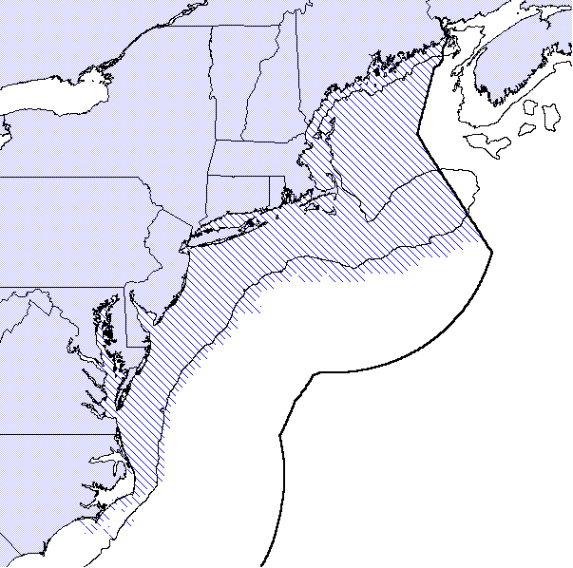

Figure 3.1: This map represents the combination of EFH from all eighteen Council-managed species, for all life history stages. The patterned areas on the map represent the combination of each species' EFH.
Essential Fish Habitat
Species Associations
Slope and Canyon Species (Adult)
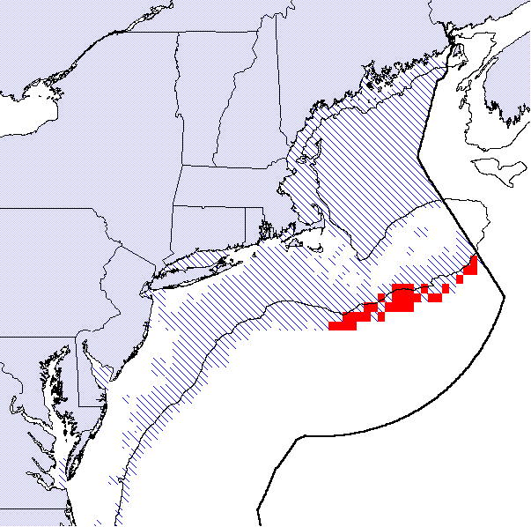
Intersection of EFH
Total EFH for Group
Figure 3.2: According to Overholtz and Tyler (1985) there are four Council-managed species associated with slope and canyon habitats: monkfish, red hake, white hake, and whiting. For the purposes of this exercise, the slope and canyon habitats are considered to be those areas on the seaward side of Georges Bank and the Mid-Atlantic Bight deeper than 50 fathoms (~ 100 meters). The solid shaded areas highlighted on the map reflect those areas of slope and canyon habitats that are EFH for all four of these species. The patterned areas on the map represent the combination of each species' EFH.
Essential Fish Habitat
Species Associations
Slope and Canyon Species (Juveniles)
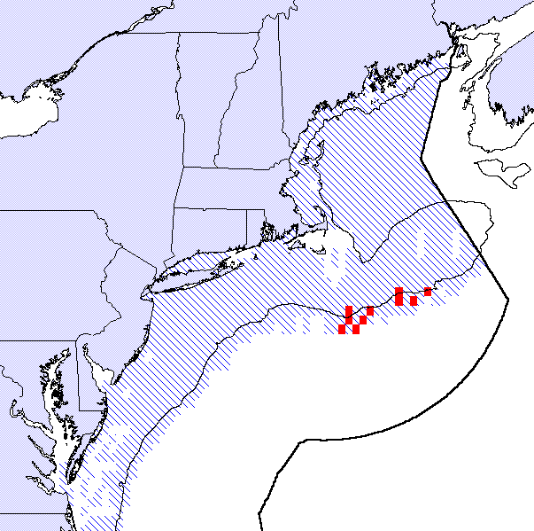
Intersection of EFH
Total EFH for Group
Figure 3.3: According to Overholtz and Tyler (1985) there are four Council-managed species associated with slope and canyon habitats: monkfish, red hake, white hake, and whiting. For the purposes of this exercise, the slope and canyon habitats are considered to be those areas on the seaward side of Georges Bank and the Mid-Atlantic Bight deeper than 50 fathoms (~ 100 meters).
The solid shaded areas highlighted on the map reflect those areas of slope and canyon habitats that are EFH for all four of these species. The patterned areas on the map represent the combination of each species' EFH.
Essential Fish Habitat
Species Associations
Shallow Water Species (Adult)
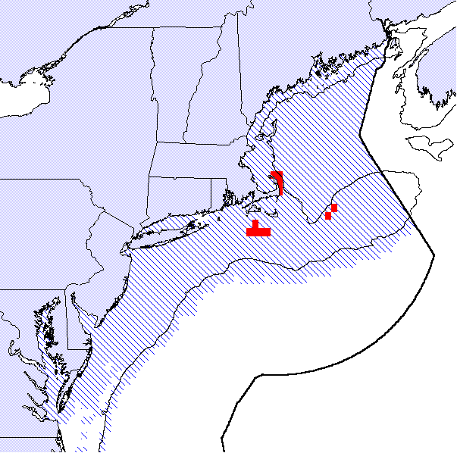
Intersection of EFH
Total EFH for Group
Figure 3.4: According to Overholtz and Tyler (1985) there are ten Council-managed species associated with the shallow water habitats of Georges Bank: Atlantic cod, haddock, monkfish, ocean pout, pollock, red hake, white hake, whiting, windowpane flounder, and yellowtail flounder. For the purposes of this exercise, the habitat area has been expanded to include all areas of Georges Bank and the Mid-Atlantic Bight landward of the 50 fathom (~ 100 meters) isobath. Also, pollock and white hake were not used in the exercise to avoid eliminating all possible areas of EFH for the species association. The solid shaded areas highlighted on the map reflect those areas of shallow water habitats that are EFH for the eight remaining species. The patterned areas on the map represent the combination of each species' EFH.
Essential Fish Habitat
Species Associations
Shallow Water Species (Juveniles)
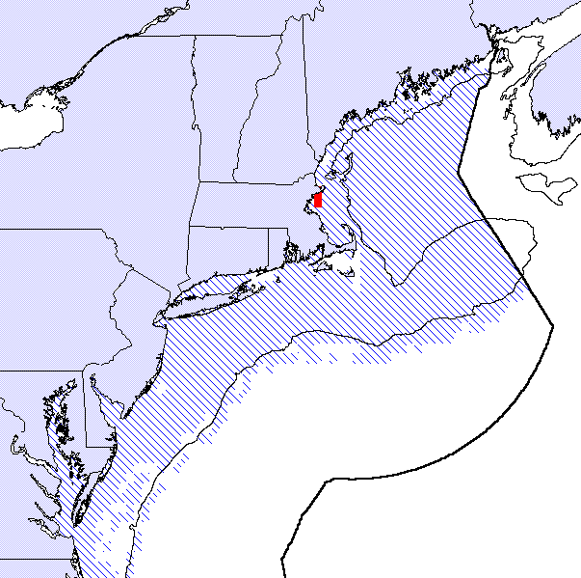
Intersection of EFH
Total EFH for Group
Figure 3.5: According to Overholtz and Tyler (1985) there are ten Council-managed species associated with the shallow water habitats of Georges Bank: Atlantic cod, haddock, monkfish, ocean pout, pollock, red hake, white hake, whiting, windowpane flounder, and yellowtail flounder. For the purposes of this exercise, the habitat area has been expanded to include all areas of Georges Bank and the Mid-Atlantic Bight landward of the 50 fathom (~ 100 meters) isobath. Also, pollock and white hake were not used in the exercise to avoid eliminating all possible areas of EFH for the species association. The solid shaded areas highlighted on the map reflect those areas of shallow water habitats that are EFH for the eight remaining species. The patterned areas on the map represent the combination of each species' EFH.
Essential Fish Habitat
Species Associations
Northeast Peak (Georges Bank) Species (Adult)
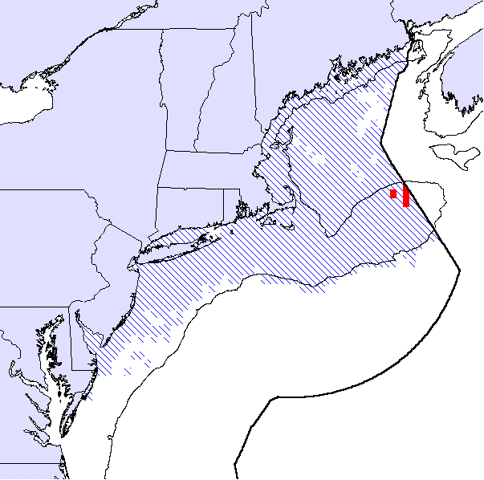
Intersection of EFH
Total EFH for Group
Figure 3.6: According to Overholtz and Tyler (1985) there are six Council-managed species associated with the habitats of the Northeast Peak of Georges Bank: Atlantic cod, haddock, ocean pout, pollock, white hake and winter flounder. The Northeast Peak is limited to the area on the northeastern edge of Georges Bank. The solid shaded areas highlighted on the map reflect those areas of the Northeast Peak that are EFH for cod, haddock, winter flounder and ocean pout. The patterned areas on the map represent the combination of each species' EFH. Pollock and white hake were dropped from the analysis to prevent all areas from being eliminated.
Essential Fish Habitat
Species Associations
Northeast Peak (Georges Bank) Species (Juveniles)
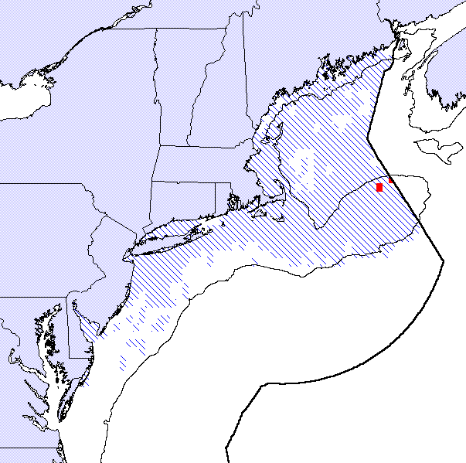
Intersection of EFH
Total EFH for Group
Figure 3.7: According to Overholtz and Tyler (1985) there are six Council-managed species associated with the habitats of the Northeast Peak of Georges Bank: Atlantic cod, haddock, ocean pout, pollock, white hake, and winter flounder. The Northeast Peak is limited to the area on the northeastern edge of Georges Bank. The solid shaded areas highlighted on the map reflect those areas of the Northeast Peak that are EFH for cod, haddock, winter flounder and pollock. The patterned areas on the map represent the combination of each species' EFH. Ocean pout and white hake were dropped from the analysis to prevent all areas from being eliminated.
Essential Fish Habitat
Species Associations
Intermediate Depth Species (Adult)
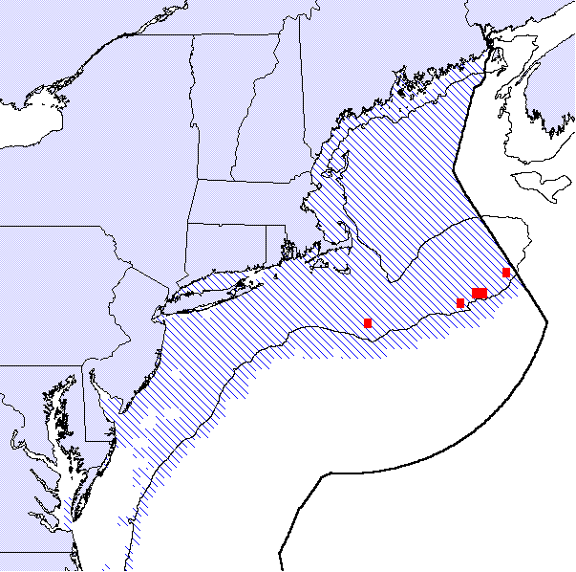
Intersection of EFH
Total EFH for Group
Figure 3.8: According to Overholtz and Tyler (1985) there are seven Council-managed species associated with intermediate depth habitats along the southern edge of Georges Bank: Atlantic cod, haddock, monkfish, ocean pout, red hake, whiting, and yellowtail flounder. For the purposes of this exercise, intermediate depth habitats are those areas along the 50 fathom (~ 100 meters) isobath. The solid shaded areas highlighted on the map reflect those areas of intermediate depth habitats that are EFH for all seven species. The patterned areas on the map represent the combination of each species' EFH.
Essential Fish Habitat
Species Associations
Intermediate Depth Species (Juveniles)
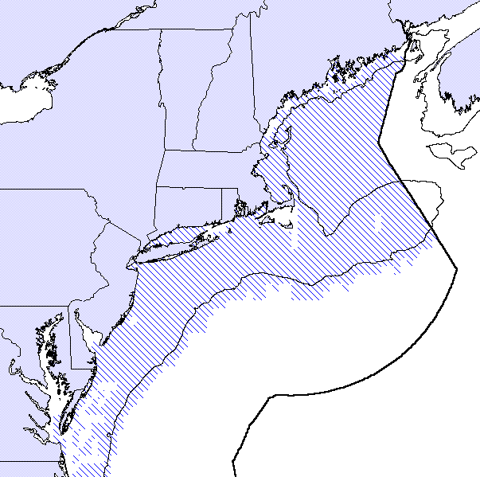
Intersection of EFH
Total EFH for Group
Figure 3.9: According to Overholtz and Tyler (1985) there are seven Council-managed species associated with intermediate depth habitats along the southern edge of Georges Bank: Atlantic cod, haddock, monkfish, ocean pout, red hake, whiting, and yellowtail flounder. For the purposes of this exercise, intermediate depth habitats are those areas along the 50 fathom (~ 100 meters) isobath. Using EFH designations for the juveniles of these seven species yielded no intersecting areas along the southern edge of Georges Bank. The patterned areas on the map represent the combination of each species' EFH.

Essential Fish Habitat
Species Associations
Gulf of Maine Deep Species (Adult)
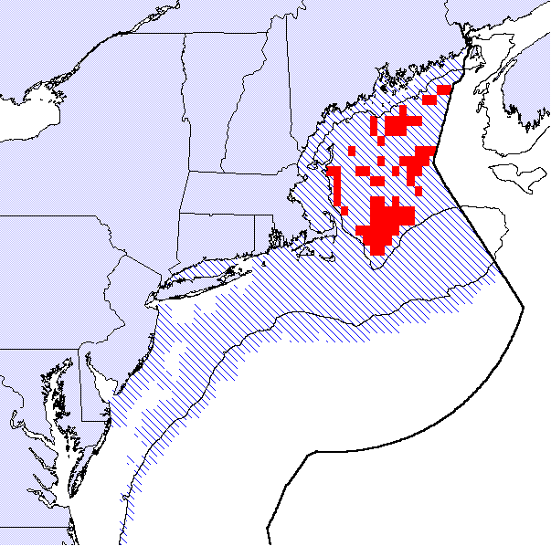
Intersection of EFH
Total EFH for Group
Figure 3.10: According to Overholtz and Tyler (1985) there are six Council-managed species associated with deep water habitats in the Gulf of Maine: American plaice, Atlantic cod, haddock, white hake, whiting, and witch flounder. Although Overholtz and Tyler limit the Gulf of Maine deep habitat to a small area just on the Gulf of Maine side of Georges Bank, for the purposes of this exercise all areas of the Gulf of Maine deeper than 50 fathoms (~ 100 meters) are considered. For the purposes of the analysis, both pollock and redfish are included in the species association group. The solid shaded areas highlighted on the map reflect those areas of Gulf of Maine deep water habitats that are EFH for all eight species. The patterned areas on the map represent the combination of each species' EFH.
Essential Fish Habitat
Species Associations
Gulf of Maine Deep Species (Juveniles)
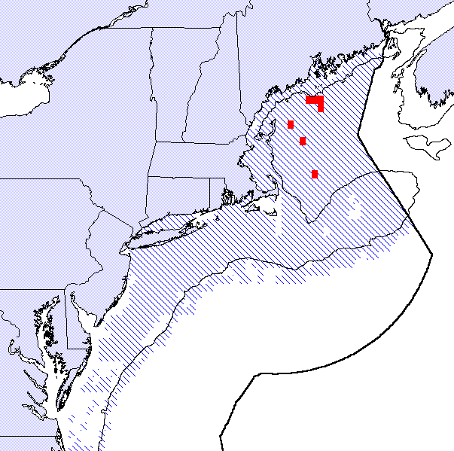
Intersection of EFH
Total EFH for Group
Figure 3.11: According to Overholtz and Tyler (1985) there are six Council-managed species associated with deep water habitats in the Gulf of Maine: American plaice, Atlantic cod, haddock, white hake, whiting, and witch flounder. Although Overholtz and Tyler limit the Gulf of Maine deep habitat to a small area just on the Gulf of Maine side of Georges Bank, for the purposes of this exercise all areas of the Gulf of Maine deeper than 50 fathoms (~ 100 meters) are considered. For the purposes of the analysis, both pollock and redfish are included in the species association group. The solid shaded areas highlighted on the map reflect those areas of Gulf of Maine deep water habitats that are EFH for all eight species. The patterned areas on the map represent the combination of each species' EFH.
Essential Fish Habitat
Species Associations
Deep Water Gulf of Maine - Georges Bank (Adults)
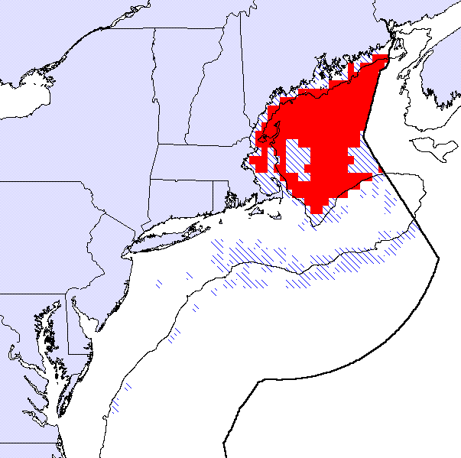
Intersection of EFH
Total EFH for Group
Figure 3.12: Wendy Gabriel (1992) describes several temporally persistent assemblages of demersal fish species, including an assemblage of species called the deep water Gulf of Maine - Georges Bank group. This group includes four Council-managed species: American plaice, redfish, white hake, and witch flounder. The solid shaded areas highlighted on the map reflect those areas that are EFH for all four species. The patterned areas on the map represent the combination of each species' EFH.
Essential Fish Habitat
Species Associations
Deep Water Gulf of Maine - Georges Bank (Juveniles)
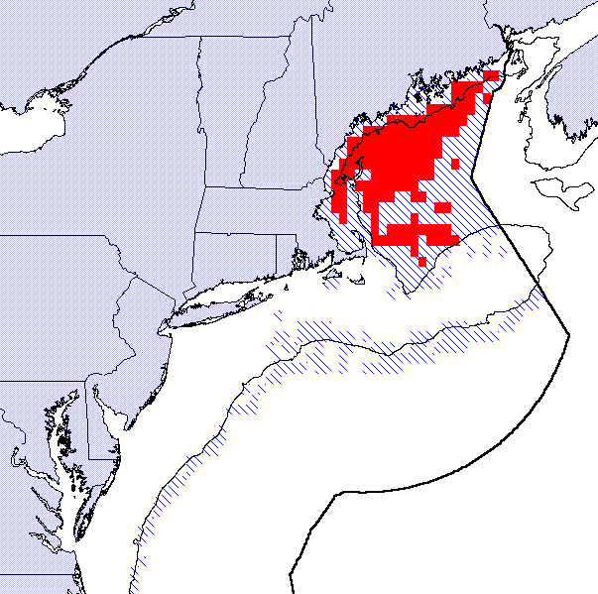
Intersection of EFH
Total EFH for Group
Figure 3.13: Wendy Gabriel (1992) describes several temporally persistent assemblages of demersal fish species, including an assemblage of deep water Gulf of Maine - Georges Bank species. This group includes four Council-managed species: American plaice, redfish, white hake, and witch flounder. The solid shaded areas highlighted on the map reflect those areas that are EFH for all four species. The patterned areas on the map represent the combination of each species' EFH.
Essential Fish Habitat
Species Associations
Gulf of Maine - Georges Bank Transition Zone (Adults)
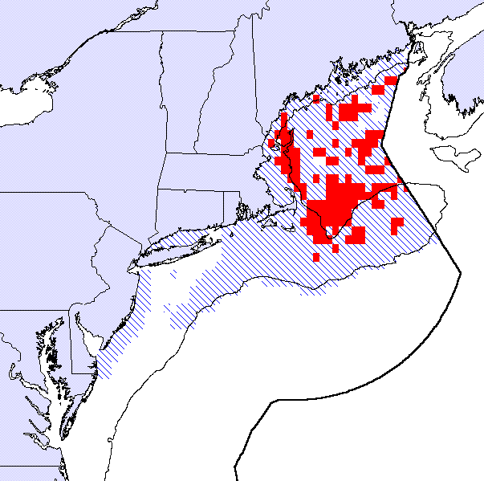
Intersection of EFH
Total EFH for Group
Figure 3.14: Wendy Gabriel (1992) describes several temporally persistent assemblages of demersal fish species, including an assemblage of Gulf of Maine - Georges Bank transition zone species. This group includes three Council-managed species: Atlantic cod, haddock, and pollock. The solid shaded areas highlighted on the map reflect those areas that are EFH for all three species. The patterned areas on the map represent the combination of each species' EFH.
Essential Fish Habitat
Species Associations
Gulf of Maine - Georges Bank Transition Zone (Juveniles)
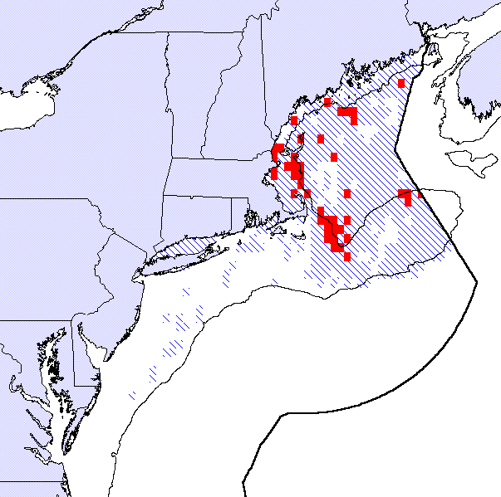
Intersection of EFH
Total EFH for Group
Figure 3.15: Wendy Gabriel (1992) describes several temporally persistent assemblages of demersal fish species, including an assemblage of Gulf of Maine - Georges Bank transition zone species. This group includes three Council-managed species: Atlantic cod, haddock, and pollock. The solid shaded areas highlighted on the map reflect those areas that are EFH for all three species. The patterned areas on the map represent the combination of each species' EFH.
Essential Fish Habitat
Species Associations
Shallow Water Georges Bank - Southern New England (Adults)
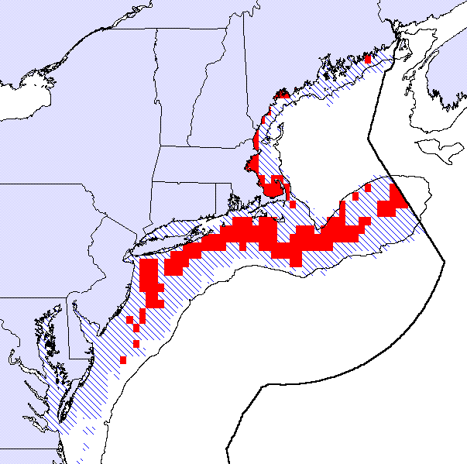
Intersection of EFH
Total EFH for Group
Figure 3.16: Wendy Gabriel (1992) describes several temporally persistent assemblages of demersal fish species, including an assemblage of shallow water Georges Bank - Southern New England species. This group includes three Council-managed species: windowpane flounder, winter flounder, and yellowtail flounder. The solid shaded areas highlighted on the map reflect those areas that are EFH for all three species. The patterned areas on the map represent the combination of each species' EFH.
Essential Fish Habitat
Species Associations
Shallow Water Georges Bank - Southern New England (Juveniles)
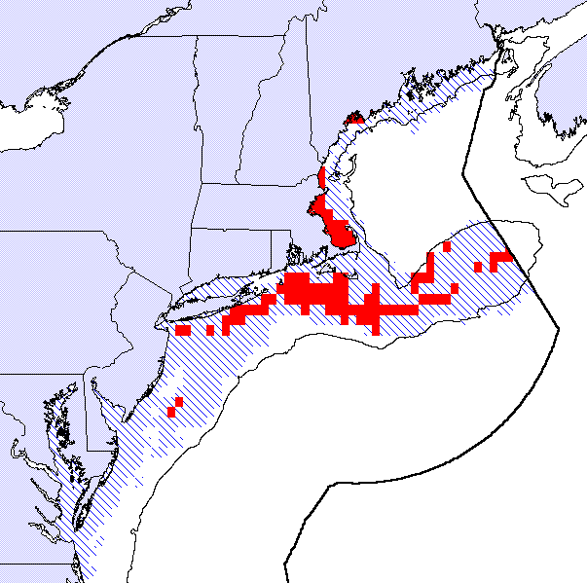
Intersection of EFH
Total EFH for Group
Figure 3.17: Wendy Gabriel (1992) describes several temporally persistent assemblages of demersal fish species, including an assemblage of shallow water Georges Bank - Southern New England species. This group includes three Council-managed species: windowpane flounder, winter flounder, and yellowtail flounder. The solid shaded areas highlighted on the map reflect those areas that are EFH for all three species. The patterned areas on the map represent the combination of each species' EFH.
Essential Fish Habitat
Species Associations
Other Gulf of Maine - Georges Bank (Adults)
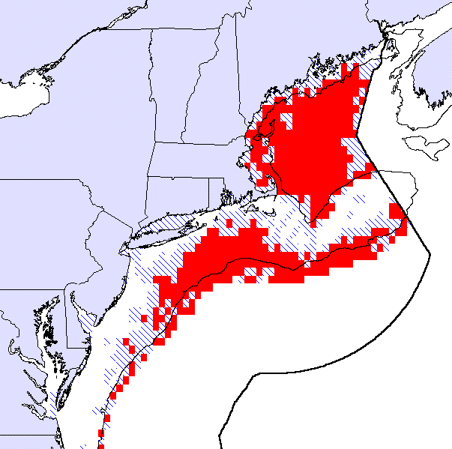
Intersection of EFH
Total EFH for Group
Figure 3.18: Wendy Gabriel (1992) describes several temporally persistent assemblages of demersal fish species, including a loose assemblage of Gulf of Maine - Georges Bank species that sometimes occur with the other Gulf of Maine - Georges Bank assemblages. This group includes three Council-managed species: monkfish, red hake, and whiting. The solid shaded areas highlighted on the map reflect those areas that are EFH for all three species. The patterned areas on the map represent the combination of each species' EFH.
Essential Fish Habitat
Species Associations
Other Gulf of Maine - Georges Bank (Juveniles)
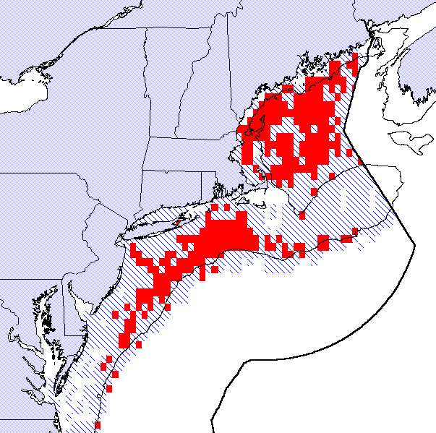
Intersection of EFH
Total EFH for Group
Figure 3.19: Wendy Gabriel (1992) describes several temporally persistent assemblages of demersal fish species, including a loose assemblage of Gulf of Maine - Georges Bank species that sometimes occur with the other Gulf of Maine - Georges Bank assemblages. This group includes three Council-managed species: monkfish, red hake, and whiting. The solid shaded areas highlighted on the map reflect those areas that are EFH for all three species. The patterned areas on the map represent the combination of each species' EFH.
Essential Fish Habitat
Species Groupings
Flatfish Species (Juvenile)
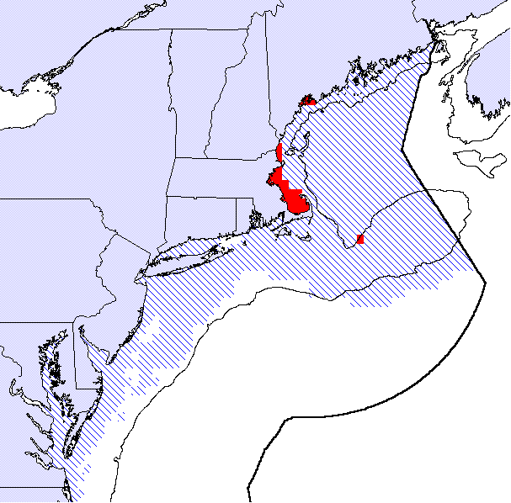
Intersection of EFH
Total EFH for Group
Figure 3.20: This overlay includes the EFH for juveniles of five species of flatfish managed by the Council: American plaice, windowpane flounder, winter flounder, yellowtail flounder, and Atlantic halibut. The solid shaded areas highlighted on the map reflect those areas that are EFH for all five species. The patterned areas on the map represent the combination of each species' EFH. Witch flounder was dropped from this analysis to avoid eliminating all possible EFH intersections.
Essential Fish Habitat
Species Groupings
Flatfish Species (Adult)
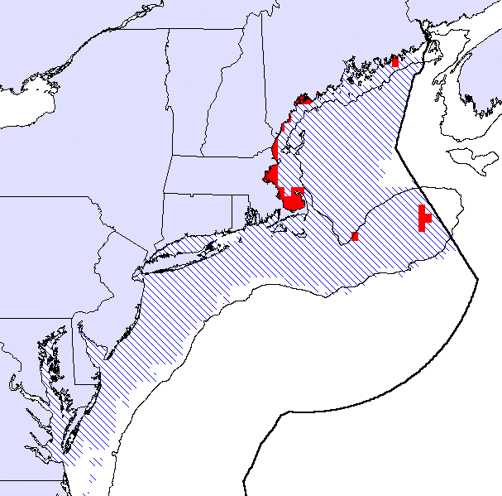
Intersection of EFH
Total EFH for Group
Figure 3.21: This overlay includes the EFH for adults of five species of flatfish managed by the Council: American plaice, windowpane flounder, winter flounder, yellowtail flounder, and Atlantic halibut. The solid shaded areas highlighted on the map reflect those areas that are EFH for all five species. The patterned areas on the map represent the combination of each species' EFH. Witch flounder was dropped from this analysis to avoid eliminating all possible EFH intersections.

Essential Fish Habitat
Species Groupings
Gadidae Species (Juvenile)
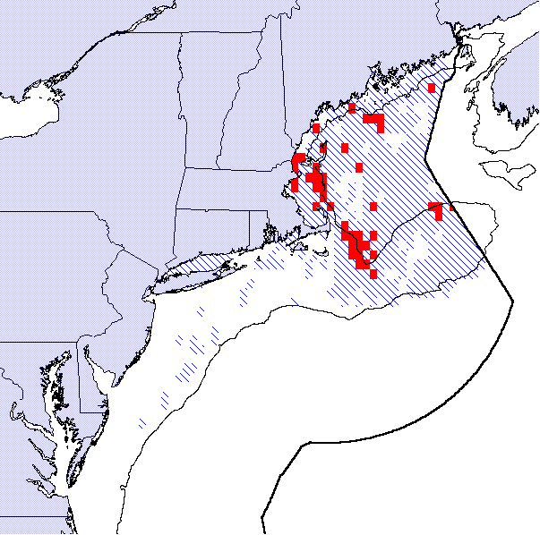
Intersection of EFH
Total EFH for Group
Figure 3.22: This overlay includes the EFH for juveniles of three related species managed by the Council: Atlantic cod, haddock, and pollock. The solid shaded areas highlighted on the map reflect those areas that are EFH for all three species. The patterned areas on the map represent the combination of each species' EFH.
Essential Fish Habitat
Species Groupings
Gadidae Species (Adult)
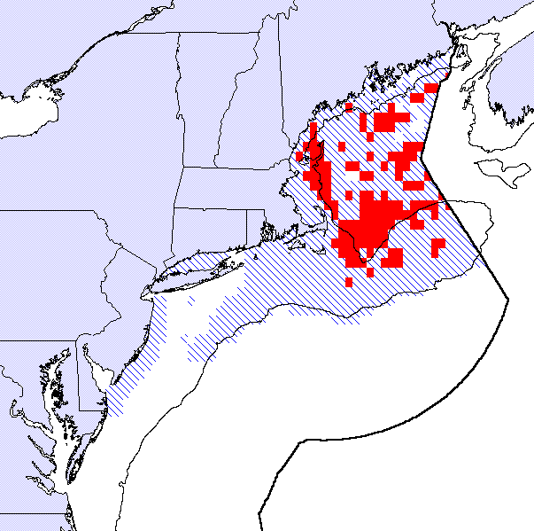
Intersection of EFH
Total EFH for Group
Figure 3.23: This overlay includes the EFH for adults of three related species managed by the Council: Atlantic cod, haddock, and pollock. The solid shaded areas highlighted on the map reflect those areas that are EFH for all three species. The patterned areas on the map represent the combination of each species' EFH.

Essential Fish Habitat
Co-Located Species
Inshore Gulf of Maine Species (Juvenile)
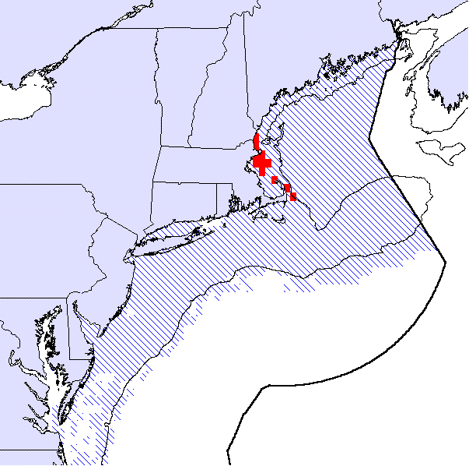
Intersection of EFH
Total EFH for Group
Figure 3.24: This overlay incorporates the EFH for juveniles of eight Council-managed species whose distribution is concentrated along the inshore waters (shallower than 50 fathoms) of the Gulf of Maine, including: Atlantic cod, Atlantic halibut, ocean pout, American plaice, red hake, Atlantic sea scallops, whiting, and winter flounder. The solid shaded areas highlighted on the map reflect those areas that are EFH for all eight species. The patterned areas on the map represent the combination of each species' EFH.
Essential Fish Habitat
Co-Located Species
Inshore Gulf of Maine Species (Adult)
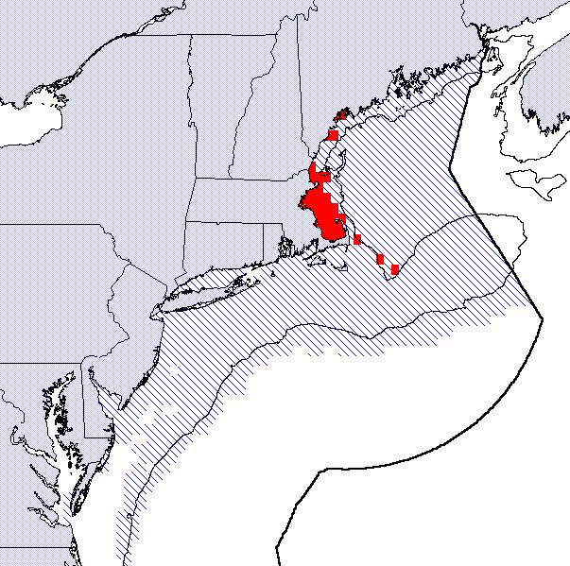
Intersection of EFH
Total EFH for Group
Figure 3.25: This overlay incorporates the EFH for adults of eight Council-managed species whose distribution is concentrated along the inshore waters (shallower than 50 fathoms) of the Gulf of Maine, including: Atlantic cod, Atlantic halibut, ocean pout, American plaice, red hake, Atlantic sea scallops, whiting, and winter flounder. The solid shaded areas highlighted on the map reflect those areas that are EFH for all eight species. The patterned areas on the map represent the combination of each species' EFH.

Essential Fish Habitat
Co-Located Species
Deep Water Gulf of Maine Species (Juvenile)
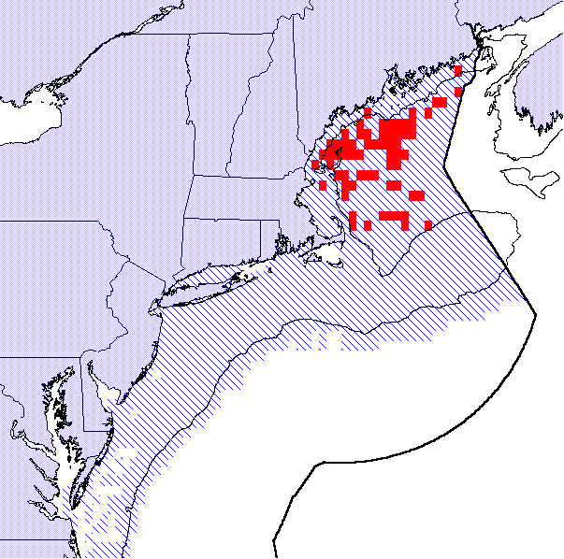
Intersection of EFH
Total EFH for Group
Figure 3.26: This overlay incorporates the EFH for juveniles of nine Council-managed species whose distribution is concentrated in the deep, offshore waters (deeper than 50 fathoms) of the Gulf of Maine, including: Atlantic halibut, monkfish, American plaice, pollock, red hake, redfish, white hake, whiting, and witch flounder. The solid shaded areas highlighted on the map reflect those areas that are EFH for all nine species. The patterned areas on the map represent the combination of each species' EFH.
Essential Fish Habitat
Co-Located Species
Deep Water Gulf of Maine Species (Adult)
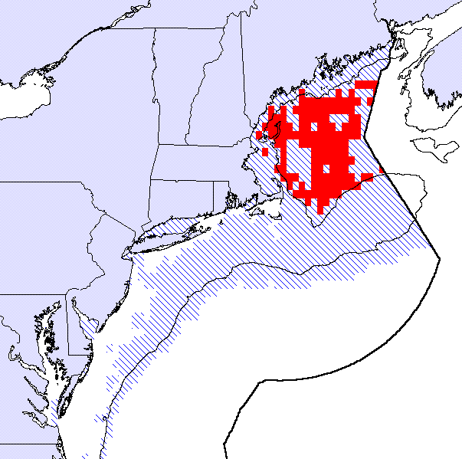
Intersection of EFH
Total EFH for Group
Figure 3.27: This overlay incorporates the EFH for adults of nine Council-managed species whose distribution is concentrated in the deep, offshore waters (deeper than 50 fathoms) of the Gulf of Maine, including: Atlantic halibut, monkfish, American plaice, pollock, red hake, redfish, white hake, whiting, and witch flounder. The solid shaded areas highlighted on the map reflect those areas that are EFH for all nine species. The patterned areas on the map represent the combination of each species' EFH.

Essential Fish Habitat
Co-Located Species
Georges Bank Species (Juvenile)
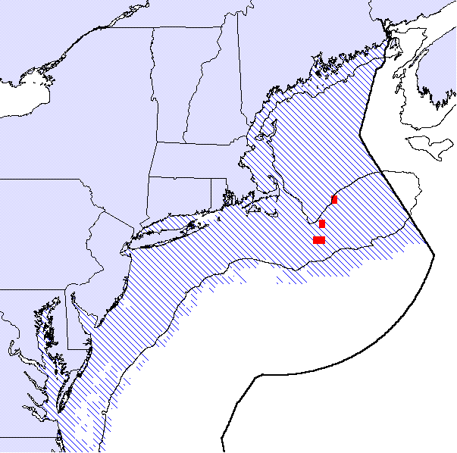
Intersection of EFH
Total EFH for Group
Figure 3.28: This overlay incorporates the EFH for juveniles of nine Council-managed species whose distribution is concentrated on Georges Bank (shallower than 50 fathoms), including: Atlantic cod, haddock, Atlantic halibut, red hake, Atlantic sea scallops, whiting, windowpane flounder, winter flounder, and yellowtail flounder. The solid shaded areas highlighted on the map reflect those areas that are EFH for all nine species. The patterned areas on the map represent the combination of each species' EFH.
Essential Fish Habitat
Co-Located Species
Georges Bank Species (Adult)
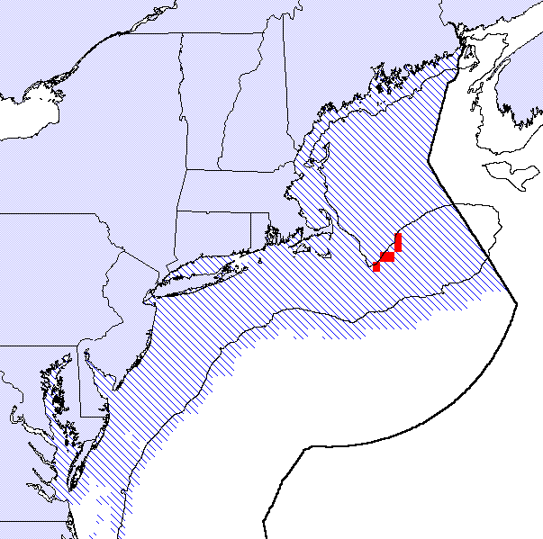
Intersection of EFH
Total EFH for Group
Figure 3.29: This overlay incorporates the EFH for adults of nine Council-managed species whose distribution is concentrated on Georges Bank (shallower than 50 fathoms), including: Atlantic cod, haddock, Atlantic halibut, red hake, Atlantic sea scallops, whiting, windowpane flounder, winter flounder, and yellowtail flounder. The solid shaded areas highlighted on the map reflect those areas that are EFH for all nine species. The patterned areas on the map represent the combination of each species' EFH.

Essential Fish Habitat
Co-Located Species
Offshore Slope Species (Juvenile)
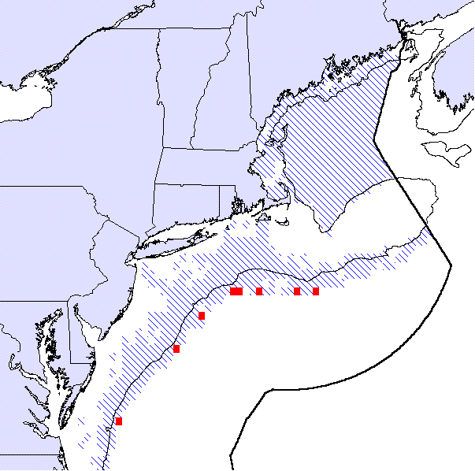
Intersection of EFH
Total EFH for Group
Figure 3.30: This overlay incorporates the EFH for juveniles of four Council-managed species whose distribution is concentrated along the offshore continental slope (deeper than 50 fathoms), including: monkfish, offshore hake, white hake, and witch flounder. The solid shaded areas highlighted on the map reflect those areas that are EFH for all four species. The patterned areas on the map represent the combination of each species' EFH.
Essential Fish Habitat
Co-Located Species
Offshore Slope Species (Adult)
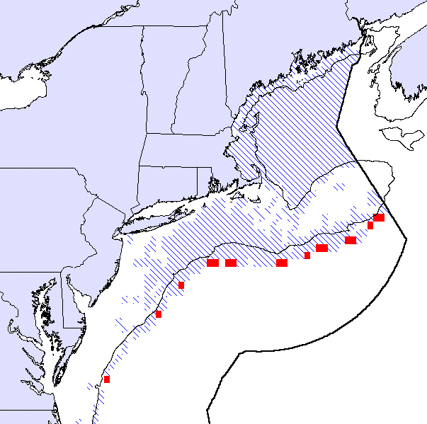
Intersection of EFH
Total EFH for Group
Figure 3.31: This overlay incorporates the EFH for adults of four Council-managed species whose distribution is concentrated along the offshore continental slope (deeper than 50 fathoms), including: monkfish, offshore hake, white hake, and witch flounder. The solid shaded areas highlighted on the map reflect those areas that are EFH for all four species. The patterned areas on the map represent the combination of each species' EFH.

Essential Fish Habitat
Co-Located Species
Mid-Atlantic Bight Species (Juvenile)
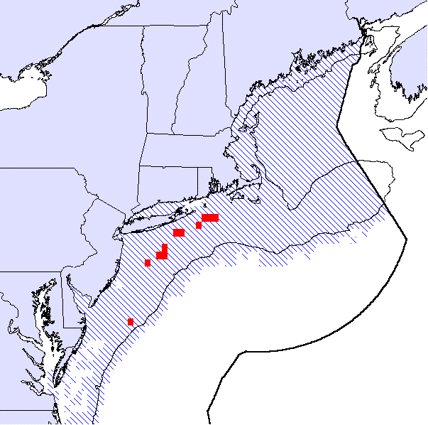
Intersection of EFH
Total EFH for Group
Figure 3.32: This overlay incorporates the EFH for juveniles of seven Council-managed species whose distribution is concentrated along the Middle Atlantic Bight (shallower than 50 fathoms), including: monkfish, ocean pout, red hake, Atlantic sea scallops, whiting, winter flounder, and yellowtail flounder. The solid shaded areas highlighted on the map reflect those areas that are EFH for all four species. The patterned areas on the map represent the combination of each species' EFH.
Essential Fish Habitat
Co-Located Species
Mid-Atlantic Bight Species (Adult)
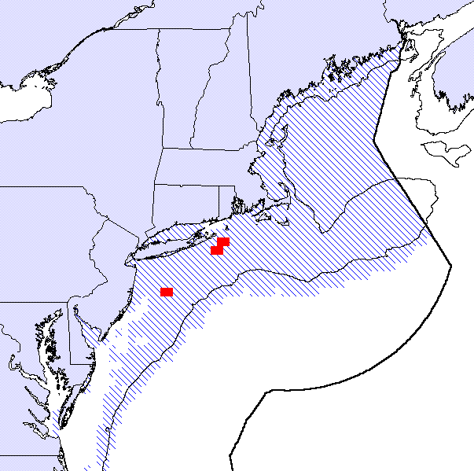
Intersection of EFH
Total EFH for Group
Figure 3.33: This overlay incorporates the EFH for adults of seven Council-managed species whose distribution is concentrated along the Middle Atlantic Bight (shallower than 50 fathoms), including: monkfish, ocean pout, red hake, Atlantic sea scallops, whiting, winter flounder, and yellowtail flounder. The solid shaded areas highlighted on the map reflect those areas that are EFH for all four species. The patterned areas on the map represent the combination of each species' EFH.

Essential Fish Habitat
Species Groupings
Herring Egg Beds, Juvenile Atlantic Cod and Juvenile Haddock
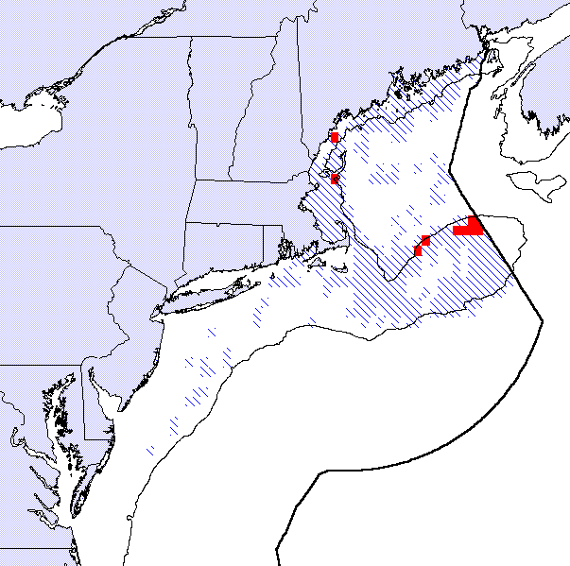
Intersection of EFH
Total EFH for Group
Figure 3.34: There are several scientific studies that demonstrate that habitat types important to juvenile Atlantic cod and juvenile haddock also support herring egg beds. This overlay incorporates the EFH designations for herring eggs, juvenile cod and juvenile haddock. The solid shaded areas highlighted on the map reflect those areas that are EFH for all three species. The patterned areas on the map represent the combination of each species' EFH.

Areas of High Concentration
The original EFH alternatives considered by the Council were based largely on the relative densities of fish observations from the NMFS otter trawl and ichthyoplankton surveys. For all demersal life history stages (juveniles and adults of all species except Atlantic herring and Atlantic salmon), the Council used a method based on the catch-per-unit-effort per ten minute square of latitude and longitude for developing the EFH designations. In analyzing the data for each species using the catch-per-unit-effort method, each ten minute square throughout the survey area and included in the analysis was ranked from highest to lowest according to an index of the mean catch per unit of effort of the survey (i.e., the number of fish caught in each tow of the survey trawl). For each life history stage, the alternatives considered included: (1) the area that comprised the top 50% of catch-per-unit-effort abundance index, (2) the area that comprised the top 75% of catch-per-unit-effort abundance index, (3) the area that comprised the top 90% of catch-per-unit-effort abundance index, and (4) 100% of the observed range of the species.

This method was used because it accurately reflects that for most demersal life history stages, the population of a species is rather concentrated in some portions of its overall range, especially where environmental conditions such as habitat and prey resources are most favorable, and it is less concentrated in other portions of its overall range where environmental conditions are not as favorable. An EFH designation is intended to represent where environmental conditions, especially habitat, are most favorable, thus the highest percentages of the catch-per-unit-effort index were a suitable proxy for identifying these areas. It is possible to extend this process to select areas with the highest relative abundance of fish distribution. Although not considered an alternative for EFH designation because it represented too small a portion of the overall population of a species, we calculated the area that comprises the top 25% of catch-per-unit-effort abundance index as well.

The areas identified using the top 25% of the catch-per-unit-effort index can be thought of as "hot spots" of fish concentration within the overall range of the species. For instance, the top 25% of the adult yellowtail flounder distribution occurs in less than 9% of its overall observed range (the observed range includes all areas where the species was observed by during the full timeframe of the NMFS bottom trawl survey). This process may be useful to identify potential candidate HAPC's, or to identify areas within which to focus management attention. For some severely depressed fish stocks (Gulf of Maine Atlantic cod, Southern New England yellowtail flounder, Gulf of Maine/Georges Bank white hake), it may be appropriate to designate an HAPC based on the areas of high concentration that are located within the stock boundaries. For stocks in relatively good shape (Georges Bank yellowtail flounder, Georges Bank winter flounder, Southern New England/Mid-Atlantic winter flounder), it may be sufficient simply to identify the areas of high concentration within the stock boundaries and track potential adverse impacts to these areas.

For most species managed by the Council, most of the areas identified as supporting the highest concentrations tend to be aggregated into distinct "clumps" that would lend themselves easily to an HAPC designation (e.g., Gulf of Maine Atlantic cod adults, American plaice juveniles, Southern New England yellowtail flounder). For some species, however, the areas identified as supporting the highest concentrations tend to be dispersed into either small groups or single ten minute squares that do not necessarily lend themselves easily to an HAPC designation (e.g., monkfish adults in the Gulf of Maine, pollock adults, Gulf of Maine/Northern Georges Bank whiting). In a few species, the high concentration areas do not even occur in U.S. waters, but rather are limited to the Canadian side of the Hague Line (i.e., haddock and Atlantic halibut). The following set of maps (Figures 3.35 - 3.63) represent the areas of highest concentration of Council-managed species (juveniles and adults) except haddock and Atlantic halibut. This analysis was limited to juveniles and adults because the distribution of eggs and larvae was dispersed widely for most species and highlighting the areas of highest concentration did not appear useful or indicative of any particularly important spawning or settlement areas.

Section 4.0 describes several alternatives based on the information presented in Section 3.0 of the HARR.

Essential Fish Habitat
High Concentration Areas (25% CPUE)
Atlantic Cod Adults

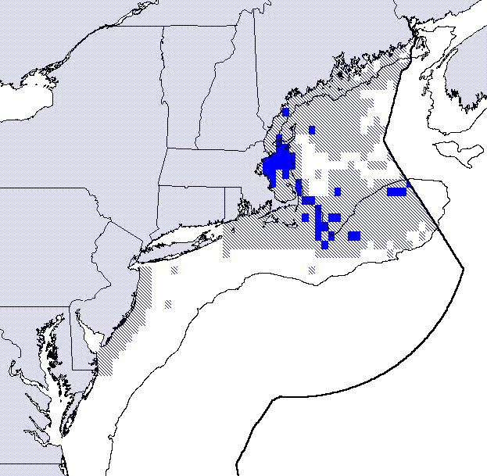
Top 25% CPUE Area
EFH for this Species
Figure 3.35: This map represents the areas of highest concentration of this species, within the boundaries of the Council's EFH designation. The solid areas indicate those areas that comprise the top 25% of the survey catch-per-unit-effort index. The light shading indicates the overall EFH designation for this species.
Essential Fish Habitat
High Concentration Areas (25% CPUE)
Atlantic Cod Juveniles

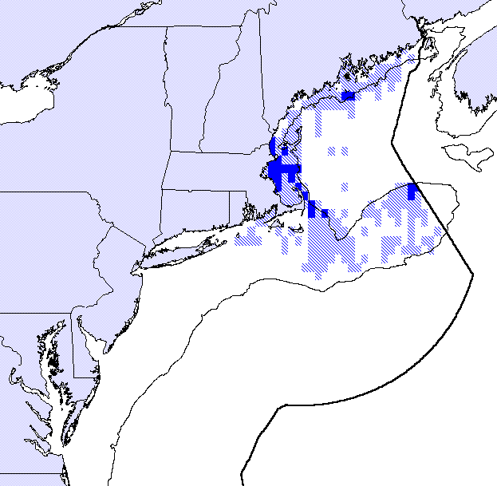
Top 25% CPUE Area
EFH for this Species
Figure 3.36: This map represents the areas of highest concentration of this species, within the boundaries of the Council's EFH designation. The solid areas indicate those areas that comprise the top 25% of the survey catch-per-unit-effort index. The light shading indicates the overall EFH designation for this species.
Essential Fish Habitat
High Concentration Areas (25% CPUE)
Atlantic Herring Adults

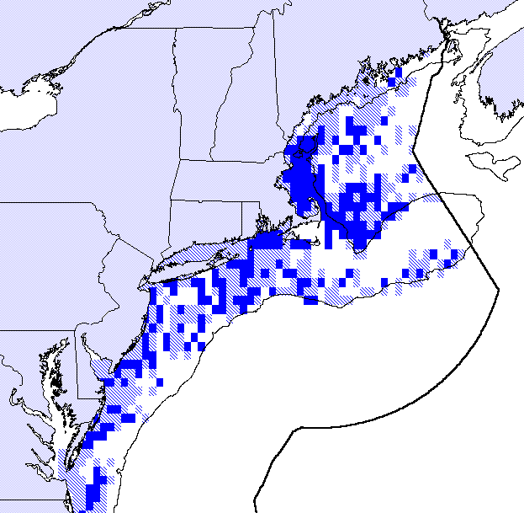
Top 25% CPUE Area
EFH for this Species
Figure 3.37: This map represents the areas of highest concentration of this species, within the boundaries of the Council's EFH designation. The solid areas indicate those areas that comprise the top 25% of the survey catch-per-unit-effort index. The light shading indicates the overall EFH designation for this species.
Essential Fish Habitat
High Concentration Areas (25% CPUE)
Atlantic Herring Juveniles

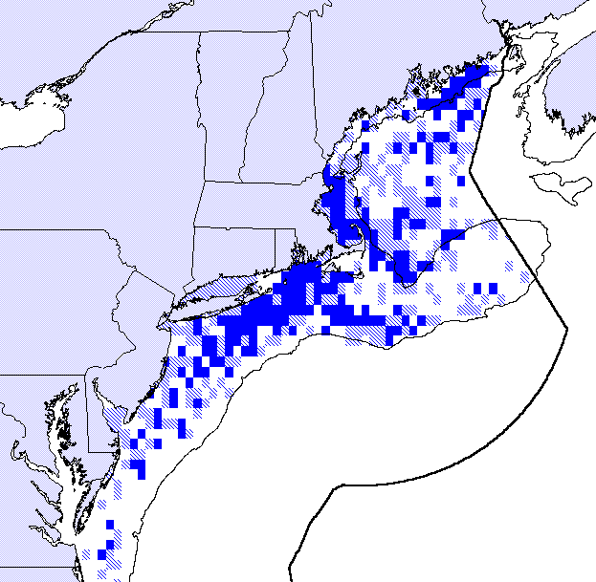
Top 25% CPUE Area
EFH for this Species
Figure 3.38: This map represents the areas of highest concentration of this species, within the boundaries of the Council's EFH designation. The solid areas indicate those areas that comprise the top 25% of the survey catch-per-unit-effort index. The light shading indicates the overall EFH designation for this species.
Essential Fish Habitat
High Concentration Areas (25% CPUE)
Monkfish Adults

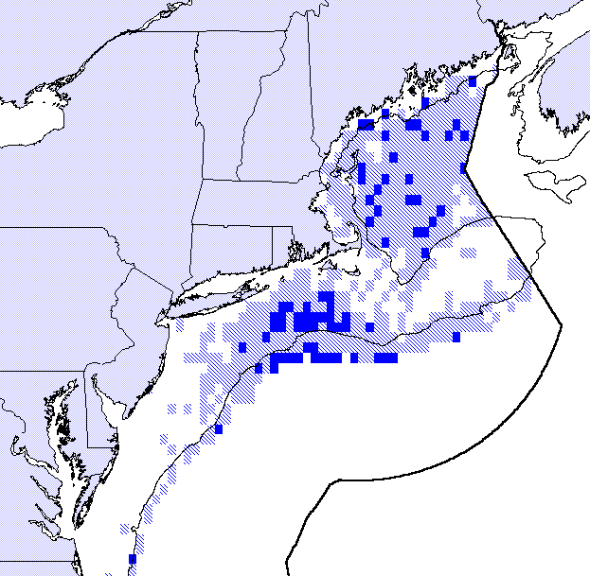
Top 25% CPUE Area
EFH for this Species
Figure 3.39: This map represents the areas of highest concentration of this species, within the boundaries of the Council's EFH designation. The solid areas indicate those areas that comprise the top 25% of the survey catch-per-unit-effort index. The light shading indicates the overall EFH designation for this species.
Essential Fish Habitat
High Concentration Areas (25% CPUE)
Monkfish Juveniles

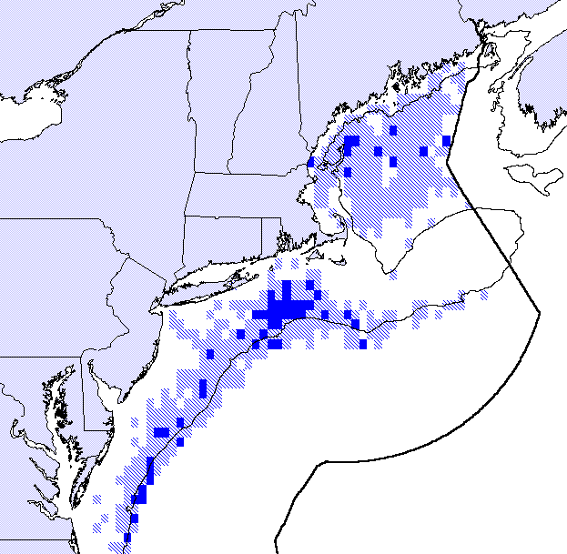
Top 25% CPUE Area
EFH for this Species
Figure 3.40: This map represents the areas of highest concentration of this species, within the boundaries of the Council's EFH designation. The solid areas indicate those areas that comprise the top 25% of the survey catch-per-unit-effort index. The light shading indicates the overall EFH designation for this species.
Essential Fish Habitat
High Concentration Areas (25% CPUE)
American Plaice Adults

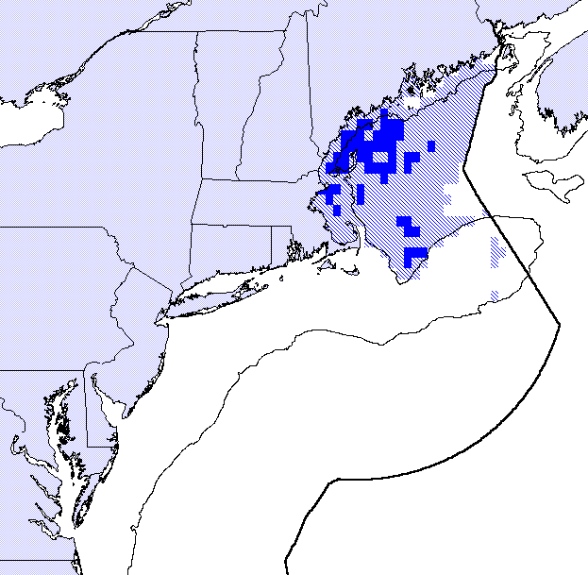
Top 25% CPUE Area
EFH for this Species
Figure 3.41: This map represents the areas of highest concentration of this species, within the boundaries of the Council's EFH designation. The solid areas indicate those areas that comprise the top 25% of the survey catch-per-unit-effort index. The light shading indicates the overall EFH designation for this species.
Essential Fish Habitat
High Concentration Areas (25% CPUE)
American Plaice Juveniles

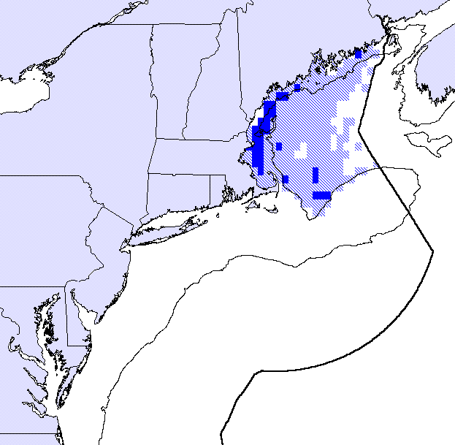
Top 25% CPUE Area
EFH for this Species
Figure 3.42: This map represents the areas of highest concentration of this species, within the boundaries of the Council's EFH designation. The solid areas indicate those areas that comprise the top 25% of the survey catch-per-unit-effort index. The light shading indicates the overall EFH designation for this species.
Essential Fish Habitat
High Concentration Areas (25% CPUE)
Pollock Adults

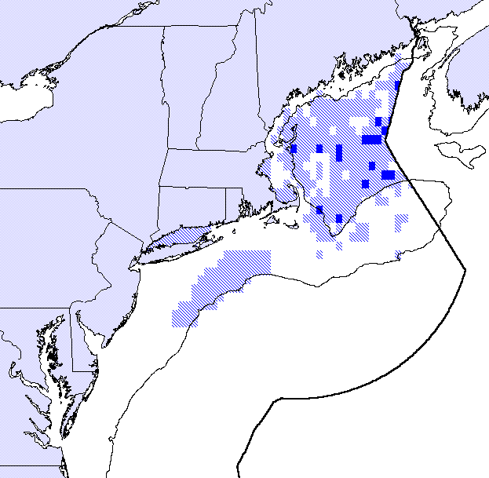
Top 25% CPUE Area
EFH for this Species
Figure 3.43: This map represents the areas of highest concentration of this species, within the boundaries of the Council's EFH designation. The solid areas indicate those areas that comprise the top 25% of the survey catch-per-unit-effort index. The light shading indicates the overall EFH designation for this species.
Essential Fish Habitat
High Concentration Areas (25% CPUE)
Pollock Juveniles

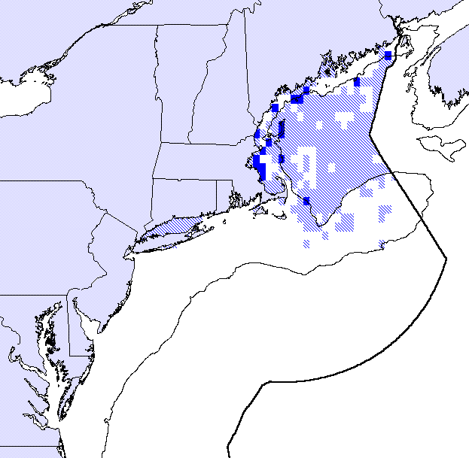
Top 25% CPUE Area
EFH for this Species
Figure 3.44: This map represents the areas of highest concentration of this species, within the boundaries of the Council's EFH designation. The solid areas indicate those areas that comprise the top 25% of the survey catch-per-unit-effort index. The light shading indicates the overall EFH designation for this species.
Essential Fish Habitat
High Concentration Areas (25% CPUE)
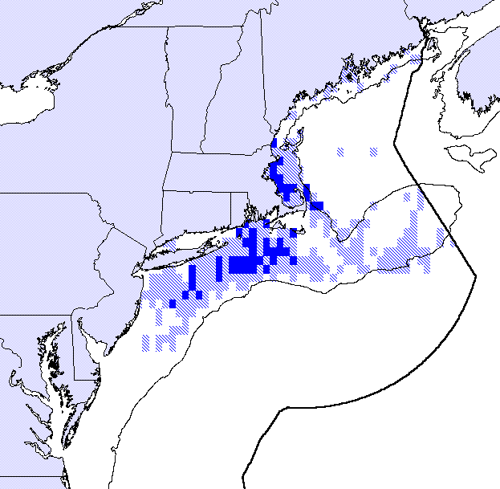
Ocean Pout Adults

Top 25% CPUE Area
EFH for this Species
Figure 3.45: This map represents the areas of highest concentration of this species, within the boundaries of the Council's EFH designation. The solid areas indicate those areas that comprise the top 25% of the survey catch-per-unit-effort index. The light shading indicates the overall EFH designation for this species.
Essential Fish Habitat
High Concentration Areas (25% CPUE)
Ocean Pout Juveniles

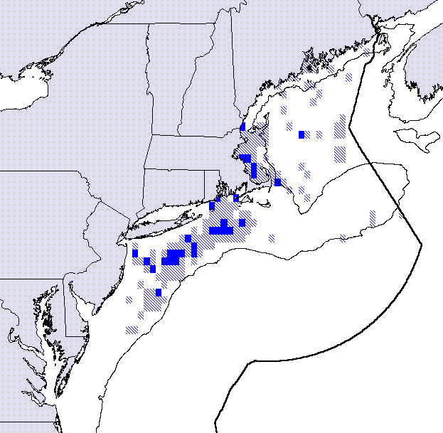
Top 25% CPUE Area
EFH for this Species
Figure 3.46: This map represents the areas of highest concentration of this species, within the boundaries of the Council's EFH designation. The solid areas indicate those areas that comprise the top 25% of the survey catch-per-unit-effort index. The light shading indicates the overall EFH designation for this species.
Essential Fish Habitat
High Concentration Areas (25% CPUE)
Redfish Adults

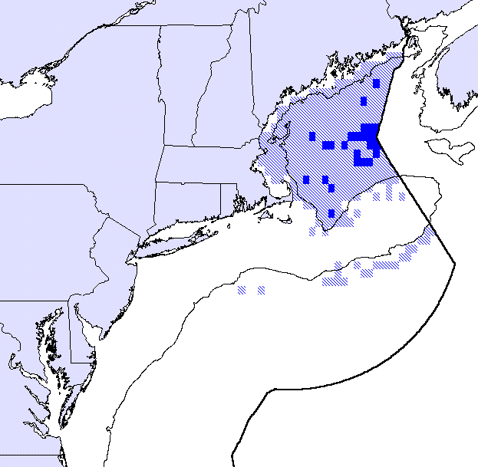
Top 25% CPUE Area
EFH for this Species
Figure 3.47: This map represents the areas of highest concentration of this species, within the boundaries of the Council's EFH designation. The solid areas indicate those areas that comprise the top 25% of the survey catch-per-unit-effort index. The light shading indicates the overall EFH designation for this species.
Essential Fish Habitat
High Concentration Areas (25% CPUE)
Redfish Juveniles

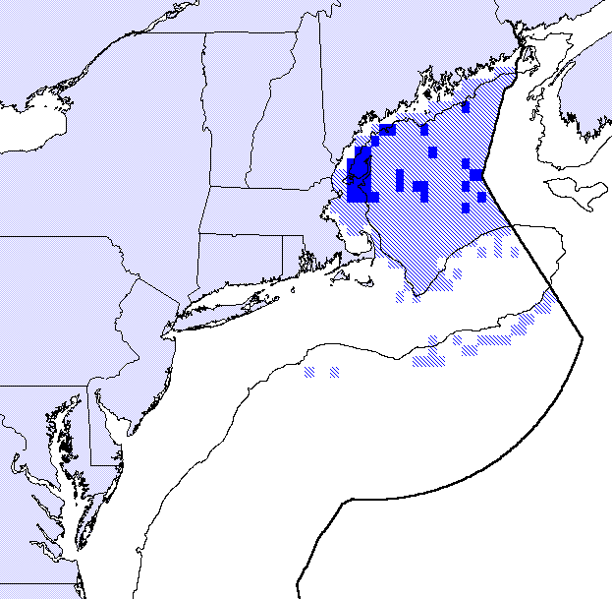
Top 25% CPUE Area
EFH for this Species
Figure 3.48: This map represents the areas of highest concentration of this species, within the boundaries of the Council's EFH designation. The solid areas indicate those areas that comprise the top 25% of the survey catch-per-unit-effort index. The light shading indicates the overall EFH designation for this species.
Essential Fish Habitat
High Concentration Areas (25% CPUE)
Red Hake Adults

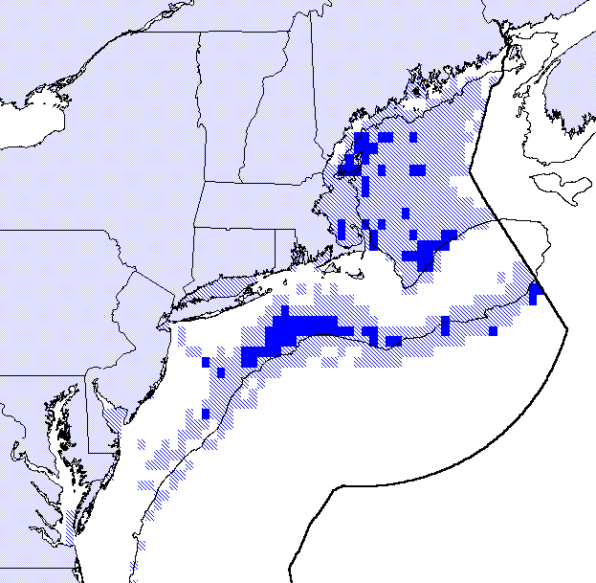
Top 25% CPUE Area
EFH for this Species
Figure 3.49: This map represents the areas of highest concentration of this species, within the boundaries of the Council's EFH designation. The solid areas indicate those areas that comprise the top 25% of the survey catch-per-unit-effort index. The light shading indicates the overall EFH designation for this species.
Essential Fish Habitat
High Concentration Areas (25% CPUE)
Red Hake Juveniles

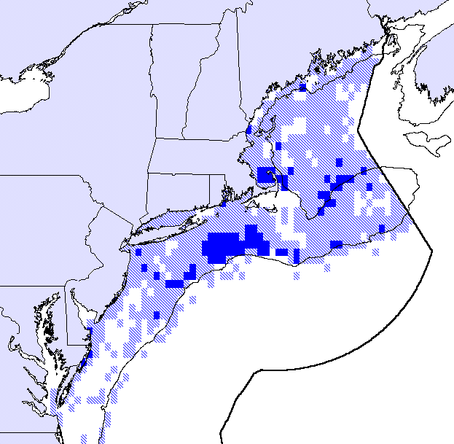
Top 25% CPUE Area
EFH for this Species
Figure 3.50: This map represents the areas of highest concentration of this species, within the boundaries of the Council's EFH designation. The solid areas indicate those areas that comprise the top 25% of the survey catch-per-unit-effort index. The light shading indicates the overall EFH designation for this species.
Essential Fish Habitat
High Concentration Areas (25% CPUE)
Sea Scallops (All life stages)

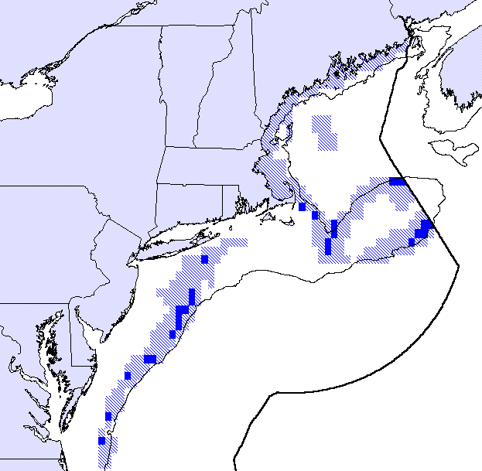
Top 25% CPUE Area
EFH for this Species
Figure 3.51: This map represents the areas of highest concentration of this species, within the boundaries of the Council's EFH designation. The solid areas indicate those areas that comprise the top 25% of the survey catch-per-unit-effort index. The light shading indicates the overall EFH designation for this species.
Essential Fish Habitat
High Concentration Areas (25% CPUE)
White Hake Adults

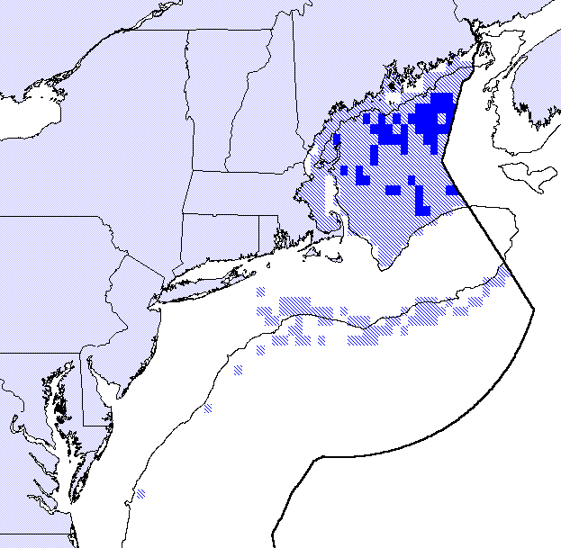
Top 25% CPUE Area
EFH for this Species
Figure 3.52: This map represents the areas of highest concentration of this species, within the boundaries of the Council's EFH designation. The solid areas indicate those areas that comprise the top 25% of the survey catch-per-unit-effort index. The light shading indicates the overall EFH designation for this species.
Essential Fish Habitat
High Concentration Areas (25% CPUE)
White Hake Juveniles

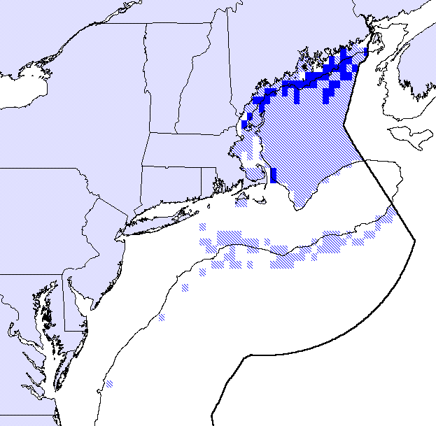
Top 25% CPUE Area
EFH for this Species
Figure 3.53: This map represents the areas of highest concentration of this species, within the boundaries of the Council's EFH designation. The solid areas indicate those areas that comprise the top 25% of the survey catch-per-unit-effort index. The light shading indicates the overall EFH designation for this species.
Essential Fish Habitat
High Concentration Areas (25% CPUE)
Whiting Adults

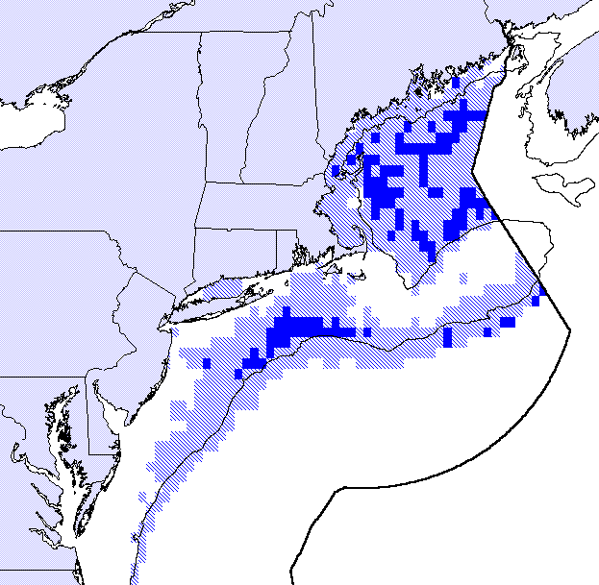
Top 25% CPUE Area
EFH for this Species
Figure 3.54: This map represents the areas of highest concentration of this species, within the boundaries of the Council's EFH designation. The solid areas indicate those areas that comprise the top 25% of the survey catch-per-unit-effort index. The light shading indicates the overall EFH designation for this species.
Essential Fish Habitat
High Concentration Areas (25% CPUE)
Whiting Juveniles

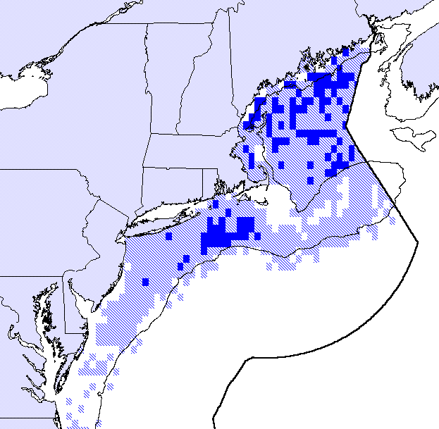
Top 25% CPUE Area
EFH for this Species
Figure 3.55: This map represents the areas of highest concentration of this species, within the boundaries of the Council's EFH designation. The solid areas indicate those areas that comprise the top 25% of the survey catch-per-unit-effort index. The light shading indicates the overall EFH designation for this species.
Essential Fish Habitat
High Concentration Areas (25% CPUE)
Windowpane Flounder Adults

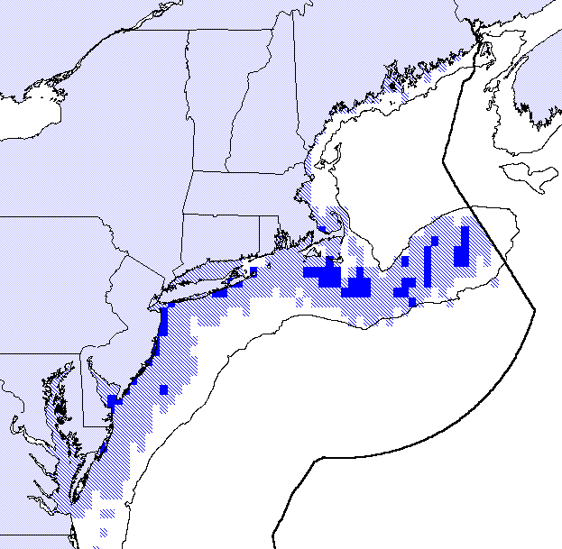
Top 25% CPUE Area
EFH for this Species
Figure 3.56: This map represents the areas of highest concentration of this species, within the boundaries of the Council's EFH designation. The solid areas indicate those areas that comprise the top 25% of the survey catch-per-unit-effort index. The light shading indicates the overall EFH designation for this species.
Essential Fish Habitat
High Concentration Areas (25% CPUE)
Windowpane Flounder Juveniles

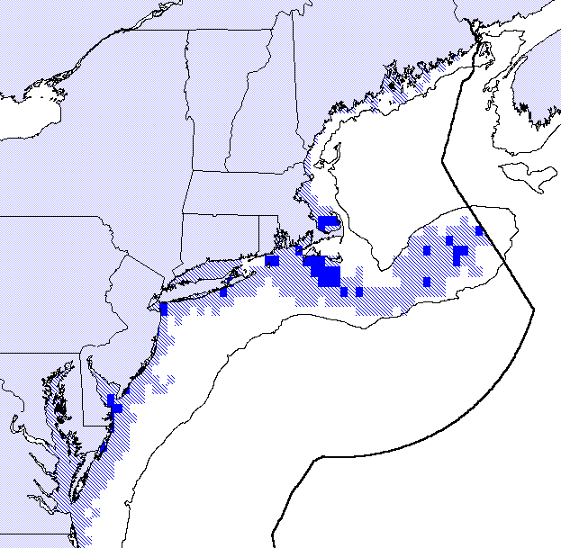
Top 25% CPUE Area
EFH for this Species
Figure 3.57: This map represents the areas of highest concentration of this species, within the boundaries of the Council's EFH designation. The solid areas indicate those areas that comprise the top 25% of the survey catch-per-unit-effort index. The light shading indicates the overall EFH designation for this species.
Essential Fish Habitat
High Concentration Areas (25% CPUE)
Winter Flounder Adults

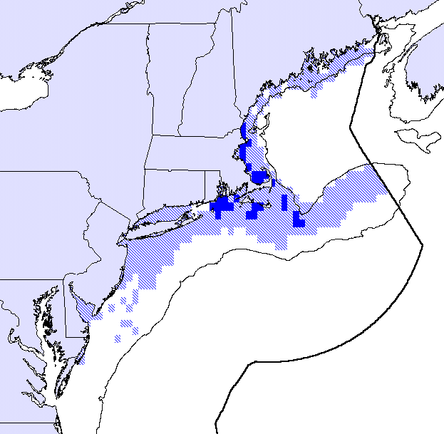
Top 25% CPUE Area
EFH for this Species
Figure 3.58: This map represents the areas of highest concentration of this species, within the boundaries of the Council's EFH designation. The solid areas indicate those areas that comprise the top 25% of the survey catch-per-unit-effort index. The light shading indicates the overall EFH designation for this species.
Essential Fish Habitat
High Concentration Areas (25% CPUE)
Winter Flounder Juveniles

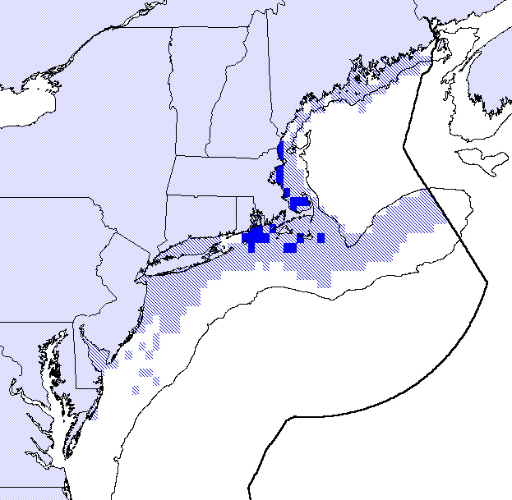
Top 25% CPUE Area
EFH for this Species
Figure 3.59: This map represents the areas of highest concentration of this species, within the boundaries of the Council's EFH designation. The solid areas indicate those areas that comprise the top 25% of the survey catch-per-unit-effort index. The light shading indicates the overall EFH designation for this species.
Essential Fish Habitat
High Concentration Areas (25% CPUE)
Witch Flounder Adults

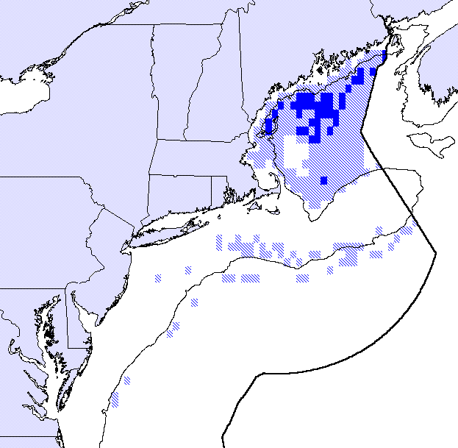
Top 25% CPUE Area
EFH for this Species
Figure 3.60: This map represents the areas of highest concentration of this species, within the boundaries of the Council's EFH designation. The solid areas indicate those areas that comprise the top 25% of the survey catch-per-unit-effort index. The light shading indicates the overall EFH designation for this species.
Essential Fish Habitat
High Concentration Areas (25% CPUE)
Witch Flounder Juveniles

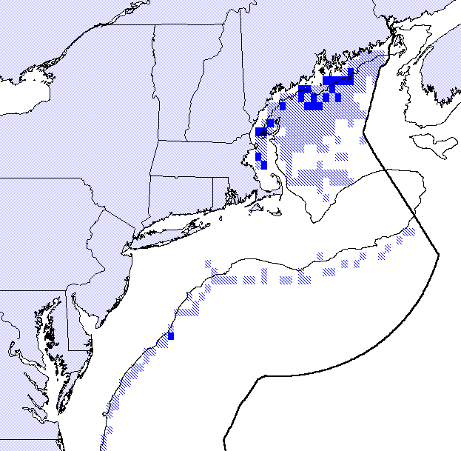
Top 25% CPUE Area
EFH for this Species
Figure 3.61: This map represents the areas of highest concentration of this species, within the boundaries of the Council's EFH designation. The solid areas indicate those areas that comprise the top 25% of the survey catch-per-unit-effort index. The light shading indicates the overall EFH designation for this species.
Essential Fish Habitat
High Concentration Areas (25% CPUE)
Yellowtail Flounder Adults

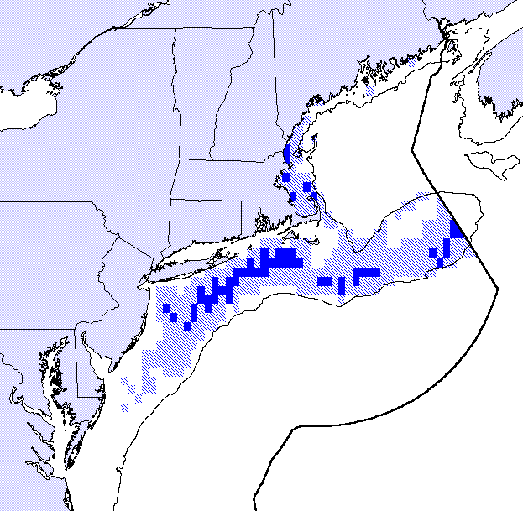
Top 25% CPUE Area
EFH for this Species
Figure 3.62: This map represents the areas of highest concentration of this species, within the boundaries of the Council's EFH designation. The solid areas indicate those areas that comprise the top 25% of the survey catch-per-unit-effort index. The light shading indicates the overall EFH designation for this species.
Essential Fish Habitat
High Concentration Areas (25% CPUE)
Yellowtail Flounder Juveniles

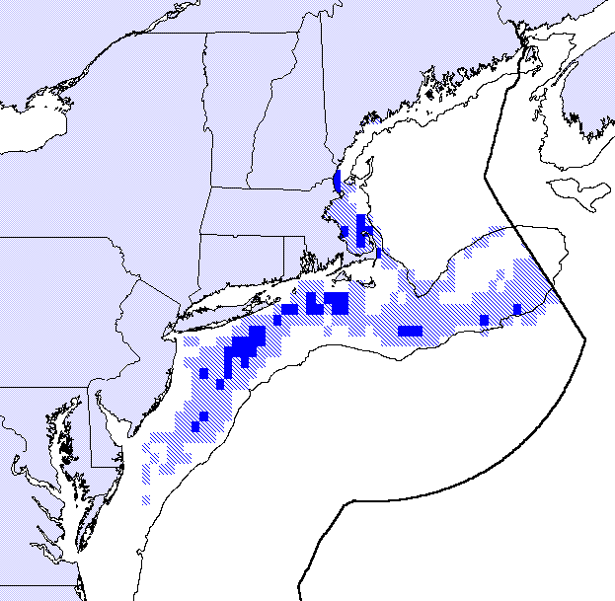
Top 25% CPUE Area
EFH for this Species
Figure 3.63: This map represents the areas of highest concentration of this species, within the boundaries of the Council's EFH designation. The solid areas indicate those areas that comprise the top 25% of the survey catch-per-unit-effort index. The light shading indicates the overall EFH designation for this species.

Information from the Fishing Industry
Another source of valuable information on the location of important and sensitive habitats is the commercial fishing industry itself. While survey data provide the best means to identify the distribution and relative abundance of fish species, most currently available survey data contain little quantitative or qualitative information on the characteristics of important habitat. Commercial fishermen are one of the best available sources of qualitative, if not quantitative, information on the location and characteristics of habitat important to commercial fish species. Commercial fishermen are also a good source of information on the sensitivity to fishing gears and practices of various habitat types. The following is a brief description of fishing areas traditionally frequented by commercial hook fishermen. They have described the marine ecosystem and identified the location of what they believe to be areas of important Atlantic cod habitat. They report that these descriptions are based largely on observations made from samples of benthic organisms which they and other hook fishermen occasionally snag on their hooks as they fish the bottom for groundfish. The areas have been delineated into four basic descriptions, with further delineations based on common fishing areas. The descriptions correspond to the map provided as Figure 3.64.

Area A: These areas represent deep water spots (45 - 75 fathoms) of “hard bottom” which are fished for groundfish and include a wider diversity of species than shallower areas. Fishing these areas hook fishermen catch cod, haddock, cusk, hake, pollock, wolffish, skates, dogfish, and occasionally redfish. The bottom consists of glacial deposits of boulders. Benthic fauna such as sea squirts are not as abundant as in shoal areas and they tend to be smaller in size. The tide in these areas moves slower than other areas which perhaps accounts for the smaller sizes of common benthic organisms. Common fishing area names in this area include: (1) East Southeast Ridge; (2) Figs; (3) Jim Dwyers Ridge; (4) The Sixty-sixes; and, (5) Pimple Ridges.

Area B: This area consists of shallower waters (15 - 40 fathoms) than Area A. This area has lots of hard bottom streaks of rock and gravel. The benthic organisms here flourish with large quantities of horse mussels, sea “lemons” and sponges. The tide flows harder here which may account for the increased faunal growth. The catch in this area for hook fishermen consists of primarily cod, haddock, pollock, skates, and some wolffish, as well as some dogfish seasonally. The close proximity of this area to Chatham makes it popular for the smaller vessels of the hook fleet. Common fishing area names in this area include: (1) Lemons and (2) Mussels.

Area C: This area is perhaps the most important area for hook fishing. The combination of shoal water (15 - 45 fathoms), strong tide, and hard bottom makes this an ideal habitat for cod and haddock. The benthic organisms tend to be similar for those in Area B, but the growth rate seems to be better for everything. The catch in this area is similar to that in Area B except that a greater proportion of the catch is cod or haddock (primarily cod). Common fishing area names in this area include: (1) Crushed Shells; (2) East of Pollock Hole; (3) Codfish Grounds; (4) Big Mussels Cove; (5) Middle Rip; and (6) Pumpkins.

Area D: This is an area of hard bottom close to the beach which holds cod and pollock, particularly in the winter months.

The most critical of all areas identified here has been highlighted within Area C. This area is suggested as the most critical Atlantic cod habitat in the region and is thought to be very sensitive to the disturbance associated with bottom-tending mobile fishing gear.

Independent data and analyses support the claim that this area is important for Atlantic cod -- corroborating information about this general area presented by members of the fishing industry. Figures 3.65 and 3.66 present some of the existing Council EFH data as overlays for the Cape Cod - Great South Channel area. Figure 3.65 highlights areas of relatively high concentrations of adult Atlantic cod (using the top 25% and top 50% of the NMFS survey CPUE index). Figure 3.66 highlights areas that have been designated as EFH for Atlantic cod, haddock and pollock. These areas of intersection serve as a subset of the individual species' EFH designations and may indicate areas of particularly important habitat. These figures illustrate that there is a high degree of agreement between the areas identified by members of the fishing industry and areas considered important based on the Council's EFH data.
Essential Fish Habitat
Information from the Fishing Industry
Cape Cod - Great South Channel Area
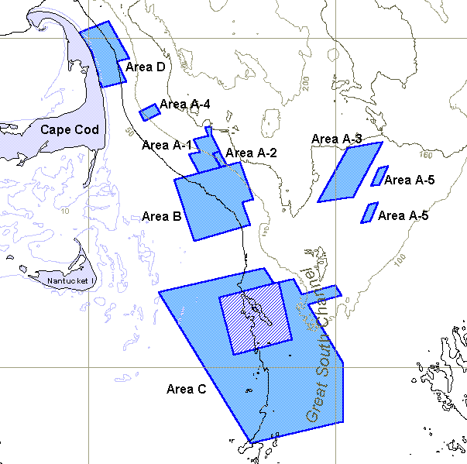
42° N
1
2
41° N
70° W
69° W
2
1
6
3
4
5

Figure 3.64: The shaded areas of this map represent the areas identified by members of the fishing industry as important habitat for Atlantic cod. The letters refer to the descriptions in the text and the numbers refer to the common fishing area names listed in the text. The highlighted area within Area C has been identified as possibly the most important habitat area for Atlantic cod within the region displayed on this map. Depths are in meters.
Essential Fish Habitat
Cape Cod - Great South Channel Area
Atlantic Cod High Concentration Areas
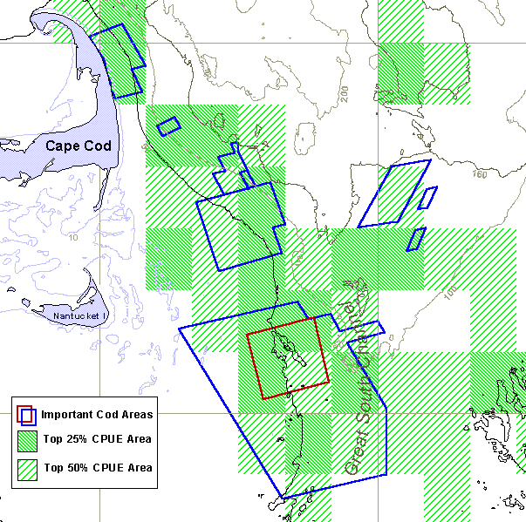
41° N
42° N
70° W
69° W

Figure 3.65: The shaded areas represent areas of relatively high concentrations (the top 25% and top 50% of the CPUE index) of adult Atlantic cod, based on the NMFS trawl survey data (1963 - 1997). The outlined areas indicate the areas of important cod habitat identified by the commercial hook fishermen (see Figure 3.64). Depths are in meters.
Essential Fish Habitat
Cape Cod - Great South Channel Area
Species Grouping - Gadidae Adults
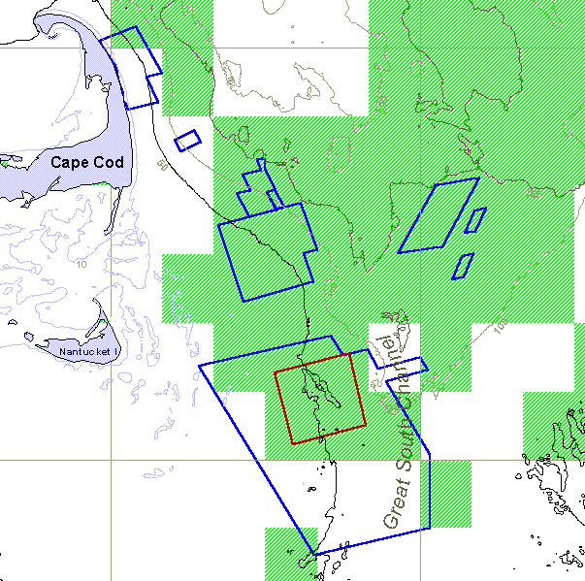
41° N
42° N
70° W
69° W

Figure 3.66: The shaded areas represent those areas that are EFH for Atlantic cod, haddock, and pollock adults (refer to Figure 3.23). The outlined areas indicate the areas of important cod habitat identified by the commercial hook fishermen (see Figure 3.64). Depths are in meters.
1
2
6
7
3
5
4

Juvenile Atlantic Cod and Inshore Gulf of Maine
One of the two HAPC designations submitted for the groundfish, sea scallop, and Atlantic salmon sections of the omnibus EFH amendment was an Atlantic cod HAPC in a specific area on the northern edge of Georges Bank. The first criterion applied on the basis of research showing increased survivability of newly settled juvenile cod in gravel/cobble substrate coupled with readily available prey (Lough et al. 1989). Studies identifying the location of this substrate and documentation of its sensitivity to the cumulative effects of bottom fishing were sufficient to prompt concerns for its degradation. The management measure selected for this area was to maintain the existing closure restrictions on mobile fishing gear, thereby hoping to promote survival and recruitment of juvenile cod to the fishery.

Presently, the Georges Bank cod stock is assessed as well below the maximum sustained yield biomass threshold (B_{msy}); however, the spawning stock biomass has been increasing in recent years under a broad suite of management regulations pursuant to the conservation goals of the FMP (NEFMC's MSMC 1998). Unfortunately, recent recruitment has been poor, and 1994-97 year classes have been among lowest on record (NEFSC 1997).

The situation for Atlantic cod in the Gulf of Maine is now much more problematic. Despite implementation of management measures in 1994 to reduce fishing mortality, commercial catch and landings have continued to decline. Spawning stock biomass is at a record low level, the fully recruited fishing mortality rate remains high, and recruitment and survival of pre-recruit fish are at record lows -- all indications that the stock is collapsing (NEFSC 1997). Both the NEFSC trawl survey, covering the entire Gulf of Maine, and the Massachusetts Division of Marine Fisheries trawl survey, operating in Massachusetts territorial waters, have found that recent year classes are the poorest in the survey time series (NEFMC's MSMC 1998). Moreover, NEFSC survey catches for the period 1979-1983, compared to 1994-1998, illustrate a contraction in distribution of age 3 and older cod to the historic center of abundance off Cape Ann, Massachusetts. A further decline in biomass in 1999 has been projected even with a drastic reduction in fishing mortality.

If the Gulf of Maine cod stock is to be rebuilt to B_{msy}, the Habitat Committee may want to consider recommending an HAPC to provide more protection for critical habitat. Available data and a review of recent scientific literature suggests that consideration be given to designating a juvenile Atlantic cod HAPC for the perimeter of the Gulf of Maine from mean low water (MLW) to a depth of 10 m below MLW (33'). The benthic community within this very narrow coastal zone has been found to be critical for Atlantic cod during a short period following metamorphosis from the larval stage and prior to settlement to demersal habitat. It serves as a source of cod replenishment for seaward fishing areas because juveniles move into deeper offshore water as they mature. Other valuable groundfish (e.g., winter flounder and white hake) as well as American lobster would also be afforded the same protection and supply stocks with new recruits.

Recent Research

During the late 1980's, Atlantic cod inhabiting the waters off southern Labrador and eastern Newfoundland (viz. northern cod stock) underwent a dramatic decline in biomass, with the result that the famous Grand Bank fishery collapsed in 1992. This lead to a fishing moratorium as well as an economic and ecological disaster (Hutchings 1996; Myers, et al. 1996). It also triggered unprecedented research at federal fisheries laboratories and universities in eastern Canada under the auspices of the Government of Canada's Northern Cod Science Program and the government / industry-funded Ocean Production Enhancement Network program. In total, there were 58 study initiatives and projects covering a broad suite of research costing about $48 million from 1990-95 (Campbell 1997).

The following description of research results from Canada and other countries deals with life history and behavioral ecology of newly settled juvenile cod, particularly post-settlement events relating to habitat that may ultimately affect recruitment strength. Studies have focused on laboratory observation experiments as well as field capture efforts utilizing active sampling equipment, SCUBA and submersible vehicles for in situ observations, and seabed classification techniques for acoustically classifying juvenile habitat. Nearly three dozen scientific papers relating to this subject have been published in recent years. The information is directly applicable to coastal nursery areas in the Gulf of Maine, the inference being that knowledge gained from such studies should be used for more risk-adverse habitat management.

Juvenile Cod Community & Interactions - Research Results

Pelagic Juvenile Settlement
Post-larval pelagic juveniles are transported by prevailing currents to shallow waters off eastern Newfoundland beginning in May and may continue arriving in periodic pulses as late as December (Methven and Bajdik 1994; Grant and Brown 1998). Their length upon settlement is 25-45 mm (Pinsent and Methven 1997). In southwest Nova Scotia, pelagic juveniles arrive inshore slightly larger (≈40-50 mm) in May (Tupper and Boutilier 1995a and 1995b), whereas influxes of larvae begin earlier in Massachusetts waters two to three months after hatching (Bigelow and Schroeder 1953). On Georges Bank, cod settle out in July at 40-60 mm, and those reaching rough and cobble bottom may experience reduced predation risk. This particular habitat may be an important demographic bottleneck to benthic recruitment on Georges Bank (Lough et al. 1989).

Pelagic juveniles exhibit no preference for habitat types at settlement, and they occupy rock reef, cobble, eelgrass (Zostera marina) beds, and sand bottom (Tupper and Boutilier 1995b). Tupper and Boutilier (1995b) assumed that settling also occurred on macroalgae habitat, as noted by Keats et al. (1987) off eastern Newfoundland, however, algal stands were scarce in the St. Margaret's Bay, Nova Scotia, study area due to subtidal grazing by sea urchins (Strongylocentrotus drobachiensis). Urchins commonly leave a partially denuded or "barren" zone along nearshore (≈2-12 m below MLW) sections of the maritime provinces and Gulf of Maine.

Age-0 Movements and Diel Feeding
Shallow water depths (<5 m) and a strong attraction to features on most substratums, except sand, afford settled juveniles an environment conducive to growth and survival (Tupper and Boutilier 1995a; Grant and Brown 1998b). The shallowness appears to ecologically segregate the 0-group cod from older age-groups at least during daylight (Tupper and Boutilier 1995a; Fraser et al. 1996; Gotceitas et al. 1997; Grant and Brown 1998a and 1998b). Age-0 cod maintain a strict diurnal foraging cycle, school (or shoal) feeding on zooplankton in a tide-related pattern during the day, and remain near protective bottom habitat which they readily seek when threatened (Gotceitas and Brown 1993; Gotceitas et al. 1995; Grant and Brown 1998a). The mottled coloring of young juveniles effectively conceals them in a pebble-gravel environment (Lough et al. 1989; Gregory and Anderson 1997). In contrast, pelagic juveniles on Georges Bank maintain a nocturnal feeding pattern (Perry and Neilson 1988). Age-0 cod cease feeding in surface waters and disperse to the substratum at night (Grant and Brown 1998b) where they are less active to reduce interactions with potential predators (Grant and Brown 1998a). The diel change in vertical distribution and activity of 0-group cod coincides with a nocturnal shoreward movement and foraging by older (age-1-3) conspecifics (Bosgstad et al. 1994; Gotceitas et al. 1997; Grant and Brown 1998a). Intercohort cannibalism is common. The occurrence of age-0 cod in very shallow water (<1.2 m) at night (Methven and Bajkik 1994) has also been interpreted as possibly an evasive response to predation risk (Grant and Brown 1998a).

Influence of Habitat Structure and Predation on Age-0 Demography
Tupper and Boutilier (1995b) found that the spatial pattern of settlement was altered by post-settlement mortality in St. Margaret's Bay, Nova Scotia. Age-0 survival was positively correlated with an index of rugosity, a measure of actual bottom surface or complexity. Capture success by fish predators (in this case, three species of Cottidae during a diurnal field study) was inversely related to the index of rugosity. As a result, higher densities of age-0 cod were found in cobble and rock reef habitats than in eelgrass. However, the rugosity index could not account for the complexity of surface area that eelgrass offered. Higher survival in sites of cobble and rock reef was attributed to increased shelter that the more structurally complex habitats afforded coupled with decreased predator efficiency (Keats et al. 1987; Lough et al. 1989; Tupper and Boutilier 1995b; Gotceitas et al. 1997; Grant and Brown 1998a and 1998b).

Tupper and Boutilier's (1995b) and Grant and Brown's (1998a) in situ studies confirmed earlier and subsequent laboratory experiments on substrate preference and predator efficiency. Clearly, the presence of conspecifics may influence the distribution and food intake of age-0 cod in the wild. Both age-0 and 1 cod preferred finer grained substrate in absence of a predator, but when in the presence of an age 3 conspecific, young-of-the-year and age-1 either avoided the predator or selected the coarser substrate (cobble vs. gravel) where they hid in interstitial spaces (Gotceitas and Brown 1993; Gotceitas et al. 1995; Fraser et al. 1996). Age-0 avoided the yearling conspecific resulting in a significant increase in use of gravel and cobble confirming the level of habitat segregation noted in the wild (Fraser et al. 1996). Also, age-0 cod avoided kelp (Laminaria) except when exposed to an actively foraging predator and cobble was unavailable. In this situation, kelp significantly reduced predation risk (Gotceitas et al. 1995). Both field and laboratory studies indicate that the association with coarse substrates, when coupled with behavior patterns that reduce predation risk, give young cod competitive advantage in avoiding detection or capture.

Eelgrass Habitat and Abiotic Factors
The presence of eelgrass beds or meadows appears to be a very important factor influencing the distribution of age-0 cod throughout the Canadian maritime provinces (Tupper and Boutilier 1995a; Gotceitas et al. 1997; Grant and Brown 1998a, 1998b). Grant and Brown (1998b) noted that cod were more highly concentrated in eelgrass beds with >65% submersed canopy coverage. Gotceitas et al. (1997) captured age-0 cod almost exclusively in eelgrass beds of Trinity Bay, Newfoundland, where their usage by 0-group cod was consistent spatially and temporally. The eelgrass sites most sheltered to natural physical disturbance produced the highest catches; lower catches occurred at the shallowest and least saline sites (10.4-19.5 ppt). Salinities were usually high (>25 ppt) at most Newfoundland study sites (Methven and Bajkik 1994). Age-0 tolerate much lower salinities as was observed in coastal waters of Wales and England where catches occurred from 20-31 ppt (Riley and Parnell 1984).

Post-settlement cod may respond to environmental gradients in addition to substrate structure and salinity. For example, high water clarity may be important for feeding (Horne and Campana 1989). Strong tidal currents may be beneficial for concentrating food in seagrass beds (Tupper and Boutilier 1995b; Grant and Brown 1998a). Water temperatures coinciding with age-0 collections in St. Margaret's Bay, Nova Scotia, ranged between 4-9°C from May to July (Tupper and Boutilier 1995b) while July to September temperatures in age-0 habitat of Trinity Bay, Newfoundland, were 12-16°C with a year-round range of 1.7-17.0°C (Methven and Bajdik 1994). Water temperature might displace 0-group and yearlings to slightly deeper waters south of Newfoundland, however (Methven and Schneider 1998).

Among-Habitat Variation in Age-0 Growth
Growth of settled age-0 cod appears to be temperature dependent (Tupper and Boutilier 1995a). Growth was most rapid in eelgrass beds, which may positively effect overwinter survival of demersal 0-group juveniles. Growth was slowest on sand bottoms; differences in growth between young inhabiting reef and cobble bottoms were not significant (Tupper and Boutilier 1995b). The growth advantage conferred by seagrass is related to the variety of microhabitats therein that support a diverse community of invertebrates (Orth et al 1984; Heck and Crowder 1991; Heck et al. 1995; Grant and Brown 1998a). Planktonic organisms may be passively concentrated by water currents and effectively retained within the eelgrass canopy. Also, invertebrates and fish may actively seek its confines even crossing predation-risky sand to reach isolated patches (Sogard 1992).

Small planktonic crustaceans, but mostly copepods, are preyed upon by young cod (Keats and Steele 1992; Grant and Brown 1998a). When mouth gape size is large enough, at a length of 6 to 10 cm, cod transition to predominately benthic prey (Keats et al. 1987; Lomond et al. 1998) which they then consume at dusk and dawn (Grant and Brown 1998a).

Among-Habitat Variation in Age-0 Survival
Eelgrass provides age-0 cod protection from predators (Tupper and Boutilier 1995; Gotceitas et al. 1997; Grant and Brown 1998b). In a laboratory experiment, eelgrass significantly increased the time required for an age 3 cod to capture 0-group cod and decreased the number captured. With a predator present, young cod either hid in cobble or in eelgrass when stem density was >720 stems/m2. Time to capture was highest and total prey taken was lowest in combinations with cobble or vegetation of 1,000 stem/m2 (Gotceitas et al. 1997). Results demonstrated that high plant density and/or biomass, whether eelgrass or macrophytic algae (Isaksson et al. 1994), means reduced predation risk just as does use of certain substrates. Moreover, there may be a trade-off between nutritional gain and enhanced predation risk for age-0 cod utilizing eelgrass habitat (Tupper and Boutilier 1995).

Mark-recapture experiments indicate age-0 cod remain very localized, not moving more than several hundred meters in both eelgrass and no-eelgrass habitats (Grant and Brown 1998b). Those that settled earliest and were largest at settlement grew faster and defended a larger territory than later/ smaller settlers (Tupper and Boutilier 1995a), thus a competitive advantage in growth and survival may exist for the earliest pulse of post-larval juveniles over those settling later when temperatures and day length are reduced (Tupper and Boutilier 1995b).

Abundance in the seagrass sites of St. Margaret's Bay, Nova Scotia, was noted to decline after early June. This was attributed to predation rather than emigration because young were strongly site-attached and defended territory as they grew. Marked individuals were not found in areas surrounding the study site (Tupper and Boutilier 1995b). As the summer season advanced, a greater decline in abundance occurred in eelgrass beds and on sand than in structurally more complex reef and cobble habitat. Observing in situ young-of-the-year seeking shelter in rock crevices, empty scallop shells, and other debris within dense grass beds, Tupper and Boutilier (1995b) believed that cod out-grew eelgrass blades as suitable refuge.

Unable to compete for nonexistent shelter on sand habitat, age-0 cod school for protection (Tupper and Boutilier 1995a); however, the population density in these areas reached zero by late June (Tupper and Boutilier 1995b). Predation by three Cottids - sea raven (Hemitripterus americanus), longhorn sculpin (Myoxocephalus octodecemspinosus), and grubby (Myoxocephalus aeneus) - was most successful on sand and least successful on cobble and rock reef. Age-0 cod schooling over sand bottoms have low site fidelity which is disadvantageous to survival (Grant and Brown 1998a).

Young-of-the-year appear to lose site fidelity and disperse into deeper water during the December-January period (Tupper and Boutilier 1995a; Gregory and Anderson 1997) adopting winter behavior of reduced activity and food consumption (Brown et al. 1989). Still, some marked demersal juveniles remained localized in the shallowest (<1.2 m) sampling site in Trinity Bay, Newfoundland, throughout the winter even when ice was present (Grant and Brown 1998b). Age-0 and older juveniles are more adapted than adult cod to survive icy subzero water due to elevated plasma antifreeze levels in their blood (Goddard et al. 1992).

Age-1 and Older Juvenile Habitat and Movements
Age-1 juveniles are found during day and night in shallow inshore waters, including locations with moderate to high wave exposure (Keats 1990). Older juveniles are generally distributed farther away from shore than 0-group and 1-group cod and at depths >25 m. Age-1 associate to a greater degree with rocky substrate and fleshy macroalgae or bottom dominated by sea urchins and coralline algae (Keats et al. 1987; Keats 1990; Gotceitas et al. 1997). The association with a macroalgal canopy seems to be more one of refuge from predators than feeding purposes (Keats et al. 1987; Gotceitas et al. 1995; Gotceitas et al. 1997). They congregate in small groups near boulders and in large crevices. In Newfoundland bays, age-1 cod have been collected within a slightly narrower temperature range, 1-16°C, than demersal 0-group fish (-1.7-17°C) (Methven and Bajdik 1994).

At dusk during summer and autumn seasons, age-1 and older juveniles move shoreward into warmer water feeding areas where the young-of-the-year cod are concentrated. The attracting stimulus appears to be the periodic influxes of early settled cod (Keats 1990; Clark and Green 1990; Methven and Bajkik 1994). Age-1 cod have usually been found feeding until dawn primarily on mysids and gammarid amphipods; however, when they become about three times larger than settled age-0 juveniles, they begin cannibalizing the demersal 0-group cod (Grant and Brown 1998a). By late fall, the earliest age-0 settlers may be large enough to begin intracohort cannibalism on the late settlers, as has been noted in waters of Iceland (Bogstad et al. 1994). When abundance of older juveniles is high, mortality may increase on young-of-the-year because of competition and predation from conspecifics (Grant and Brown 1998a).

Age-1 cod have also been observed feeding on plankton after moving inshore in spring (Keats et al. 1987) as well as resting near bottom in shallow water at night (Keats and Steele 1992). In the latter situation, age-1 were not feeding and analysis of stomach contents indicated daytime foraging on planktonic crustaceans leading the authors to speculate that post-transitional feeding on benthic invertebrates might be patchy in space and time. Where, when, and to some extent what yearlings eat is likely related to trade-offs between predation risk and food availability.

Juvenile cod may utilize the intertidal zone for feeding purposes although there is no mention of this in recent studies. Earlier, an underwater television camera mounted on a herding fence recorded 423 "young" Atlantic cod (no size given), and Atlantic tomcod (Microgadus tomcod), which were sometimes indistinguishable from cod, as well as six, 30-40 cm (age 3 to 4) cod moving up and down a beach, either with or against tidal current, during daytime between June and October in Passamaquoddy Bay, New Brunswick (Tyler 1971). Of eight fish species observed undertaking these movements, the cod/ tomcod combination ranked third, behind only winter flounder (Pseudopleuronectes amercianus) and Atlantic herring (Clupea harengus) in their use of the intertidal zone.

Diel Differences in Abundance
Keats (1990) found one- and two-year-olds 16 times more abundant at night than during the day while making SCUBA transects at a depth of 5-10 m MLW. Methven and Bajdik (1994) were able to seine age-1 cod throughout the year but only at night in a cove of Trinity Bay, Newfoundland, whereas age-1 were caught both day and night by Grant and Brown (1998a) in a different cove of the same embayment. An explanation for the difference in catch of yearling cod between the two studies may be related to sampling techniques. The first study employed a 9 m seine pulled from a maximum depth of 1.2 m (no bridle). The second utilized a 30 m seine deployed by small boat 50 m from shore and pulled by towropes thereby encircling age-1 cod inhabiting a slightly greater depth range.

Researchers studying young cod recognized that gear avoidance occurred during daylight, but avoidance was secondary to diel activity in explaining abundance differences between day and night catches for both age-0 and the older juveniles (Methven and Bajdik 1994; Gibson et al. 1996; Methven and Schneider 1998; Grant and Brown 1998b). Abundance of age-1 peaked in the shore zone from August-November and again in April-June period, but was much reduced in winter (temperature <0°C) indicating withdrawal to deeper habitat. The offshore movement by young cod was also reported in Passamaquoddy Bay, Bay of Fundy (MacDonald et al. 1984).

Juvenile Winter Habitat and Activity
Juveniles inhabit progressively deeper water and associate with coarser substratum as they grow and mature, especially in winter (Keats et al. 1987). Age-1-4 cod were observed at 18 to 150 m from submersible vehicles during April (-1°C at 25-75m), Placenta Bay, Newfoundland (Gregory and Anderson 1997; Gregory et al. 1997). They found that 80% of two-to four-year-olds were associated with rock, boulders, and high bathymetric relief (cliffs) and often maintained fidelity to such features including crevices in rocks. They exhibited significant increases in swimming speed with increasing distance from structure. Yearling cod showed no such connection, 59% of those observed were primarily over gravel and low relief with the fish appearing to rely on cryptic patterns to remain undetected. Macroalgae was neither avoided or preferred by either group. Age-1 and ages 2-4 co-occurred laterally and vertically throughout the study area most abundantly at depths of 60-120 m. Juveniles did not appear to undertake a diel movement shoalward during the winter/ early spring season. However, onshore movements may be initiated during March and April after ice break-up and coincident with nearshore water temperature of ≈2-3°C. The same temperature prompts offshore movements in late autumn (Methven and Bajkik 1994).

Sonic tagged age 3 cod (28-33 cm) rested almost exclusively in rocky areas at night during winter (Clark and Green 1990). Between June and September, however, individuals were active nocturnally and wide ranging (>3 km/day), moving daily between deep (30 m) cold water, where they were inactive in rocky areas, to shallow (<15 m) sandy substratum where they were active at night in relatively small feeding areas (≈540-2,580 m²). When the water column became isothermal in September, age 3 cod remained in the shallow water during daylight leading researchers to speculate that the switch from nocturnal to diurnal feeding might be an antipredator strategy, i.e., to avoid being cannibalized at night when adult cod are seasonally active in relatively shallow water. Other common predators of juvenile cod off Newfoundland are pollock (Pollachius virens) and shortfinned squid (Illex illecebrosus).

Spatial Depth Gradient of Juveniles
For three years following stock collapse, Methven and Schneider (1998) undertook extensive sampling of the Newfoundland coastal zone to a depth of 55 m and by a variety of gears. Finding consistent spatial and diel changes in catch across gears, they interpreted results as characteristic of cod distribution. Catch rate of age-0 cod was inversely related to depth each year, highest at night, and higher at 4-7 m, the center of 0-group distribution during autumn. There was a sharp decrease in catch rate at 20 m (Schneider et al. 1997). Demersal age-0 cod were found almost exclusively alongshore within the northeastern coastal bays of Newfoundland; yearlings extended further offshore and older juveniles were widely distributed on the continental shelf confirming an ontogenetic pattern of movement to deeper water with increasing size. Age-dependent distribution was also obvious from trawl station catches on survey transects extending from the coast to hundreds of kilometers offshore (Dalley and Anderson 1997). When the stock was more robust, demersal age-0 cod were distributed more widely onto the shelf.

The only coastal region of eastern Canada where the seasonal pattern of distribution for young cod appears to be different is the coastal portion of southern Gulf of St. Lawrence where water temperatures might be too warm during summer months (Hanson 1996). Fine scale distribution studies with trawls found that cod did not occupy water 2-12 m deep along shores of Prince Edward Island during summer. They were mostly absent from shallow waters (<20 m deep) in the Miramichi estuary and the contiguous Shediac Valley coastal shelf during any time of year. Yearlings and 2-year-olds, but not age-0 cod, were almost exclusively found in 15-35 m depths of the Gulf from June to early October before joining older age-groups in an extensive migration to deep (>100 m) offshore water for winter.

The spatial depth gradient of juvenile cod from all other areas of eastern Canada seems consistent with published information from the Northeast Atlantic. The depth of highest age-0 cod abundance using a beam trawl off the British Isles was 6 m (Riley and Parnell 1984). Greatest density of age-1 cod sampled with gill nets off Greenland was <20 m (Hansen and Lehmann 1986; Hovgard and Nygaard 1990). Acoustic surveys off the Norwegian coast showed most juveniles at depths <35 m and highest densities of demersal 0-group cod very close to rocky shores where the research vessel could not survey (Olsen and Soldal 1989).

Density-dependent Habitat Use and Mortality
Contraction or expansion of geographic range with decreasing or increasing population size has been observed in a number of cod stocks including the Labrador-East Newfoundland complex and southern Gulf of St. Lawrence stock. In the latter region, the area occupied by age groups 3-8+ cod increased as abundance increased (Swain and Wade 1993). In comparison to the older cod, age 3 were more spatially restricted at low population size, their range expanded more slowly as abundance increased, and changes in relative density among parts of the Gulf were smaller between years of low- and high-abundance. Younger juveniles were thought to experience less severe competitive pressures for food or wider variation in habitat quality than the older age-groups.

A behavioral theory applied to explain the pattern of geographic distribution is density-dependent habitat use. This hypothesis was applied to young cod in coastal habitats (Olsen and Soldal 1989) where catches of post-settlement juveniles showed a high degree of small-scale spatial consistency regardless of cohort size. In years of high year-class abundance, density increases to an upper limit in the most suitable habitat and as the fitness of individuals occupying the prime sites declines due to intraspecific competition, diffusion to and use of suboptimal habitat expands. Accordingly, at low population size, individuals occupy habitat with high basic foraging and protective suitability.

The theory was tested for the Labrador-East Newfoundland stock complex for which contraction has been confirmed for adult cod at low stock size (Taggart et al. 1994; Atkinson et al. 1997). Catches of age-groups 0-2 were analyzed from 1959-64 and 1992-94 at a series of fixed sampling sites extending over 1,500 miles of Newfoundland coastline (Schneider et al. 1997). In years of low cohort size, contraction did not occur in coastal habitats, i.e., density of juvenile cod was independent of area within the occupied <20 m depth range. They noted that sampling sites with high densities in some years had low densities in years of high abundance, an observation inconsistent with spillover theory in good years.

In support of density-dependent theory, high post-settlement densities of age-0 cod were found in eelgrass beds of Trinity Bay, Newfoundland, during 1994 and 1995, years of good and bad year-classes, respectively; however, a significant increase in abundance in less suitable no-eelgrass habitat was noted in 1994 when settlement strength was high (Grant and Brown 1998a). The high 1994 densities in less-utilized no-eelgrass habitat during a year of high abundance would be consistent with the hypothesis of density-dependent habitat use or selection. The researchers acknowledged that their observations were on a small temporal and spatial scale. Re-analysis of the fixed sampling site juvenile catch data from Newfoundland showed a stronger recruitment signal from a small number of sites visited frequently than the entire set of sites (Ings et al. 1997). The 1994 year class was ranked significantly stronger than the three previous year-classes following stock collapse in a broad-scale study (Anderson and Dalley 1997). On the other hand, there was no evidence of fewer settled 0-group juveniles anywhere along the coast in 1995 relative to the 1992-94 year-classes (Smedbol et al. 1998).

For a number of cod stocks, variability in year class strength is usually determined in the larval stage and attenuated by density-dependent juvenile mortality (Myers and Cadigan 1993a). Biological processes that may result in density-dependent mortality would include: (1) competition for food with mortality resulting from increased predation or starvation; (2) intercohort cannibalism; (3) predators switching to abundant year-classes; and (4) a circumscribed area of prime juvenile habitat with those settling surviving while others do not, resulting in a upper limit to the number of survivors regardless of egg/larval production. This mechanism could involve food limitation and/or increased predation risk outside a prime nursery area. It presumes mechanisms maintaining a relatively constant density such as territorial behavior or some other form of density-dependent habitat utilization.

Notwithstanding the study by Schneider et al. (1997), many of the research results discovered and re-confirmed by scientists undertaking the studies summarized herein, describe or infer habitat mediated density-dependent mortality rates. These mechanisms systematically affect cod survival rates from the post-settlement pelagic stage well into the demersal juvenile stage. Annual variation in survival rates on these life stages may be more important in affecting year class size than survival in pre-settlement stages (Sissenwine 1984). This suggests that the nearshore bottom habitat may become a potential bottleneck to year-class size particularly in areas where the availability of the most suitable habitat might be low.

Summary of Research
In shallow (< 5 m) coastal areas of eastern Canada, pelagic juvenile cod settle onto various subtidal habitats in several periodic pulses beginning in May. Space use is highly localized and primarily focused on the need to acquire food and avoid predators. Relative to fulfilling both needs, activity periods, substrate choices, and interactions with members of same species and others are critical. Diurnal feeding in intercohort schools aids location of patchily distributed plankton and provides protection against predators. Site fidelity and nightly concealment in all habitats, except sand, minimizes interactions with cannibalistic age-1 cod that move shoalward at dusk to feed. The spatial pattern of age-0 cod distribution is altered by post-settlement mortality such that abundance among bottom habitats matches substratum complexity: cobble/gravel ≥ rock reef > eelgrass ≥ macroalgae > sand. Of bottom habitats studied, eelgrass confers a significant advantage in growth to age-0 cod. Significantly reduced predation risk also occurs if eelgrass stems are above a threshold density and/or they are associated with cobble bottom. Eelgrass meadows are highly utilized as nursery habitat both spatially and temporally through at least mid-summer. The transition to a demersal existence occurs at a length of 6-10 cm and is marked by a switch to benthic prey foraged at dawn and dusk. The distribution of age-0 cod in autumn is centered at depths of 4-7 m MLW with a sharp drop off at 20 m. In late autumn/ early winter, age-0 lose site fidelity and disperse to deeper water where they congregate primarily over gravel and low relief cover.

Older juveniles inhabit progressively deeper water and associate with coarser, hard-bottom features as they grow. Seasonal inshore movements are usually associated with nocturnal feeding. Age-1 cod, while co-existing in all but the shallowest depths with young-of-the-year, are many times more abundant in the shore zone at night than during the day apparently attracted there by the presence of periodic influxes of post-larval pelagic juvenile cod.

Competitive advantage accrues to the largest and earliest settling juveniles especially those finding coarse substratum with vegetative cover. Those less favored must disperse from feeding patches more often thereby accepting a lower rate of food intake in order to avoid detection and capture. As Tupper and Boutilier (1995b) hypothesized: "one habitat might supply the population with a greater number of smaller recruits, each with a somewhat lesser chance of survival, while another habitat supplies fewer, larger recruits, each with a relatively high chance of survival".

The trade-offs between habitat use and frequency of feeding in the face of predation risk are processes consistent with density-dependent habitat use and mortality. Although empirical evidence of density-dependent usage off Newfoundland is contradictory, stock size/recruitment may not yet be large enough following the northern cod stock collapse to induce significant density-dependent effects on a large spatial scale. Nevertheless, behavioral research details ways age-0 juveniles respond to spatial heterogeneity, the consequences for fitness through utilization of resources, and the intraspecific competitive effects which emphasizes the importance of habitat availability and quality in determining recruitment success.

Gulf of Maine Coastal Marine Environment and Juvenile Cod Distribution

Coastal Environment
The margin of the Gulf of Maine is similar to the Canadian coastal zone of higher latitudes with the exception that the latter generally has more imposing headlands and bathymetric relief, narrower beaches, and a more steeply sloping shore zone. The coastline of the northern Gulf between Passamaquoddy Bay and Cape Elizabeth, Maine, is also rugged, wave-exposed, and rock-framed. Within hundreds of indented bays and coves are thousands of islands and ledges. The subtidal seafloor is largely hard-bottom (ledge and boulder), often giving way to cobble/gravel, and sediment within < 10 m depth. Submerged bedrock outcroppings and rocks provide bathymetric relief and substantial vegetative algal habitats.

From Cape Elizabeth to Cape Cod, the coast is characterized by long sandy beaches, unconsolidated cliffs and bluffs, and occasional rocky headlands, most prominently Cape Ann and Marblehead. With the exception of the headland littoral zone, the nearshore seafloor is generally wave-rippled coarse sand broken occasionally by restricted patches of cobble. Numerous barrier beaches protect estuaries and occasionally extensive salt marshes lying behind them. Along the southern part of the coast, in particular, but near entrances of protected inlets or river deltas, sand may be vegetated with eelgrass meadows. Sublittoral hard bottom relief including sand ripples, troughs, empty shells, worm tubes, motile or sessile invertebrate taxa (e.g., mussels, starfish, urchins, anemones, hydrozoans, bryozoans, ascidians, and sponges) and marine vegetation provides valuable interspersion of cover types for age-0 juvenile nursery habitat similar to the nearshore regions of the Canadian maritime provinces. However, unlike some areas north of the international border, the coastal zone is the only known source of recruits to the Gulf of Maine cod stock.

Juvenile Cod Distribution
For the Gulf of Maine cod stock, the distribution pattern of eggs, larvae, and juveniles has been demarcated along the coast from eastern Maine to Cape Cod; hence, the western perimeter of the Gulf has been designated EFH for these life stages (NEFMC 1998). The EFH designation for juveniles (<35 cm) was based on presence/absence as identified by several sources: NMFS and MDMF inshore bottom trawl surveys (1963-97 and 1978-97, respectively), NMFS MARMAP ichthyoplankton survey (1977-87), and NOAA's Estuarine Living Marine Resources (ELMR) program encompassing abundance records for 13 major bays and harbors and four river systems. Results from additional, less systematic or more spatially restricted coastal sampling efforts (the basis for ELMR classifications with some exceptions) are now being compiled and should reveal more complete information on cod distribution. A pertinent example is the notation that juvenile Atlantic cod were seined only at night from eelgrass meadows of Nauset Harbor, Cape Cod (Heck et al. 1989).

The mapped EFH designations mirror the long held knowledge that inshore waters are principal habitat for juvenile cod. The distribution of juvenile cod observed in the latter half of 19th century and early part of this century was summarized by Bigelow and Schroeder (1953). They described young-of-the-year cod living in very shoal water to the littoral zone, and small, presumably one-year-olds, along the coast within two fathoms (≈4 m) in summer.

From the contemporary NMFS trawl survey catch in the Southern New England-Georges Bank region, water temperature was determined to be a factor in explaining interseasonal spatial and depth distribution of age-1-4 cod. However, water temperatures were insufficient to explain distributional differences among age classes (Wigley and Serchuk 1992). From a slightly earlier time series of research vessel catches in the Gulf of Maine, as well as collections on Georges Bank and Southern New England, Wigley and Gabriel (1991) noted juvenile (<37 cm) cod inhabiting a mean depth of 62 m in the spring and 75 m in the autumn with seasonal occurrence at minimum depths of about 10 m in both seasons. Within the Gulf of Maine, juvenile concentrations occurred between Jeffrey's Ledge and Cape Cod in spring and were more restricted to Massachusetts Bay in fall. Lower densities of juveniles also occurred all along the 100 m isobath off New Hampshire/ Maine coast during both seasons. However, the NMFS survey completes relatively few stations nearshore in the northern part of the Gulf due to the rough bottom habitats that are untrawlable with traditional survey gear.

The most southern inshore portion of the Gulf of Maine is more accessible to research vessels and has been covered by the MDMF survey. The occurrence of juvenile cod (<35 cm) matched all temperatures (<13°C) and depths sampled in spring (5-80 m), but during fall surveys, young cod tended to occur at deeper (15-50 m) and cooler (<17°C) sampling stations. The juvenile cod catch per tow was highest along the north shore of Massachusetts Bay and Cape Ann/ Ipswich Bay in spring (500-1,765 fish/tow) and fall (500-2,925 fish/tow), as well as the tip of Cape Cod in spring (200-500 fish/tow), and throughout Cape Cod Bay in fall (500-2,925 fish/tow) (NEFMC 1998). Age-groups 0 and 1 cod predominate in the fall survey with the highest densities of 0-group cod usually occurring at alongshore stations, catches invariably associated with bycatch of live bottom material [e.g., sulphur sponge (Cliona), kelp, spaghetti grass (Codium), and eelgrass (A. Howe, pers. comm.)].

Status of Eelgrass
The presence of eelgrass beds may be an equally important factor influencing distribution and abundance of post-settled cod juveniles in the Gulf of Maine as documented in the Canadian maritime provinces and certain countries bordering the Northeast Atlantic. However, eelgrass has been in general decline in the United States coastal regions for over half a century. There are multiple stressors and disturbances contributing to loss of eelgrass acreage (Short et al. 1987, Muehlstein and Porter 1991; Nixon 1995). Wasting disease caused by the pathogenic marine slime mold, Labyrinthua sp. Nov, is responsible for epidemic losses a half century ago and has re-occurred in some areas. In many estuaries and coastal areas, sediment loading (turbidity) from the watershed and increased anthropogenic nitrogen loading (eutrophication) via groundwater has stimulated algal competitors that shade and stress plants and significantly reduce stem density and depth of the plants. Fishing gear that cuts shoots has also been implicated.

Because eelgrass is sensitive to variations in water quality from watershed-level impacts, it is considered an indicator of ecosystem state (Dennison et al. 1993). Whereas once large eelgrass meadows colonized much of the shallow water of Boston Harbor, they are now restricted to a few, small patches (Colarusso et al. in press). Airborne remote sensing, field observations, and GIS technology are being used to find and map eelgrass meadows in nearshore habitats of the Gulf of Maine.

In comparison to other estuarine nursery habitats measured, species richness, macroinvertebrate biomass, and primary production is significantly higher in eelgrass. Its loss and subsequent changes in food web structure (McClelland and Valiela 1998) has not only resulted in foregone predator (benthic fish, lobster, and large shellfish) biomass (Heck et al. 1995), but also lost habitat complexity and diminished sediment stability. It is thought that some recolonization of former eelgrass meadows will occur slowly if nitrogen loading is reduced (Duarte 1995). Protecting eelgrass habitat should be an high priority with respect to conservation of coastal nurseries for Atlantic cod (Gotceitas et al. 1997).

Utilization of Proposed HAPC by American Lobster and other Multispecies Groundfish
The American lobster (Homarus americanus) is New England's largest single-species fishery and its most valuable. The life stage distribution relative to nearshore habitats of coastal lobster populations has been well documented. Densities tend to be at least two orders of magnitude higher on hard bottoms than on sediment habitat. Lobster larvae settle in shallow subtidal or low intertidal cobble/ gravel/ pebble substrates, and like post-settlement cod, are very susceptible to predation. These hard-bottom patches support high densities of one and two-year-olds (<40 mm CL) because of the protection afforded by the interstitial spaces (Wahle and Steneck 1992). No studies have detected early benthic stages (<10 mm CL) on featureless sediment (Wahle 1993). As lobsters outgrow the early benthic phase, they become increasingly mobile on nearshore sediment habitat. The research trawl catch of sublegal (30-82 mm CL) lobster alongshore at depths ≤9 m may reach 4,000 lobsters (13 bu) in tow times of less than 20 minutes in MDMF bottom trawl surveys (A. Howe, pers. comm.).

Among other multispecies groundfish, it is well known and corroborated by scientific information that winter flounder spend their first two years of life in very shallow coastal water co-occurring with young cod throughout the northern part of their range. While they are commonly reported occupying unvegetated substrates in Canada and New England, eelgrass meadows also serve as nurseries for winter flounder as well as white hake, Urophycis tenuis (Heck et al. 1989).

Conclusion

Although Atlantic cod adults are depleted in the Gulf of Maine, some recruitment will continue to occur because density-dependent effects will increase juvenile survival rates at low abundance (Myers and Cadigan 1993b). Unfortunately, recruitment at low spawner abundance happens at greatly reduced levels for cod (Myers and Barrowman 1996). Recognizing critical habitat (e.g., nearshore cobble patches and eelgrass beds), and protecting it from anthropogenic impacts by risk-adverse management measures should improve juvenile survivorship.

Fishing and Non-Fishing Related Impacts

Non-Fishing Related Adverse Impacts to Fish Habitat
There is no new information available regarding the adverse impacts to fish habitat associated with non-fishing related activities. For a complete review of this issue, please refer to section 5.0 of the EFH amendment.

Fishing Related Adverse Impacts to Fish Habitat
Several articles were recently published that discuss the likely impacts to fish habitat from a variety of fishing gears and practices, with a focus on bottom-tending mobile fishing gear. These articles represent the most recent work done on the subject by a variety of researchers. The following summaries are intended to provide an overview of these recent papers. The first five articles were published in a special section of the December 1998 issue of Conservation Biology. Following the summaries of the Conservation Biology articles, there is a summary of a paper by Dr. Joe DeAlteris that describes some research he and two colleagues have conducted to compare seabed disturbance by mobile fishing gear with natural processes.

A Conceptual Model of the Impacts of Fishing Gear on the Integrity of Fish Habitats. Peter J. Auster

Habitats considered valuable such as coral reefs, kelp beds and seagrass beds, are often studied to determine habitat damage due to fishing practices, while habitats that are less charismatic, like soft muddy bottoms, are often ignored. Fishing gear can damage the sea floor by leveling vertical structure such as sand waves, and destroying animals that are attached to the bottoms, as well as those that form burrows. The author has developed a model that examines the impacts of different types of fishing gear on various types of seafloor habitat. The model predicts that increasing levels of fishing effort will have increasing impacts on the seafloor, but the amount of impact may vary. There also may be a threshold effect, meaning that a particular habitat might experience a certain amount of fishing effort without sustaining much damage, but once the fishing effort gets to a certain point, significant damage to the habitat results. This threshold effect would depend on the type of habitat, the type of fishing gear, and the amount of fishing effort. This model can be used to help better manage fisheries systems, working to protect biodiversity as well as a sustainable harvest of fishes.

Impact of otter trawling on a benthic community in Monterey Bay National Marine Sanctuary. Jonna Engel and Rikk Kvitek

Two fishing areas off central California in Monterey Bay National Marine Sanctuary were compared, one with light levels of trawling and one with high levels of trawling. The area with high levels of trawling had significantly more trawl tracks, exposed sediment, and shell fragments and significantly less rocks, mounds, and flocculent material than the lightly trawled area. Invertebrates were significantly more abundant in the lightly trawled area. Due to the near universal absence of true unfished control sites it is difficult to determine appropriate levels of harvest pressure for maintaining sustainable fisheries and marine biodiversity. To obtain these answers, it will be necessary to establish marine reserves in which fishing effort and methods can be manipulated in collaborative studies involving fishermen, researchers, and resource agencies.

Effects of Experimental Otter Trawling on Surficial Sediment Properties of a Sandy Bottom Ecosystem of the Grand Banks of Newfoundland. Peter Schwinghamer, Donald C. Gordon Jr., Terence W. Rowell, Jens Prena, David L, McKeown, G. Sonnichsen and J.Y. Guigné

A 3-year experiment on the effects of otter trawling was conducted on a sandy bottom ecosystem of the Grand Banks of Newfoundland. Each year, three 13-km long corridors were trawled 12 times, creating a disturbance zone 120-250 m wide. Using a variety of oceanographic instruments, measurements were made before and after trawling to document effects. Tracks made by trawl doors were readily visible on the sea floor immediately after trawling and 10 weeks later; in some cases they were still faintly visible after 1 year. Acoustic data indicated that trawling increased the roughness of surficial sediments, and changed small seabed structures down to depths of 4.5 cm. Video data demonstrated that untrawled sediments had a hummocky, mottled appearance, whereas trawled sediments were smoother and cleaner. It appears that in the area studied the physical effects of otter trawling are moderate and that recovery occurs in about one year.

Resuspension of Sediment by Bottom Trawling in the Gulf of Maine and Potential Geochemical Consequences. Cynthia H Pilskaln, James H. Churchill and Lawrence M. Mayer

The high frequency of bottom trawling in the Gulf of Maine likely contributes to the amount of sediment suspended near the seafloor. Sediment traps were placed 25 meters above the seafloor in two different areas within the Gulf of Maine which were subject to greater or lesser trawling activity. Traps in areas of more frequent trawling pressure collected large amounts of sediment, along with worms that normally live in the sediment on the seafloor and are not known to swim. The times when the greatest amount of sediment were found in the traps were coincident with seasonal periods of intense bottom trawling activity. Sediment traps in areas with less trawling pressure collected significantly less sediment and very few worms. The resuspension of sediments by trawling activities may have important effects on the nutrients found in the Gulf of Maine, affecting nutrients in both the sediment and in the water column. The disturbance of the seafloor by trawling may also change the organization and structure of the animal communities found there. These aspects must be studied in detail to determine the complete effects that bottom trawling has on the environment.

Significance of Bottom-fishing Disturbance. Michel J. Kaiser

There has been increasing interest in the effects of fishing practices on the ecology of marine ecosystems, but often it is difficult to differentiate between fishing-related effects and natural perturbations of the environment. Many parts of the ocean have been subjected to heavy fishing pressure for many years, but most scientific studies have concentrated on short-term effects. In addition, different habitats are more or less susceptible to various types of disturbance. These attributes can complicate efforts to predict long-term effects of environmental disturbance based on the results of short-term studies. A greater understanding of the relative effects of fishing pressure and natural environmental change will aid in predicting the effects of fishing activities in different marine habitats. This article suggests ways to study both current fishing effects as well as past environmental changes.

The Significance of Seabed Disturbance by Mobile Fishing Gear Relative to Natural Processes: A Case Study in Narragansett Bay, Rhode Island. Joseph DeAlteris, Laura Skrobe, and Christine Lipsky

Seabed disturbance by bottom-tending mobile fishing gear has emerged as a major concern related to the conservation of essential fish habitat. Unquestionably, dredges and trawls disturb the seabed. However, the seabed is also disturbed by natural physical and biological processes. The biological communities that utilize a particular habitat have adapted to that environment through natural selection, and, therefore, the impact of mobile fishing gear on the habitat structure and biological community must be scaled against the magnitude and frequency of seabed disturbance due to natural causes. Fishermen operating in the mouth of Narragansett Bay, Rhode Island, use trawls to harvest lobsters, squid and finfish, and dredges to harvest mussels. These mobile fishing gears disturb rock, sand and mud substrates. Side-scan sonar data from 1995 with 200% coverage were available from NOAA for the mouth of Narragansett Bay. Analysis of these data indicates that evidence of bottom scarring by the fishing gear is restricted to deeper waters with a seabed composition of soft cohesive sediments, despite the observation that fishing activity is ubiquitous throughout the bay mouth.

A quantitative model has been developed to compare the magnitude and frequency of natural seabed disturbance to mobile fishing gear disturbance. Wave and tidal currents at the seabed are coupled with sediment characteristics to estimate the degree of seabed disturbance. Field experiments designed to compare the longevity of bottom scars indicate that scars in shoal water and sand sediments are short-lived, as compared to scars in deep water and mud sediments, which are long-lasting. Finally, the model results are compared to the recovery time of sediments disturbed by the interaction of the fishing gear with the seabed. The impact of mobile fishing gear on the seabed must be evaluated in light of the degree of seabed disturbance due to natural phenomena. The application of this model on a larger scale to continental shelf waters and seabed sediment environments will allow for the identification of problematic areas relative to the degradation of essential fish habitat by mobile fishing gear.

Management Alternatives

Proposed Revisions to EFH and HAPC Designations

At this time, the EFH Technical Team does not propose modifying any EFH designations. The only new information presented are the NMFS reports reviewing the Rhode Island and Connecticut state surveys. These were not presented to the EFH Technical Team with sufficient time to prepare any recommendations for consideration by the Habitat Committee. Following Committee review of the state survey reports, the EFH Technical Team will review the information presented in the reports to determine if any modifications to Council EFH designations are warranted. Any suggested modifications to EFH designations will be presented to the Habitat Committee for review at an upcoming meeting.

Based on the information presented in Section 3 of the Habitat Annual Review Report, the EFH Technical Team suggests the following alternatives for consideration by the Habitat Committee. These alternatives identify areas that meet at least one of the criteria for HAPC designation. The purposes in identifying areas for consideration as an HAPC are twofold: first, the HAPC designation prioritizes areas that should be given special attention during NMFS EFH consultation with other agencies; and, second, the HAPC designation identifies areas in which the Council may focus management attention.

Inshore Gulf of Maine
Based on the information presented on juvenile Atlantic cod and the inshore areas of the Gulf of Maine, the EFH Technical Team suggests that the areas identified in this report and on Figure 4.1 meet the criteria for designation as an HAPC. A coastal HAPC designation would be justified on the criteria of ecological function and sensitivity to induced environmental degradation. An HAPC designation for the nearshore Gulf of Maine could assist in the enhancement of Atlantic cod, American lobster, and other groundfish species. Potential measures to protect this proposed HAPC are discussed below.

The most practical approach for delineating an HAPC for settled age-0 cod is to circumscribe the reported center of distribution for this life stage throughout the range of the stock. The information available suggests that the HAPC should be from the low tide line to a depth of 10 m (33') MLW from eastern Maine to Cape Cod, Massachusetts, conforming to the center of distribution (4-7 m). This narrow depth range describes critical habitat from settlement (<5m) through the first autumn of life and overlaps seasonal habitat of age-1 juvenile cod. It also bounds the critical nursery zone for early benthic stages of American lobster as well as important juvenile habitat for some other groundfish. Consideration of a more encompassing HAPC to the depth range occupied by most age-0 cod would involve extending the isobath to at least the 20 m (66') and might be unjustifiably exclusionary to mobile gear fisheries conducted on sandy seafloor seaward of hard bottom habitat and generally >10 m, should these gears be restricted with the proposed HAPC.

The HAPC proposal should be somewhat flexible to allow modification as results from additional research and fine-scale resource mapping become available. For example, drawing a mean low water boundary of HAPC is problematic given knowledge that eelgrass beds may extend well inside embayments and river deltas, so drawing a shoreline boundary crossing from headland to headland versus across arbitrary points farther up estuary or river is initially convenient. Fine-scale mapping of most important habitat components might resolve the above dilemma and afford more localized protection to the most sensitive habitat components. It also could result in more permitted activities within the HAPC zone.

Future information could also prompt consideration of extending the HAPC into contiguous waters east of Cape Cod and south of Nantucket and Martha's Vineyard into Buzzards Bay. For assessment purposes, cod inhabiting this area are considered part of the Georges Bank stock. Settled age-0 cod are taken nearshore in May by the Massachusetts DMF trawl survey (NEFMC 1998). There is no information on whether or not these fish survive the summer. They do not re-occur at larger size on later inshore surveys but that does not mean that the southern shore zone does not serve an important role relative to recruitment for the Georges Bank stock.

With consideration of the above caveats, the EFH Technical Team suggests that the Habitat Committee consider designating an HAPC for subtidal age-0 Atlantic cod, within the existing juvenile Atlantic cod EFH designation, from MLW to 10 m (33') below MLW extending from the international border with Canada southwestward along the entire western perimeter of the Gulf of Maine to Race Point, Provincetown, Massachusetts, including subtidal bottom to 10 m below MLW around all coastal islands. This designation could be refined at a later date, depending on the availability of better information about the actual distribution and spatial extent of seagrasses and hard bottom habitats.

Great South Channel
Based on the information presented by members of the commercial hook fishing industry, the EFH Technical Team suggests that the area identified as the most important habitat for Atlantic cod meets the criteria for designation as an HAPC (Figure 4.2). Independent data and analyses support the claim that this area is important for Atlantic cod --corroborating the information about this general area presented by members of the fishing industry. Figures 3.65 and 3.66 present some of the existing Council EFH data as overlays for the Cape Cod - Great South Channel area. These figures illustrate that there is a high degree of agreement between the areas identified by members of the fishing industry and the areas considered important based on the Council's EFH data. This agreement points out that the data support the identification of this area as a proposed HAPC. Potential measures to protect this proposed HAPC are discussed below.

Areas of High Species Concentration
Based on the information and maps presented for all Council-managed species identifying areas that support the highest relative concentrations of fish, the EFH Technical Team suggests that at least some of these areas meet the criteria for designation as HAPCs. HAPC designation could be considered for those stocks of Council-managed species for which the most recent biomass estimates indicate that the stocks are currently at less than one-quarter of B_{msy}. This would include Gulf of Maine Atlantic cod, southern New England yellowtail flounder, and Gulf of Maine/Georges Bank white hake. The areas proposed for HAPC designation are indicated in Figures 4.3 - 4.8. Since the Council is embarking on the development of an amendment to the Northeast Multispecies FMP that will include rebuilding plans and schedules for these stocks of groundfish, specific management measures for these areas may not be necessary at this time. It may be appropriate, however, for the specific measures designed to implement the rebuilding plans be targeted at areas designated as HAPCs.
Essential Fish Habitat
Proposed Inshore Gulf of Maine Juvenile Atlantic Cod
Habitat Area of Particular Concern
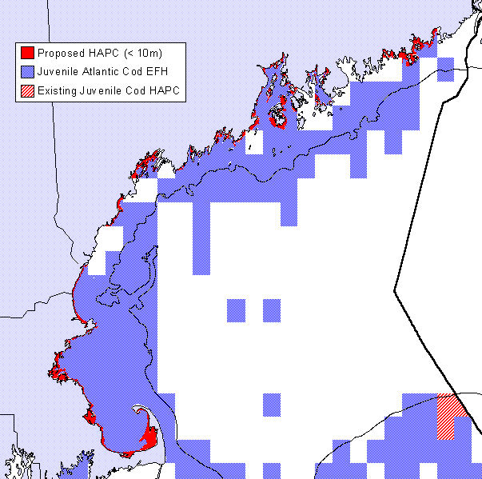

Figure 4.1: This map displays the area proposed for Habitat Area of Particular Concern (HAPC) designation. Within the existing boundaries of EFH for juvenile Atlantic cod, the HAPC proposal includes all areas of the perimeter of the Gulf of Maine, from the mean low water (MLW) mark out to the 10 meter isobath.

Essential Fish Habitat
Proposed Great South Channel Atlantic Cod
Habitat Area of Particular Concern
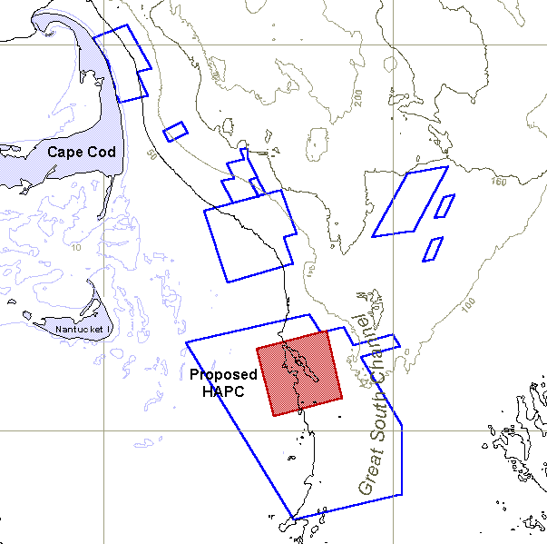
42° N
70° W
69° W
41° N

Figure 4.2: The shaded area of this map represents the area proposed for Habitat Area of Particular Concern (HAPC) designation. The outlined areas represent those areas identified by members of the fishing industry as important habitat for Atlantic cod within the Cape Cod - Great South Channel area (see Figure 3.64). Depths are in meters.

Essential Fish Habitat
Proposed High Concentration Area Habitat Areas of Particular Concern
Gulf of Maine Atlantic Cod Juveniles

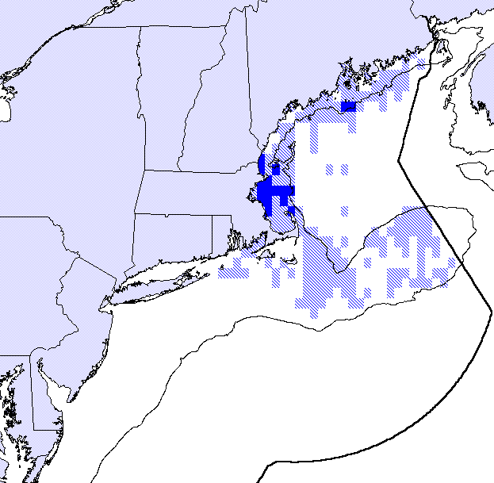
Proposed HAPC
EFH for this Species
Figure 4.3: This map displays the area proposed for Habitat Area of Particular Concern (HAPC) designation. Within the existing boundaries of EFH for juvenile Atlantic cod, the HAPC proposal includes those areas of highest concentration (the areas that comprise the top 25% of the survey catch-per-unit-effort index) within the Gulf of Maine cod stock delineation. The light shading indicates the overall EFH designation for this species.
Essential Fish Habitat
Proposed High Concentration Area Habitat Areas of Particular Concern
Gulf of Maine Atlantic Cod Adults

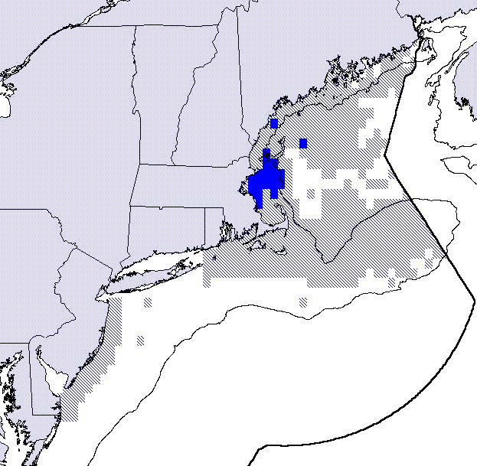
Proposed HAPC
EFH for this Species
Figure 4.4: This map displays the area proposed for Habitat Area of Particular Concern (HAPC) designation. Within the existing boundaries of EFH for adult Atlantic cod, the HAPC proposal includes those areas of highest concentration (the areas that comprise the top 25% of the survey catch-per-unit-effort index) within the Gulf of Maine cod stock delineation. The light shading indicates the overall EFH designation for this species.
Essential Fish Habitat
Proposed High Concentration Area Habitat Areas of Particular Concern
Southern New England Yellowtail Flounder Juveniles

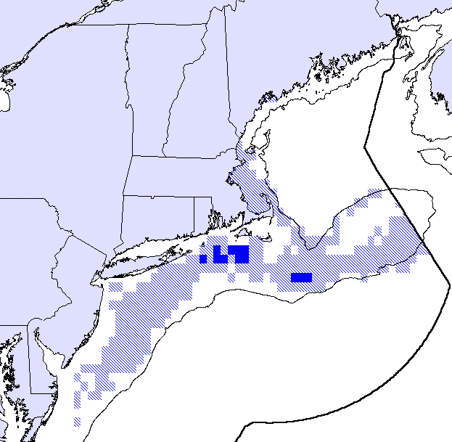
Proposed HAPC
EFH for this Species
Figure 4.5: This map displays the area proposed for Habitat Area of Particular Concern (HAPC) designation. Within the existing boundaries of EFH for juvenile yellowtail flounder, the HAPC proposal includes those areas of highest concentration (the areas that comprise the top 25% of the survey catch-per-unit-effort index) within the Southern New England stock delineation. The light shading indicates the overall EFH designation for this species.
Essential Fish Habitat
Proposed High Concentration Area Habitat Areas of Particular Concern
Southern New England Yellowtail Flounder Adults

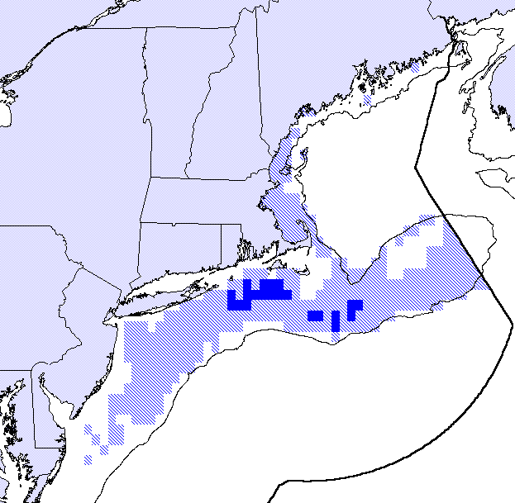
Proposed HAPC
EFH for this Species
Figure 4.6: This map displays the area proposed for Habitat Area of Particular Concern (HAPC) designation. Within the existing boundaries of EFH for adult yellowtail flounder, the HAPC proposal includes those areas of highest concentration (the areas that comprise the top 25% of the survey catch-per-unit-effort index) within the Southern New England stock delineation. The light shading indicates the overall EFH designation for this species.
Essential Fish Habitat
Proposed High Concentration Area Habitat Areas of Particular Concern
Gulf of Maine / Georges Bank White Hake Juveniles

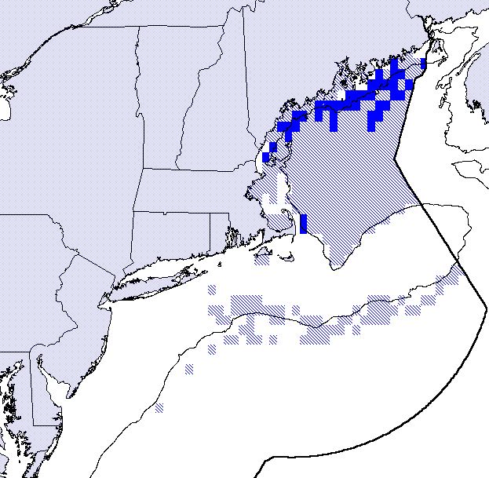
Proposed HAPC
EFH for this Species
Figure 4.7: This map displays the area proposed for Habitat Area of Particular Concern (HAPC) designation. Within the existing boundaries of EFH for juvenile white hake, the HAPC proposal includes those areas of highest concentration (the areas that comprise the top 25% of the survey catch-per-unit-effort index) within the Gulf of Maine/Georges Bank stock delineation. The light shading indicates the overall EFH designation for this species.
Essential Fish Habitat
Proposed High Concentration Area Habitat Areas of Particular Concern
Gulf of Maine / Georges Bank White Hake Adults

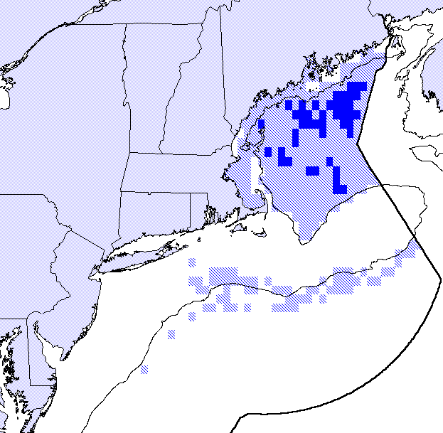
Proposed HAPC
EFH for this Species
Figure 4.8: This map displays the area proposed for Habitat Area of Particular Concern (HAPC) designation. Within the existing boundaries of EFH for adult white hake, the HAPC proposal includes those areas of highest concentration (the areas that comprise the top 25% of the survey catch-per-unit-effort index) within the Gulf of Maine/Georges Bank stock delineation. The light shading indicates the overall EFH designation for this species.

EFH Overlays and Intersections
The EFH Technical Team has employed several methods to identify potentially important areas of habitat based on the co-occurrence of EFH for groups of Council-managed species (see Section 3.2.1 of the HARR), but there is not general agreement on which method most accurately reflects the known habitat requirements of the majority of Council-managed species, nor on which groupings of Council-managed species are most appropriate. At this time, the EFH Technical Team does not propose modifying any EFH or HAPC designations based on this process; however, this is an important tool which can be used to identify areas of important habitat and the EFH Technical Team will continue to review the results of these analyses. Once the most appropriate method is identified, the EFH Technical Team may present the Habitat Committee with suggestions for consideration for one or more areas to be designated as HAPCs. If and when the additional areas are proposed for HAPC designation based on this process, potential measures to protect these areas will be addressed if necessary and appropriate.

Although the EFH Technical Team is not suggesting that any HAPCs be considered based on these analyses, the results do lend support to other proposals and the importance of particular areas. For instance, the areas in the Great South Channel identified by members of the commercial hook fishing industry are supported by the intersection of EFH for Atlantic cod, haddock, and pollock (Figures 3.22 and 3.23).

aLTERNATIVES to Minimize Adverse Impacts to EFH

Measures to Protect Newly Proposed HAPCs
The following are suggestions for consideration by the Habitat Committee that would provide at least some degree of protection to the areas proposed for designation as HAPCs. These alternatives are premised upon the Committee accepting the proposed HAPC designations and recommending these designations to the Council for approval. At best, the following alternatives are a rough sketch of the types of measures which may be appropriate for some of these areas. Prior to implementation, a full review and analysis of such measures by the EFH Technical Team and the appropriate Plan Development Teams would be required. The timing and implementation vehicle most appropriate for these suggested measures would require Council review. In some cases, an upcoming framework adjustment that proposes a required annual FMP adjustment may be most appropriate; however, since the Council plans to develop full amendments for both the Sea Scallop and Northeast Multispecies FMPs within the coming year, these may be the most appropriate avenues to further explore the suggested management options outlined here.

Inshore Gulf of Maine

This proposed HAPC would be located entirely within the waters of the states of Maine, New Hampshire and Massachusetts. The only jurisdiction the Council has over activities occurring in this proposed HAPC is for the fishing activities of federal permit holders who also fish in near-shore state waters. Most activities that would occur within the proposed HAPC fall under the management jurisdiction of state agencies.

There are a range of alternatives the Council could consider to minimize the potential adverse impacts of fishing gear and practices within the proposed HAPC. One option would be to impose no additional restrictions on the fishing activities of federal permit holders within this area. At the other end of the range of options, the Council could consider restricting all fishing activity by federal permit holders within this proposed HAPC. The Council could also consider restricting only such fishing activities of federal permit holders that employ bottom-tending mobile fishing gear.

To have a meaningful effect on the activities that may adversely impact the proposed HAPC, it may be necessary for state fishery agencies to restrict the use of certain fishing gears and practices. The Council can make specific recommendations to state fishery agencies and encourage them to protect EFH and HAPCs. Many seemingly benign activities -- ranging from hand raking of bay scallops, which are almost always found in eelgrass beds, to subtidal aquaculture operations -- may require more scrutiny than they have been given to date and the Council could recommend that state fishery agencies consider these activities in light of the importance of this habitat.

Although depths < 10 m are rarely fished with large bottom-tending mobile fishing gear, small boat commercial fishermen use dredges to fish for sea scallops and sea urchins. Such gear might be more properly restricted to waters deeper than 10 m. When nearshore fisheries commenced for these species, they were reported to be initially undertaken by SCUBA divers but now dredging is the most popular method. Hand gathering may be a more appropriate method for harvesting relatively sessile resources in sensitive shallow habitats. The Council could recommend that state fishery agencies consider options to close this shallow coastal zone to some or all bottom-tending mobile fishing gear.

Other traditional fisheries undertaken close to the littoral zone, such as dragging for blue mussels (Mytilus edulus), raking Irish moss (Chondrus crispus), or hand digging quahogs (Mercenaria mercenaria) may not be a problem based on the substratum occupied. It is possible that these types of activities may be benign to critical habitat for age-0 cod. The Council could consider recommending that state fishery agencies review the potential impacts of these types of activities and, if necessary, consider options to minimize their impacts on the proposal HAPC. Even if no specific measures are proposed, the HAPC designation would create a higher level of review for non-fishing related activities during the NMFS consultation process.

Great South Channel

This area has been suggested as the most important Atlantic cod habitat in the region and is thought to be very sensitive to the disturbances associated with bottom-tending mobile fishing gear. There are several alternatives available to the Council for managing the habitat of this proposed HAPC. Of course, one option would be to implement no new management measures for this area. Another option would be to close this area (as delineated by the proposed HAPC designation) to all bottom-tending mobile fishing gear, allowing only static fishing gear to be used within the area of the proposed HAPC. A third option would be to close the entire proposed HAPC, or a subset of the area, to all types of fishing activity.

An example of another alternative would be to close the area of the proposed HAPC, or a subset of the area, to all types of fishing activity and set up a system of rotational area closures around the proposed HAPC (see Figure 4.9). Based on the information presented in Section 3.2.3 of the HARR, the area surrounding the proposed HAPC is also important habitat for Atlantic cod. Four areas of relatively equal size could be delineated which would encompass most of the area identified as important habitat for Atlantic cod. At any one time, only two or three of these four areas would be open to fishing activity. One or two of the areas open for fishing activity would be open only to static gear fishing and the other area open for fishing activity would be open only to bottom-tending mobile fishing gear. The areas would rotate every year or every other year. Each area, once closed, would have either three or six years to recover from the effects of disturbance by bottom-tending mobile fishing gear. Prior to re-opening to mobile gear, each area would be open to static fishing gear for from one to four years. This would encourage the use of more “habitat-friendly” fishing gear and minimize the adverse effects on habitat that are associated with fishing. The rotational basis of this proposal would also reduce gear conflicts in the area since mobile fishing gear and static fishing gear would not be allowed in the same area at the same time. A permanently closed area at the center of the rotating areas would serve as a refuge and seed area to allow faster and more complete recovery of the rotating areas, as well as to provide an area for much needed habitat-related research (see section 5.0).

These measures are but several alternatives among many that the Council could consider, should the proposed HAPC be accepted and approved. The system of rotational management areas would not be meant to replace any existing closed areas, but could work within the context of the current groundfish closed areas. The complete closure to all types of fishing activity of at least some of this area would provide a valuable location for research on benthic production, recovery, and the link with fish productivity.

Areas of High Species Concentration

There are no specific measures suggested here to protect the proposed HAPCs based on identifying areas of high species concentrations. However, as noted above, it may be appropriate for specific measures designed to implement the rebuilding plans in the upcoming Northeast Multispecies FMP amendment to be targeted at areas designated as HAPCs.
Essential Fish Habitat
Proposed Great South Channel Area Rotational Closure System
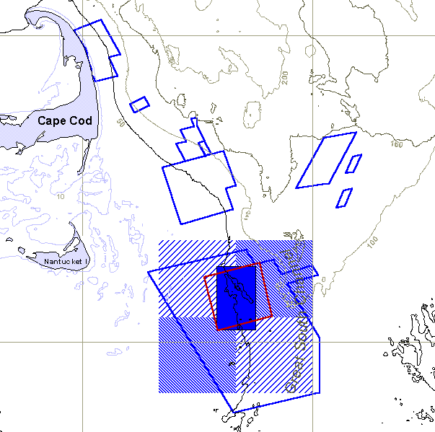
42° N
3
4
1
2
PCA
70° W
69° W
41° N
Figure 4.9: One example of potential alternatives for managing the important Atlantic cod areas identified by the hook fishing industry involves setting up a system of rotating fishing areas surrounding a permanently closed area (primarily the proposed HAPC). The permanently closed area (PCA) would remain closed to all types of fishing gear, in order to protect the sensitive and valuable habitat found there, provide opportunities for needed research, and serve as a "seed" area to improve recovery of the surrounding areas. In any given year, one or two areas could be open only to static fishing gear, one area could be open only to mobile fishing gear, and one or two areas could be closed to all fishing activity. The outlined areas represent those areas identified by members of the fishing industry (see Figure 3.64). Depths are provided in meters.

Measures to Minimize any Adverse Impacts of Fishing Gear and Practices
In addition to specific measures targeted at protecting the proposed HAPCs, the Habitat Committee may want to consider recommending additional measures designed to minimize any adverse impacts to fish habitat from currently used fishing gear and practices. The Sustainable Fisheries Act of 1996 requires the Council to act to minimize, where practicable, adverse effects of fishing on fish habitat. Although several of the management measures developed by the Council in 1998 serve to protect EFH to some degree (e.g., effort reduction in the scallop fishery, implementation of the Western Gulf of Maine closure, restrictions on the use of “rockhopper” trawls, etc.), no management measures were developed with the specific intent of reducing the impacts of fishing gear and practices on EFH.

The planned upcoming amendments to the Sea Scallop and Northeast Multispecies FMPs provide the Council with an opportunity to begin developing management measures and programs specifically intended to minimize any adverse impacts to EFH associated with currently used fishing gear and practices. There may be many appropriate measures which could serve this purpose, and the following are only meant as a suggested starting point for consideration by the Habitat Committee. During development of these plan amendments, a full review and analysis of such measures by the EFH Technical Team and the appropriate Plan Development Teams would be required.

Sea Scallop FMP Amendment

The following alternatives are suggestions for consideration by the Habitat Committee that could provide at least some degree of protection to some areas of EFH currently disturbed by scallop fishing.

- The Council could consider requiring the use of a “tender” or “light duty” dredge in areas thought to contain important and sensitive habitats (primarily hard bottom areas throughout the Gulf of Maine and on Georges Bank), if it can be demonstrated that the use of this type of scallop dredge reduces adverse impacts to sensitive and important hard bottom habitats; and/or,
- The Council could consider developing an area management program for scallop fishing that takes into account the sensitivity of some habitat types to disturbance by scallop dredges, including the recovery times of various habitats (i.e., in a rotational area management system, habitat types that take longer to recover would remain closed longer than habitats that recover quickly); and/or,
- Once sensitive hard bottom habitats have been identified and mapped, these areas could be closed to scallop fishing; and/or,
- The number and size of rock chains used at any one time on a scallop dredge could be limited to ensure that scallop dredges cannot effectively be used on the most sensitive and important hard bottom areas.

Northeast Multispecies FMP Amendment

The following alternatives are suggestions for consideration by the Habitat Committee that could provide at least some degree of protection to some areas of EFH currently disturbed by fishing for groundfish.

- As was done in limited areas in Framework 27 to protect Gulf of Maine Atlantic cod, the Council could consider limiting the allowable size of rockhopper and roller gear throughout the Gulf of Maine. This could serve to protect valuable and sensitive hard bottom habitats of high complexity from disturbance by otter trawls; and/or,.
- The Council could consider redesigning all current groundfish closed areas to ensure that the most important and sensitive habitats are enclosed by the boundaries of the closed areas. This does not mean that the closed areas would be larger, in fact, they could probably be significantly smaller if they are selected appropriately to include the most sensitive habitats and habitats that recover slowly following disturbance by bottom-tending mobile fishing gear; and/or,
- The Council could consider re-opening portions of the current groundfish closed areas to only certain fishing gear types as an incentive to promote the use of “habitat-friendly” fishing gears, once these gears are demonstrated to be relatively benign to sensitive and important habitat types, and if this type of action fits with the overall stock recovery plans; and/or,
- The Council could consider the continued prohibition of “streetsweeper” gear (and other potential gear modifications) until such time that it is demonstrated to have minimal impact on fish habitat.

Atlantic Herring FMP

At this time, the EFH Technical Team has no suggestions for consideration by the Habitat Committee regarding the Atlantic Herring FMP.

Atlantic Salmon FMP

At this time, the EFH Technical Team has no suggestions for consideration by the Habitat Committee regarding the Atlantic Salmon FMP.

Monkfish FMP

At this time, the EFH Technical Team has no suggestions for consideration by the Habitat Committee regarding the Monkfish FMP.

Research and Information Needs and Goals

The regulatory text of the Interim Final Rule directs the Council to include in the EFH amendment recommendations, preferably in priority order, for research efforts that the Council and NMFS view as necessary for carrying out their EFH management mandate. The need for additional research is to make available sufficient information to support a higher level of description and identification of EFH. Additional research may also be necessary to identify and evaluate actual and potential adverse effects on EFH including, but not limited to, direct physical alteration, impaired habitat quality / functions, cumulative impacts from fishing, or indirect adverse effects such as sea level rise, global warming and climate shifts, and non-equipment related fishery impacts. There is also a continuing need for additional research on the effects of fishing gear on EFH.

Section 7 of the EFH amendment describes research recommendations for expanded life history information that will result in the comprehensive identification of the habitat requirements of species or species assemblages, including all life history stages, as well as habitat-related information that defines the interrelationship between the species, the environment and the food web. The identified research needs also include information on adverse impacts from both non-fishing and fishing activities. Fishing activities include both recreational and commercial fishing equipment or practices.

Implementation of the Magnuson-Stevens Act requires a program of research that provides information to support higher levels of description and identification of EFH. Research on the ecology of fish and their linkages with habitat is the foundation for such description and identification of EFH. The diversity, quality, and extent of habitats are among the most significant environmental determinants of distribution, abundance, and diversity of fishery resources. At present, the contribution of many of these habitats to the productivity of managed fishery species is unknown. Scientific information is required on the structure and function of fishery habitats to judge the impacts of threats and provide recommendations to protect and restore habitats.

The following are the priority research and information needs identified by the EFH Technical Team, Habitat Committee and their Advisors as important and necessary to continue the work begun with the EFH amendment. Within each general category of priorities, there are more specific research and identification needs.

- Information on commercial and recreational fish landings. The EFH Technical Team is working with NMFS to get this information in a format usable for our purposes, but this is still a high priority. NMFS has agreed to provide landings data, by species, by ten minute square, for a reasonable time span (~ 10 years). They have also agreed to work with the EFH Technical Team to provide a breakdown of fish landings by gear type by ten minute square. The EFH Technical Team expects to incorporate and analyze this information in next year's Habitat Annual Review Report.
- Information on the distribution of fishing effort. This is a high priority for ongoing work on addressing gear impacts. We need to know how much effort exists by gear type by ten minute square. This is different than the landings by gear type, as effort may differ for a given amount of landings. It is also important that we get this information for different configurations of gear (e.g., roller vs. rockhopper vs. raised footrope trawls, etc., rather than just "otter trawls, fish"). In addition to basic information on the distribution of fishing effort, we have also identified the following related needs:
- Determine rates of impacts for primary fishing gears, through a range of effort, to the diversity of habitat types occurring within the management region.
- Determine rates of recovery of a range of habitats, in a range of physiographic settings, from chronic fishing disturbances.
- Model population effects on managed species and primary prey from fishing gear impacts to fish habitats. Models should generate predictions through a range of fishing effort across the diversity of habitat types based on a range of management options.
- Develop a reporting or vessel tracking system to collect high resolution data on where fishing occurs. The system should endeavor to collect effort at the scale of individual tows or sets of gear.
- Determine the effects of fishing gear on ecosystem processes (e.g., primary production and detrital pathways) compared to natural and other anthropogenic impacts.
- Identify baselines or control areas that have had the least gear related impacts for all bottom types in order to estimate what is possible in terms of regrowth: primarily areas with high relief geologic structure; areas in close proximity to wrecks that might be identified by age; or areas that might have been for whatever reason left undisturbed.
- Higher levels of information on the link between habitat and fish productivity (Level 3 and 4 EFH information). The Interim Final Rule for EFH describes Level 3 information as "growth, reproduction, or survival rates within habitats" by life history stage. The rule describes Level 4 information as "production rates by habitat." This type of research should be a high priority if EFH designations are to be refined to a meaningful level. The Northeast Fisheries Science Center is engaged in a suite of research projects designed to contribute to these levels of information (see section 2.3). Specific information needs include:
- Focus on the functional role of habitat in fisheries management. Existing EFH designations are descriptive. The next step is to analyze species distributions with quantitative models.
- Determine the patterns in distribution and abundance between managed species, and primary prey taxa, and their associated habitats.
- Determine how habitat structure effects rates of settlement, mortality and growth of managed species and primary prey. Rates should be determined for the full range of life history stanzas.
- Develop models to predict the role of protected areas in the long-term sustainable management of fisheries. Research will be required to determine movement rates of target species at all life history stages (e.g., with tagging studies).
- High resolution sediment mapping. If we are to manage important and sensitive habitats then we need to know where those habitats are, and not just at a broad and general scale (i.e., the USGS - Poppe et al. map). We need high resolution maps of hard bottom, soft bottom, mud bottom, boulder areas, etc. throughout the Gulf of Maine, Georges Bank, and Mid-Atlantic Bight.

As with any list of priority research and information needs such as this, it is critical that research needs be coordinated with existing extramural funding programs (e.g., Sussman-Kennedy grants, NURC, Sea Grant, etc.). Research needs should be prioritized within the context of the respective program which will solicit proposals. Research and information collection also should be coordinated to the maximum extent possible with Council actions, such as fishing closures and openings and other restrictions.

EFH Technical Team

Mr. Michael Pentony, NEFMC Staff, EFH Technical Team Chair
Mr. Brad Barr, Stellwagen Bank National Marine Sanctuary
Dr. Robert Buchsbaum, Massachusetts Audubon - North Shore
Dr. Jeremy Collie, Univ. of Rhode Island Graduate School of Oceanography
Dr. Jeff Cross, NMFS/NEFSC Howard Marine Sciences Lab
Ms. Laura Ernst, Rhode Island Coastal Resources Management Council
Ms. Patricia Fiorelli, NEFMC Staff
Mr. Arnold Howe, Massachusetts Division of Marine Fisheries
Ms. Penny Howell, Connecticut Dept. of Environmental Protection
Mr. Jon Kurland, NMFS Northeast Region Habitat Conservation Division
Dr. Rich Langton, Maine Department of Marine Resources
Mr. Eric Nelson, EPA Office of Ecosystems Protection
Mr. Joe Pelczarski, Massachusetts Coastal Zone Management Program
Mr. Chris Powell, Rhode Island Division of Fish & Wildlife
Mr. Stephen Rideout, U.S. Fish & Wildlife Service
Ms. Dianne Stephan, NMFS Northeast Region Habitat Conservation Division
Mr. Tony Wilbur, Massachusetts Coastal Zone Management Program
Dr. Page Valentine, U.S. Geological Survey

References

Anderson, J.T. and E.L. Dalley. 1997. Spawning and year-class strength of northern cod (Gadus morhua) as measured by pelagic juvenile cod surveys, 1991-1994. Can. J. Fish. Aquat. Sci. 54(Suppl. 1):158-167.
Atkinson, D.B., Rose, G.A., Murphy, E.F., and C.A. Bishop. 1997. Distribution changes and abundance of northern cod (Gadus morhua), 1981-1993. Can. J. Fish. Aquat. Sci. 54(Suppl. 1):132-138.
Auster, P. J. 1998. A Conceptual Model of the Impacts of Fishing Gear on the Integrity of Fish Habitats. Conservation Biology 12(6):1198-1203.
Brown, J.A., Pepin, P., Methven, D.A. and D.C. Somerton. 1989. The feeding, growth and behavior of juvenile cod, Gadus morhua L., in cold environments. J. Fish. Biol. 35:373-380.
Bigelow, H.B. and W.C. Schroeder. 1953. Fishes of the Gulf of Maine. U.S. Fish Wildl. Serv., Fish. Bull. 53:1-577.
Bogstad, B., Lilly, G.R., Mehl, S., Palsson, O.K., and G. Stefansson. 1994. Cannibalism and year-class strength in Atlantic cod (Gadus morhua) in Arcto-boreal ecosystem (Barents Sea, Iceland, and eastern Newfoundland. ICES Mar. Sci. Symp. 198:576-594.
Campbell, J.S. 1997. Introduction to the Northwest Atlantic cod symposium. Can. J. Fish. Aquat. Sci. 54(Suppl. 1):1
Clark, D.S. and J.M. Green. 1990. Activity and movement patterns of juvenile Atlantic cod, Gadus morhua, in Conception Bay, Newfoundland as determined by sonic telemetry. Can. J. Zool. 68:1434-1442.
Dalley, E.L. and J.T. Anderson. 1997. Age-dependent distribution of demersal juvenile Atlantic cod (Gadus morhua) in inshore/ offshore northeast Newfoundland. Can. J. Fish. Aquat. Sci. 54(Suppl. 1):168-176.
DeAlteris, J., L. Skrobe, and C. Lipsky. 1999. The Significance of Seabed Disturbance by Mobile Fishing Gear Relative to Natural Processes: A Case Study in Narragansett Bay, Rhode Island. American Fisheries Society Symposium 22.
Dennison, W.C., Orth, R.J., Moore, R.A., Stevenson, J.C., Carter, V., Kollar, S., Bergstrom, P.W., and R.A. Batiuk. 1993. Assessing water quality with submersed aquatic vegetation. Bioscience 43:86-94.
Duarte, C.M. 1995. Submerged aquatic vegetation in relation to different nutrient regimes. Ophelia 41:87-112.
Engel, J. and R. Kvitek. 1998. Impact of otter trawling on a benthic community in Monterey Bay National Marine Sanctuary. Conservation Biology 12(6):1204-1214.
Fraser, S., Gotceitas, V. and J.A. Brown. 1996. Interactions between age-classes of Atlantic cod and their distribution among bottom substrates. Can. J. Fish. Aquat. Sci. 53:305-314.
Gabriel, W. 1992. Persistence of demersal fish assemblages between Cape Hatteras and Nova Scotia, Northwest Atlantic. J. Northw. Atl. Fish. Sci. 14:29-14
Gibson, R.N., Robb, L., Barrows, M.T., and A.D. Ansell. 1996. Tidal, diel and longer term changes in the distribution of fishes on a Scottish sandy beach. Mar. Ecol. Prog. Ser. 130:1-17.
Goddard, S.V., Kao, M.H., and G.L. Fletcher. 1992. Antifreeze production, freeze resistance, and overwintering of juvenile northern Atlantic cod (Gadus morhua). Can. J. Fish. Aquat. Sci. 49:516-522.
Gotceitas, V. and J.A. Brown. 1993. Substrate selection by juvenile Atlantic cod (Gadus morhua): effects of predation risk. Oecologia 93:31-37.
Gotceitas, V., Fraser, S. and J.A. Brown. 1995. Substrate selection by juvenile Atlantic cod in the presence of an actively foraging and non-foraging predator. Mar. Biol. 123:421-430.
Gotceitas, V., Fraser, S. and J.A. Brown. 1997. Use of eelgrass (Zostera marina) by juvenile Atlantic cod (Gadus morhua). Can. J. Fish. Aquat. Sci. 54:1306-1319.
Grant, S.M. and J.A. Brown. 1998a. Diel foraging cycles and interactions among juvenile Atlantic cod (Gadus morhua) at a nearshore site in Newfoundland. Can. J. Fish. Aquat. Sci. 55:1307-1316.
Grant, S.M. and J.A. Brown. 1998b. Nearshore settlement and localized populations of age-0 Atlantic cod (Gadus morhua) in shallow coastal waters of Newfoundland. Can. J. Fish. Aquat. Sci. 55:1317-1327.
Gregory, R.S. and J.T. Anderson. 1997. Substrate selection and use of protective cover by juvenile Atlantic cod Gadus morhua in inshore waters of Newfoundland. Mar. Ecol. Prog. Ser. 146:9-20.
Gregory, R.S., Anderson, J.T. and E.L. Dalley. 1997. Distribution of juvenile Atlantic cod (Gadus morhua) relative to available habitat in Placentia Bay, Newfoundland. NAFO Sci. Coun. Studies 29:3-12.
Hansen, H.H., and K.M. Lehmann. 1986. Distribution of young cod in coastal regions of west Greenland, 1985. NAFO SCR. Doc. 86/42 Ser. No. N1158.
Hanson, J.M. 1996. Seasonal distribution of juvenile Atlantic cod in the southern Gulf of St. Lawrence. J. Fish. Biol. 49:1138-1152.
Heck, K.L.,Jr., Able, K.W., Fahey, M.P. and C.T. Roman. 1989. Fishes and decapod crustaceans of Cape Cod eelgrass meadows: species composition, seasonal abundance patterns and comparisons with unvegetated substrates. Estuaries 12:59-65.
Heck, K.L. and L.B. Crowder. 1991. Habitat structure and predator-prey interactions in vegetated aquatic systems. In Habitat structure: the physical arrangement of objects in space. Edited by S.S. Bell, E.D. McCoy, and H.R. Mushinsky. Chapman and Hall, New York. pp. 282-299.
Heck, K.L., Jr., Able, K.W., Roman, C.T. and M.P. Fahey. 1995. Composition, abundance, biomass, and production of macrofauna in a New England estuary: comparison among eelgrass meadows and other nursery habitats. Estuaries 18(2):379-389.
Horne, J.K. and S.E. Campana. 1989. Environmental factors influencing the distribution of juvenile groundfish in nearshore habitats of southwest Nova Scotia. Can. J. Fish. Aquat. Sci. 46:1277-1286.
Hovgard, H.H. and K.H. Nygaard. 1990. Young cod distribution and abundance in west Greenland inshore areas, 1989. NAFO SCR. Doc. 90/30 Ser. No. N1747.
Hutchings, J.A. 1996. Spatial and temporal variation in the density of northern cod and a review of hypotheses for the stock's collapse. Can. J. Fish. Aquat. Sci. 53:943-962.
Ings, D.W., Schneider, D.C., and D.A. Methven. 1997. Detection of a recruitment signal in juvenile Atlantic cod (Gadus morhua) in coastal nursery areas. Can. J. Fish. Aquat. Sci. 54(Suppl. 1):25-29.
Isaksson, I., Pihl, L. and J. vanMontfrans. 1994. Eutrophication-related changes in macrovegetation and foraging of young cod (Gadus morhua L.): a mesocosm experiment. J. Exp. Mar. Biol. Ecol. 177:203-217.
Kaiser, M.J. 1998. Significance of Bottom-fishing Disturbance. Conservation Biology 12(6):1230-1235.
Keats, D.W. 1990. A nocturnal inshore movement of juvenile cod Gadus morhua L. in eastern Newfoundland. J. Exp. Mar. Biol. Ecol. 139:167-173.
Keats, D.W., Steele, D.H., and G.R. South. 1987. The role of fleshy macroalgae in the ecology of juvenile cod (Gadus morhua L.) in inshore waters off eastern Newfoundland. Can. J. Zool. 65:49-53.
Keats, D.W. and D.H. Steele. 1992. Diurnal feeding of juvenile cod (Gadus morhua) which migrate into shallow water at night in Eastern Newfoundland. J. Northw. Atl. Fish. Sci. 13:7-14.
Lomond, T.M., Schneider, D.C., and D.A. Methven. 1998. The transition from pelagic to benthic prey of 0-1 group Atlantic cod. Fish. Bull. 96:908-911.
Lough, R.G., Valentine, P.C., Potter, D.C., Auditore, P.J., Bolz, G.R., Neilson, J.D., and R.P. Perry. 1989. Ecology and distribution of juvenile cod and haddock in relation to sediment type and bottom currents on eastern Georges Bank. Mar. Ecol. Prog. Ser. 56:1-12.
MacDonald, J.S., Dadswell, M.J., Appy, R.J., Melvin, G.D., and D.A. Methven. 1984. Fishes, fish assemblages, and their seasonal movements in the lower Bay of Fundy and Passamaquoddy Bay, Canada. Fish. Bull. 82(1):121-140.
Mahon, R., S.K. Brown, K.C.T. Zwanenburg, D.B. Atkinson, K.R. Buja, L. Claflin, G.D. Howell, M.E. Monaco, R.N. O'Boyle and M. Sinclair. 1998. Assemblages and biogeography of demersal fishes of the east coast of North America. Can. J. Fish. Aquat. Sci. 55:1704-1738.
McClelland, J.W. and I. Valiela. 1998. Changes in food web structure under the influence of increased anthropogenic nitrogen inputs to estuaries. Mar. Ecol. Prog. Ser. 168:259-271.
Methven, D.A., and C. Bajdik. 1994. Temporal variation in size and abundance of juvenile Atlantic cod (Gadus morhua) at an inshore site off eastern Newfoundland. Can. J. Fish. Aquat. Sci. 51:78-90.
Methven, D.A. and D.C. Schneider. 1998. Gear-independent patterns of variation in catch of juvenile Atlantic cod (Gadus morhua) in coastal habitats. Can. J. Fish. Aquat. Sci. 55:1430-1442.
Muehlstein, L.K. and D. Porter. 1991. Labyrinthula zosterae sp. Nov. the causative agent of wasting disease of eelgrass, Zostera marina. Mycologia 83(2):180-191.
Myers, R.A. and N.J. Barrowman. 1996. Is fish recruitment related to spawner abundance? Fish. Bull. 94:707-724.
Myers, R.A. and N.C. Cadigan. 1993a. Density-dependent juvenile mortality in marine demersal fish. Can. J. Fish. Aquat. Sci. 50:1576-1590.
Myers, R.A. and N.C. Cadigan. 1993b. Is juvenile natural mortality in marine demersal fish variable? Can. J. Fish. Aquat. Sci. 50:1591-1598.
Myers, R.A., Hutchings, J.A. and N.J. Barrowman. 1996. Hypotheses for the decline of cod in the North Atlantic. Mar. Ecol. Prog. Ser. 138:293-308.
NEFMC. 1998. Omnibus essential fish habitat amendment to fishery management plans. Saugus, MA.
NEFMC's Multispecies Monitoring Committee. 1998. Report of the New England Fishery Management Council's Multispecies Monitoring Committee. Dec, 1998.
NEFSC [Northeast Fisheries Science Center]. 1997. Report of the 27th Northeast Regional Stock Assessment Workshop (27th SAW) Consensus summary of Assessments.
Nixon, S.W. 1995. Coastal marine eutrophication: a definition, social causes, and future concerns. Ophelia 41:199-219.
Olsen, S. and A.V. Soldal. 1989. Observations on inshore distribution and behaviour of 0-group northeast Arctic cod. Rapp. P.-v. Reun. Cons. Int. Explor. Mer., 191:296-302.
Orth, R.J., Heck, K.L., and J. vanMontfrans. 1984. Faunal communities in seagrass beds: a review of the influence of plant structure and prey characteristics on predator-prey relationships. Estuaries 7:339-350.
Overholtz, W.J. and A.V. Tyler. 1985. Long-term responses of the demersal fish assemblages of Georges Bank. Fishery Bulletin 83(4):507-520
Perry, R.I. and J.D. Neilson. 1988. Vertical distributions and trophic interactions of age-0 Atlantic cod and haddock in mixed and stratified waters of Georges Bank. Mar. Ecol. Prog. Ser. 49:199-214.
Pilskaln, C.H., J.H. Churchill and L.M. Mayer. 1998. Resuspension of Sediment by Bottom Trawling in the Gulf of Maine and Potential Geochemical Consequences. Conservation Biology 12(6):1223-1229.
Pinsent, D.L. and D.A. Methven. 1997. Protracted spawning of Atlantic cod (Gadus morhua) in Newfoundland waters: evidence from otolith microstructure. Can. J. Fish. Aquat. Sci. 54(Suppl. 1):19-24.
Poppe, L.J., J.S. Schlee, B. Butman, and R.S. Lewis. 1989. Map showing distribution of surficial sediment, Gulf of Maine and Georges Bank. U.S. Geological Survey, Misc. Invest. Ser., Map 1-1986-A.
Riley, J.D. and W.G. Purnell. 1984. The distribution of young cod. In The propagation of cod, Gadus morhua L. Edited by E. Dahl, S.S. Danielssen, E. Moksness, and P. Solemdal. Flod. Rapp. 1:563-580. (ISSN 0333-2594).
Schneider, D.C., Methven, D.A., and E.L. Dalley. 1997. Geographic contractions in juvenile fish: a test with northern cod (Gadus morhua) at low abundances. Can. J. Fish. Aquat. Sci. 54(Suppl. 1):187-199.
Schwinghamer, P., D.C. Gordon Jr., T.W. Rowell, J. Prena, D.L. McKeown, G. Sonnichsen and J.Y. Guigné. 1998. Effects of Experimental Otter Trawling on Surficial Sediment Properties of a Sandy Bottom Ecosystem of the Grand Banks of Newfoundland. Conservation Biology 12(6):1215-1222.
Short, F.T., Muehlstein, L.K. and D. Porter. 1987. Eelgrass wasting disease: cause and recurrence of a marine epidemic. Biol. Bull. 173:557-562.
Sissenwine, M.P. 1984. Why do fish populations vary? In Exploitation of marine communities. Edited by R.M. May. Springer-Verlag, Berlin. pp. 59-94.
Smedbol, R.K., Schneider, D.C., Wroblewski, J.S. and D.A. Methven. 1998. Outcome of an inshore spawning event by northern Atlantic cod (Gadus morhua) at a low stock level. Can. J. Fish. Aquat. Sci. 55:2283-2291.
Sogard, S.M. 1989. Colonization of artificial seagrass by fishes and decapod crustaceans: importance of proximity to natural eelgrass. J. Exp. Mar. Biol. Ecol. 133:15-38.
Swain, D.P. and E.J. Wade. 1993. Density-dependent geographic distribution of Atlantic cod (Gadus morhua) in the southern Gulf of St. Lawrence. Can. J. Fish. Aquat. Sci. 50:725-733.
Taggart, C.T., Anderson, J., Bishop, C., Colbourne, E., Hutchings, J., Lilly, G., Morgan, J., Murphy, E., Myers, R., Rose, J., and P. Shelton. 1994. Overview of cod stocks, biology, and environment in the Northwest Atlantic region of Newfoundland with emphasis on northern cod. ICES Mar. Sci. Symp. 198:140-157.
Tupper, M. and R.G. Boutilier. 1995a. Size and priority at settlement determine growth and competitive success of newly settled Atlantic cod. Mar. Ecol. Prog. Ser. 118:295-300.
Tupper, M. and R.G. Boutilier. 1995b. Effects of habitat on settlement, growth, and postsettlement survival of Atlantic cod (Gadus morhua). Can. J. Fish. Aquat. Sci. 52:1834-1841.
Tyler, A.V. 1971. Surges of winter flounder, Pseudopleuronectes americanus, into the intertidal zone. J. Fish. Res. Bd. Canada 28(11):1727-1731.
Wahle, R.A. 1993. Recruitment to American lobster populations along an estuarine gradient. Estuaries 16(4):731-738.
Wahle, R.A. and R.S. Steneck. 1992. Habitat restrictions in early benthic life: experiments in substratum selection and in situ predation with the American lobster. J. Exp. Mar. Biol. and Ecol. 157:91-114.
Wigley, S.E. and W.L. Gabriel. 1991. Distribution of sexually immature components of 10 Northwest Atlantic groundfish species based on Northeast Fish. Center bottom trawl surveys, 1968-86. NOAA Tech. Memo. NMFS-F/NEC-80:17 p.
Wigley, S.E. and F.M. Serchuk. 1992. Spatial and temporal distribution of juvenile Atlantic cod Gadus morhua in the Georges Bank-Southern New England region. Fish. Bull. 90:599-606.

New England Fishery Management Council

Habitat Annual Review Report

APPENDICES

April 1999

Habitat Annual Review Report

APPENDIX A

Rhode Island State Survey Report

Habitat Annual Review Report

APPENDIX B

Connecticut State Survey Report

